PRESS RELEASE

Custom Capabilities Catalog, Including Over 90 Transformer Packages is Released
Explore Wurth Electronics Midcom Capabilities
Watertown (USA), 21 June 2016 – Released to the public in June 2016, Wurth Electronics Midcom is proud to announce the publication of the newest Capabilities Catalog. This comprehensive catalog includes capabilities for the design of custom transformers and toroids, the focus of the company for over 25 years.
The catalog offers customers over 90 transformer package styles as the foundation for a custom design. Three new transformer package styles, EP5, EPW15, and ER.5S, are featured this year, as well as a new chapter of finished magnetic components.
Contact your local sales representative for your own copy, or download the digital copy www.we-online.com/CapabilitiesCatalog.

Available images
The following images can be downloaded from the Internet in printable quality: http://www.htcm.de/kk/wuerth
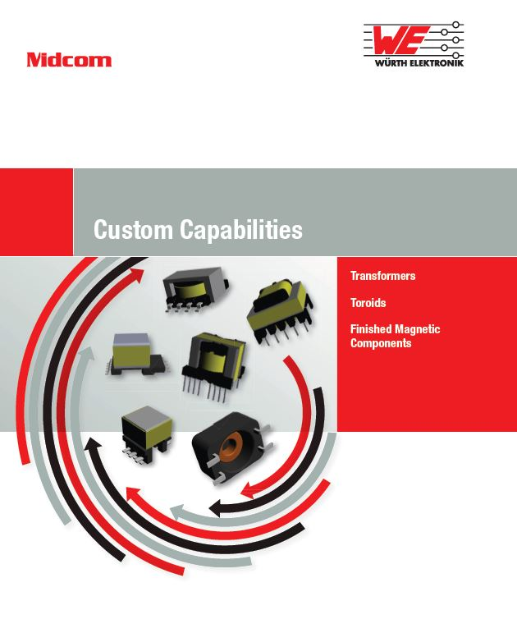
Image source: Wurth Electronics Midcom
Capabilities Catalog from Midcom

About Wurth Electronics Midcom, Inc.

Wurth Electronics Midcom is a global leader in the design and manufacture of custom magnetics. A standard line of magnetics is offered, including inductors, ferrites, chokes, and EMI shielding materials. Recently, the electromechanical and interconnect line was added to the product offering, which includes Board-to-Board, Wire-to-Board, Terminal Blocks, and Input/Output Communication.
Customers in Asia, Europe and the Americas are supported through a local direct technical sales network, regional design and applications engineers and manufacturing based in the People’s Republic of China.
Our standard lines and custom-made transformers are used around the world in LED lighting, smart grid and utility metering, industrial controls, telecom (CPE and CO), home automation, and home appliances.
Wurth Electronics Midcom offers all catalog products in stock. Free samples are offered to customers on connectors and both catalog and custom magnetics.
Further information at www.we-online.com

Further information:  Wurth Electronics Midcom, Inc.  Lindsey Esche  121 Airport Drive  PO Box 1330  Watertown, SD 57201 USA  Phone: +1 605 886 4385  Toll-free (in the U.S.):  Phone: +1 800 643 2661  E-mail: lindsey.esche@we-online.com  www.we-online.com | Press contact:  HighTech communications GmbH  Brigitte Basilio  Grasserstrasse 1c  80339 Munich  Germany  Phone: +49 89 500778-20  Fax: +49 89 500778-77  E-mail: b.basilio@htcm.de  www.htcm.de

