PRESS RELEASE

Würth Elektronik eiSos and Zuken launch Component Libraries for CADSTAR
Component Library Ready at Hand
Waldenburg (Germany), Bristol (UK), 18 July 2016 – Würth Elektronik eiSos, a manufacturer of electronic and electromechanical components and Zuken, a leader in PCB and IC package design, announce the launch of new component libraries for CADSTAR.
Würth Elektronik eiSos will now provide free-of-charge component libraries of its passive components for Zuken’s CADSTAR design software. The libraries allow users to simply download the correct components and start designing, without needing to worry about creating the right footprint or mechanical dimensions. These details, as well as the electrical parameters, are defined within the libraries, which are updated regularly.
Starting with passive components, Würth Elektronik eiSos already plans to expand the library to include semiconductors, optoelectronics and electromechanical components.
Jochen Baier, Technical Marketing Manager at Würth Elektronik eiSos said: “Würth Elektronik places great importance on high quality component libraries, to simplify and speed-up the design process for our customers.”
Jeroen Leinders, CADSTAR Distribution Manager at Zuken, said: “CADSTAR users now enjoy shorter implementation design time thanks to Würth component libraries in CADSTAR. With the need to keep up with ever-reducing design cycle times, the libraries reduce the time engineers must spend creating PCB footprints and schematic symbols.”
The libraries build on an existing partnership with Würth Elektronik’s PCB division, through which Würth Elektronik’s design rules and layer structures are incorporated into CADSTAR as free templates which can be applied during the layout process.
The new libraries are available free at www.we-online.com/cadstar and are also supplied with the regular CADSTAR updates.
For further information, see: www.we-online.com/cadstar

Available images
The following images can be downloaded from the Internet in printable quality: http://www.htcm.de/kk/wuerth
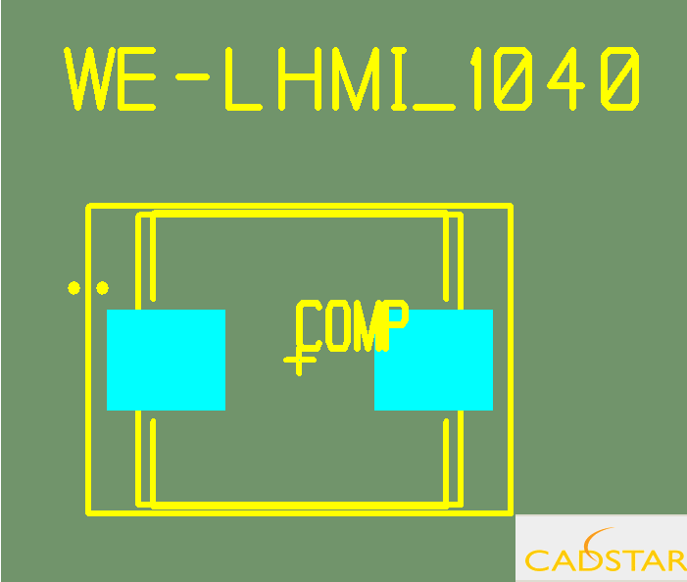 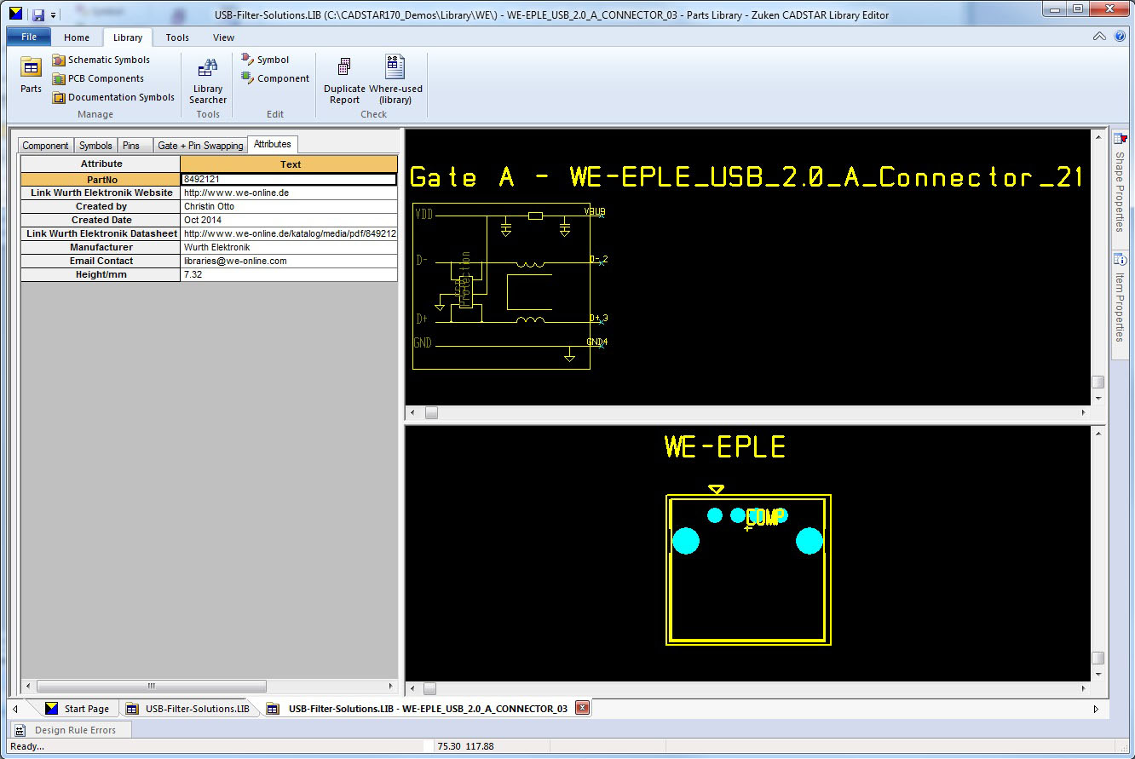 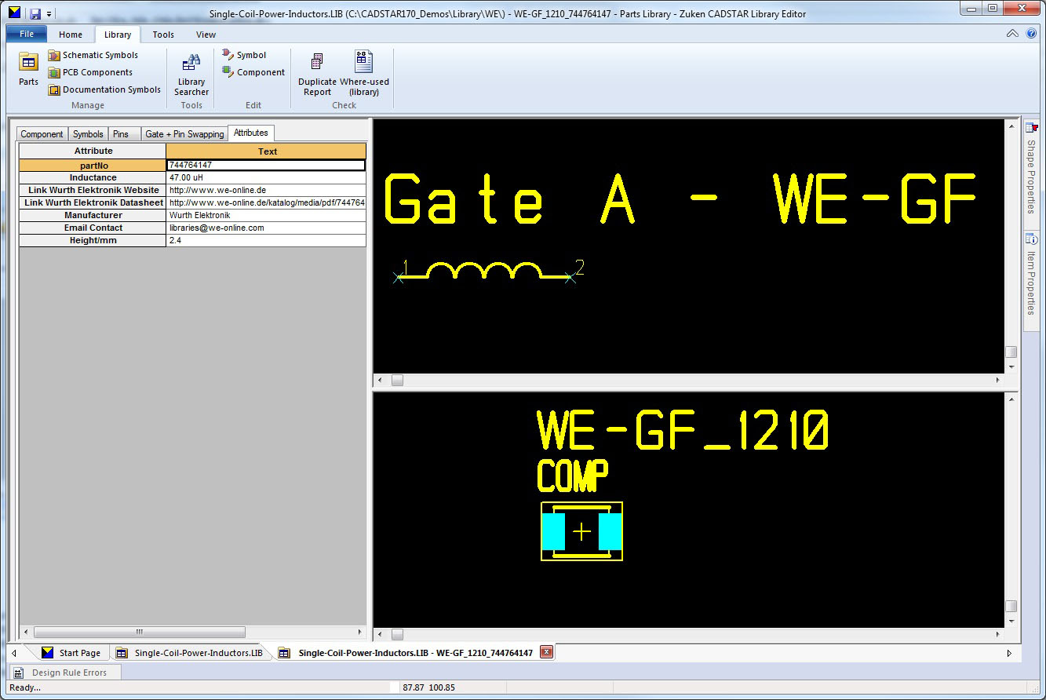
Image source: Würth Elektronik eiSos
With the new CADSTAR libraries, footprint and dimensions of Würth Elektronik eiSos components are available together with the electrical parameters.
(Image 1–3)

About Zuken

Zuken is a global provider of leading-edge software and consulting services for electrical and electronic design and manufacturing. Founded in 1976, Zuken has the longest track record of technological innovation and financial stability in the electronic design automation (EDA) software industry. The company’s extensive experience, technological expertise and agility, combine to create world-class software solutions. Zuken’s transparent working practices and integrity in all aspects of business produce long-lasting and successful customer partnerships that make Zuken a reliable long-term business partner.
Zuken is focused on being a long-term innovation and growth partner. The security of choosing Zuken is further reinforced by the company’s people—the foundation of Zuken’s success. Coming from a wide range of industry sectors, specializing in many different disciplines and advanced technologies, Zuken’s people relate to and understand each company’s unique requirements.
For more information about the company and its products, visit www.zuken.com.

About Würth Elektronik eiSos GmbH & Co. KG

Würth Elektronik eiSos GmbH & Co. KG is a manufacturer of electronic and electromechanical components for the electronics industry. The company is part of the Würth Group, the global market leader for fastener technology. It employs 6,100 people and generated sales of almost 475 million Euros in 2015. Würth Elektronik eiSos is active in 50 countries worldwide.
Manufacturing facilities in Europe, Asia and North America ensure delivery to a customer base that is growing worldwide. The product range covers EMC components, inductors, transformers, HF components, varistors, capacitors, power modules, LEDs, connectors, power elements, switches, assembly technology and fuse holders.
Würth Elektronik eiSos is one of Europe's largest manufacturers of passive components.
Würth Elektronik: more than you expect!
Further information at www.we-online.com

Further information:  Würth Elektronik eiSos GmbH & Co. KG  Sarah Hurst  Max-Eyth-Strasse 1  74638 Waldenburg  Germany  Phone: +49 7942 945-5186  E-mail: sarah.hurst@we-online.de  www.we-online.de | Press contact:  HighTech communications GmbH  Brigitte Basilio  Grasserstrasse 1c  80339 Munich  Germany  Phone: +49 89 500778-20  Fax: +49 89 500778-77  E-mail: b.basilio@htcm.de  www.htcm.de

