MEDIA INFORMATION

Würth Elektronik eiSos presents its Mix and Match selection tool
Find the right coils for wireless power transfer
Waldenburg (Germany), 25 July 2016 – Würth Elektronik eiSos is the manufacturer with the world’s broadest product spectrum of wireless power charging coils. Now the company provides developers with a tool to simplify selection of the right transmitter and receiver coils. Mix and Match, like the world's most precise AC loss calculator for power inductors, is another offering from the RED EXPERT Toolbox. Also like the other tools in RED EXPERT, Mix and Match shows online accessible product specifications are based on extensive electrical performance measurements of the individual modules in sample applications.
The WE-WPCC (Wireless Power Charging Coil) product group offers a wide selection of coils for various types of wireless power applications – extending across consumer electronics, industrial applications through to medical technology. Some combinations of transmitter and receiver coils work perfectly, some only with larger transmission losses, and then there are combinations that must be advised against, because the coils may have the wrong size ratio, for example.
“A common misconception is that all coils can be combined with one another arbitrarily according to the Qi inductive power standard”, explains Cem Som from Strategic Product Development at Würth Elektronik eiSos. “We make the developer’s work easier by evaluating all coils and their combinations. Now we provide our customers with a tool – Mix and Match – with which every developer finds the suitable coils for their application.
We relieve them of the problem of performing their own initial measurements for proof of operation, as measurement curves, such as those for the permeability or thermal behavior of the coils, are available here.”
Empirical values
The extensive measurement series that form the basis of the new Mix and Match coil combination tool for wireless power transfer are a service with which Würth Elektronik eiSos saves its customers time and money. The background: Calculations based on specifications cannot predict all aspects of coil performance and have to be confirmed in tests. For its own wireless power product portfolio, Würth Elektronik eiSos relieves its customers of this step. The free-of-charge Mix and Match online tool will continue to be expanded. For instance, it is planned for Q4 2016 to publish data on the resonant circuits of the coil combinations tested.

Available images
The following images can be downloaded from the Internet in printable quality: http://www.htcm.de/kk/wuerth
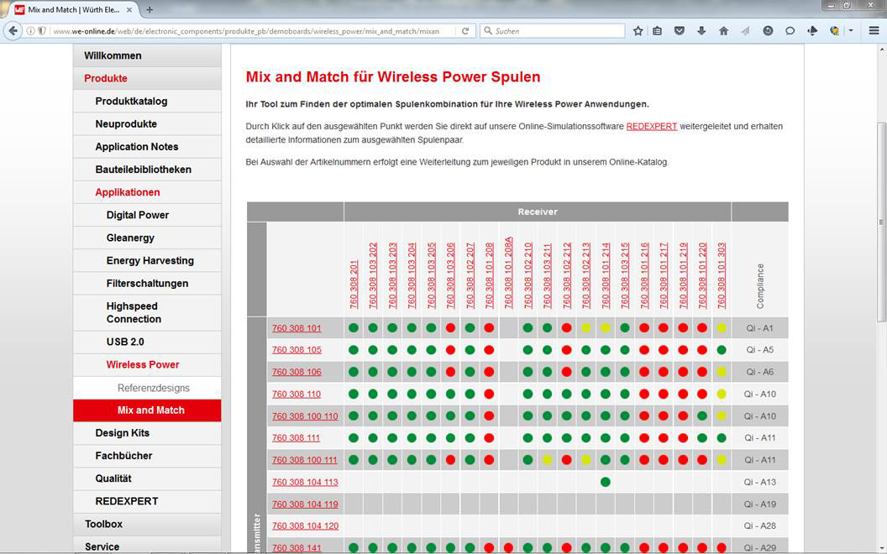Picture source: Würth Elektronik eiSos  With the Mix and Match tool, developers find the suitable coils for wireless power applications. | 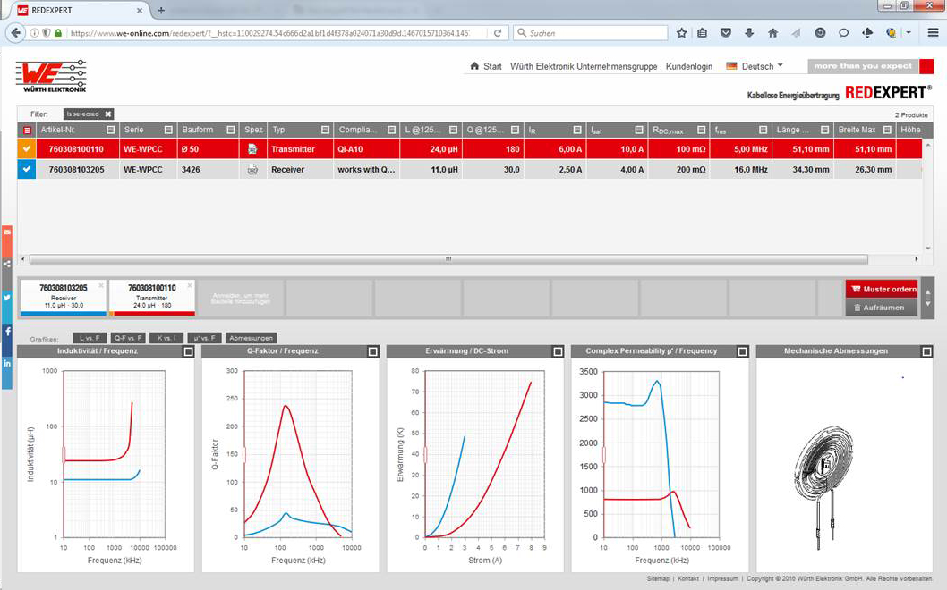  Picture source: Würth Elektronik eiSos  The extensive measurement series that form the basis of the new Mix and Match coil combination tool for wireless power transfer are a service with which Würth Elektronik eiSos saves its customers time and money.

About Würth Elektronik eiSos GmbH & Co. KG

Würth Elektronik eiSos GmbH & Co. KG is a manufacturer of electronic and electromechanical components for the electronics industry. The company is part of the Würth Group, the global market leader for fastener technology. It employs 6,100 people and generated sales of almost 475 million Euros in 2015. Würth Elektronik eiSos is active in 50 countries worldwide.
Manufacturing facilities in Europe, Asia and North America ensure delivery to a customer base that is growing worldwide. The product range covers EMC components, inductors, transformers, HF components, varistors, capacitors, power modules, LEDs, connectors, power elements, switches, assembly technology and fuse holders.
Würth Elektronik eiSos is one of Europe's largest manufacturers of passive components.
Würth Elektronik: more than you expect!
Further information at www.we-online.com

Further information:  Würth Elektronik eiSos GmbH & Co. KG  Sarah Hurst  Max-Eyth-Strasse 1  74638 Waldenburg  Germany  Phone: +49 7942 945-5186  E-mail: sarah.hurst@we-online.de  www.we-online.de | Press contact:  HighTech communications GmbH  Brigitte Basilio  Grasserstrasse 1c  80339 Munich  Germany  Phone: +49 89 500778-20  Fax: +49 89 500778-77  E-mail: b.basilio@htcm.de  www.htcm.de

