PRESS RELEASE

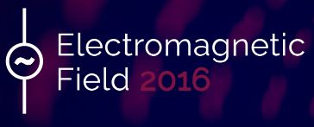
Würth Elektronik eiSos is sponsor of the Electromagnetic Field 2016 festival
Components featured in the multifunctional festival badge!
5 - 7 August 2016
Waldenburg (Germany), 2nd August 2016 – Würth Elektronik eiSos, leading European manufacturer of electronic and electromechanical components, is sponsor of the Electromagnetic Field community festival in Guildford, south-west of London. A broad spectrum of attendees including technophile hackers, electronic crafters and hobby inventors will gather from August 5th and 7th for this festival. Würth Elektronik eiSos is a badge sponsor and has contributed various passive components within the legendary TiLDA festival badge. Each festival participant will receive a complimentary badge featuring a programmable microcontroller with display and WiFi interface.
Würth Elektronik eiSos stands alongside other prominent sponsors of the TiLDA festival badge including STMicroelectronics and Texas Instruments. Details on the batch runs Python and details of the preinstalled software will be published at the start of the festival, but its functions should be similar to those at Electromagnetic Field 2014. Back then it was possible to view the current workshop and presentation program online and to be informed about events. The device contains an in-built flash light, a rain alarm and two games. Very much in the “hacker and maker” spirit of the festival, TiLDA can be individually reprogrammed by the Electromagnetic Field participants after the event. The components from Würth Elektronik eiSos integrated include LEDs (WL-SMCW) and ceramic capacitors (WCAP-CSGP).
“The hacker and maker scene is extremely innovative and Würth Elektronik being a technology company has a shared enthusiasm for creative technical solutions; we are pleased to be a badge sponsor for the event. Who knows, maybe there will also be future Würth Elektronik developers soldering and hacking in this electrified non-profit festival. We wish the ‘geeks’ a fantastic time!” says Benjamin Benchimol, Division Manager Strategic Partnerships at Würth Elektronik eiSos.

Available images
The following images can be downloaded from the Internet in printable quality: http://www.htcm.de/kk/wuerth
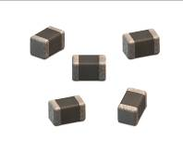  Image source: Würth Elektronik eiSos  WCAP-CSGP ceramic capacitors (image) and LEDs (WL-SMCW) – components Würth Elektronik eiSos is contributing to the Electromagnetic Field 2016 geek festival. | 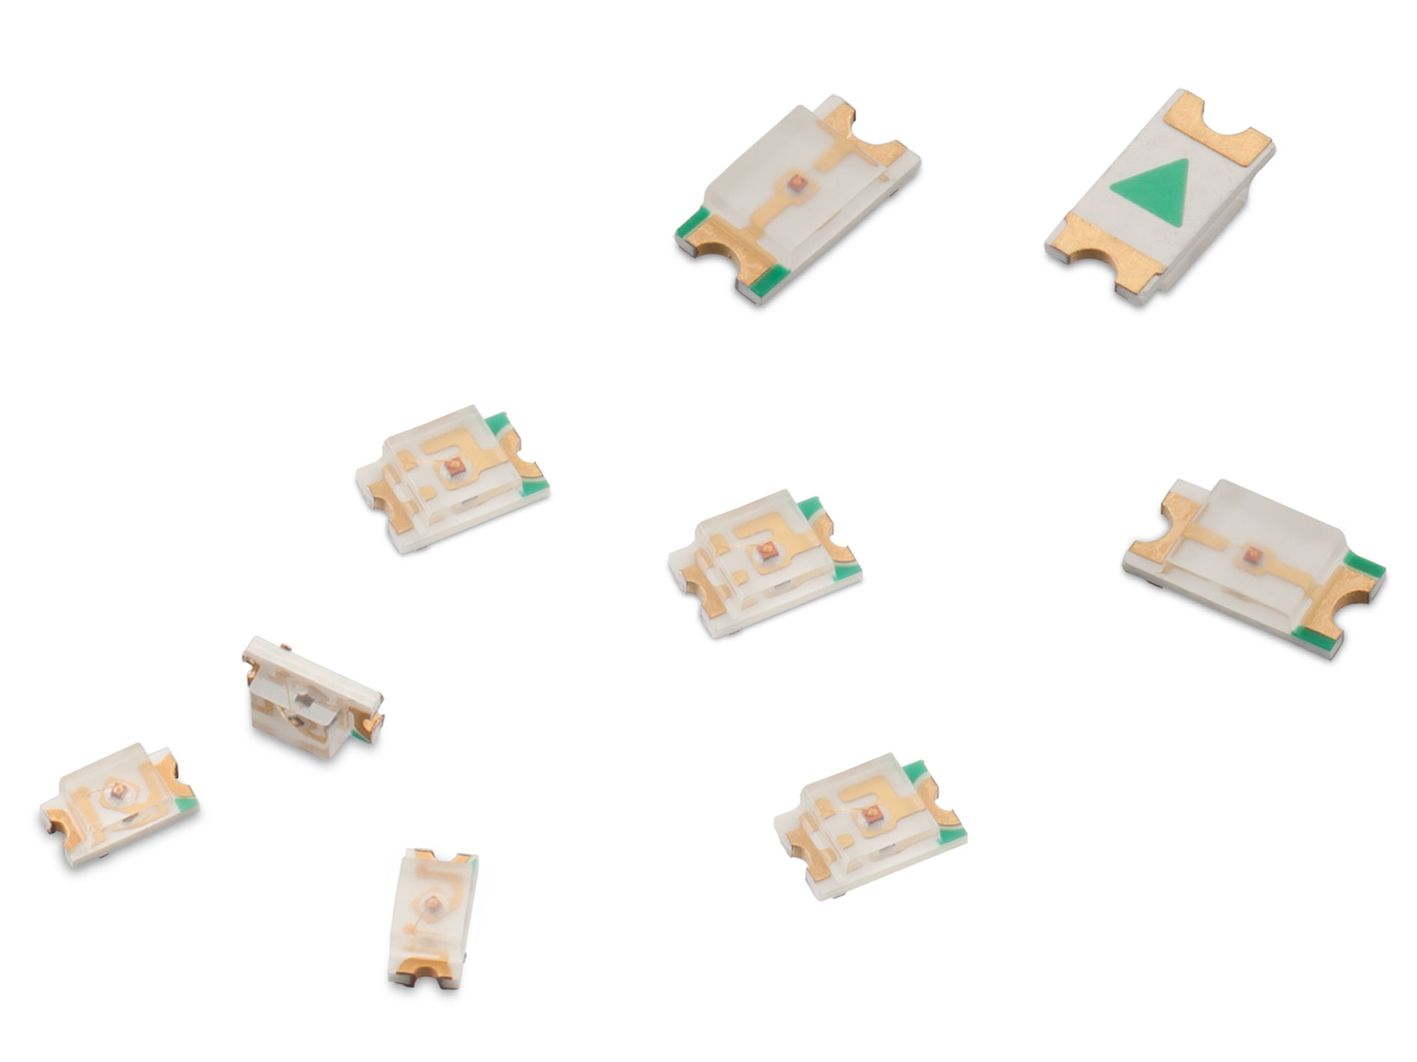  Image source: Würth Elektronik eiSos  Components from Würth Elektronik eiSos: LEDs (WL-SMCW)

About Würth Elektronik eiSos GmbH & Co. KG

Würth Elektronik eiSos GmbH & Co. KG is a manufacturer of electronic and electromechanical components for the electronics industry. The company is part of the Würth Group, the global market leader for fastener technology. It employs 6,100 people and generated sales of almost 475 million Euros in 2015. Würth Elektronik eiSos is active in 50 countries worldwide.
Manufacturing facilities in Europe, Asia and North America ensure delivery to a customer base that is growing worldwide. The product range covers EMC components, inductors, transformers, HF components, varistors, capacitors, power modules, LEDs, connectors, power elements, switches, assembly technology and fuse holders.
Würth Elektronik eiSos is one of Europe's largest manufacturers of passive components.
Würth Elektronik: more than you expect!
Further information at www.we-online.com

Further information:  Würth Elektronik eiSos GmbH & Co. KG  Sarah Hurst  Max-Eyth-Strasse 1  74638 Waldenburg  Germany  Phone: +49 7942 945-5186  E-mail: sarah.hurst@we-online.de  www.we-online.de | Press contact:  HighTech communications GmbH  Brigitte Basilio  Grasserstrasse 1c  80339 Munich  Germany  Phone: +49 89 500778-20  Fax: +49 89 500778-77  E-mail: b.basilio@htcm.de  www.htcm.de

