PRESS RELEASE

Wurth Electronics Midcom Announces New Flyback Transformers in Partnership with Dialog Semiconductor

Watertown (USA), 31 August 2016 – In partnership with Dialog Semiconductor, Wurth Electronics Midcom announces the new flyback transformers for iW1818 and iW1830, reference designs for AC/DC controllers. Equipped with single or dual outputs, these MID-OLDIA offline transformers offer high efficiency, low leakage inductance, and excellent EMI performance. The new, reinforced, insulation, flyback transformers are best suited for white goods, home appliances, and offline flyback power supplies.
To review the transformer family, visit www.we-online.com/MID-OLDIA.
Free samples can be requested at www.we-online.com/midcom.

Available images
The following images can be downloaded from the Internet in printable quality: http://www.htcm.de/kk/wuerth
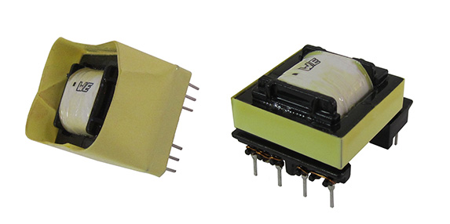
Image source: Wurth Electronics Midcom
New flyback transformers for iW1818 and iW1830, reference designs for AC/DC controllers.

About Wurth Electronics Midcom, Inc.

Wurth Electronics Midcom is a global leader in the design and manufacture of custom magnetics. A standard line of magnetics is offered, including inductors, ferrites, chokes, and EMI shielding materials. Recently, the electromechanical and interconnect line was added to the product offering, which includes Board-to-Board, Wire-to-Board, Terminal Blocks, and Input/Output Communication.
Customers in Asia, Europe and the Americas are supported through a local direct technical sales network, regional design and applications engineers and manufacturing based in the People’s Republic of China.
Our standard lines and custom-made transformers are used around the world in LED lighting, smart grid and utility metering, industrial controls, telecom (CPE and CO), home automation, and home appliances.
Wurth Electronics Midcom offers all catalog products in stock. Free samples are offered to customers on connectors and both catalog and custom magnetics.
Further information at www.we-online.com

Further information:  Wurth Electronics Midcom, Inc.  Lindsey Esche  121 Airport Drive  PO Box 1330  Watertown, SD 57201 USA  Phone: +1 605 886 4385  Toll-free (in the U.S.):  Phone: +1 800 643 2661  E-mail: lindsey.esche@we-online.com  www.we-online.com | Press contact:  HighTech communications GmbH  Brigitte Basilio  Grasserstrasse 1c  80339 Munich  Germany  Phone: +49 89 500778-20  Fax: +49 89 500778-77  E-mail: b.basilio@htcm.de  www.htcm.de

