PRESS RELEASE

Würth Elektronik eiSos and Fraunhofer IIS to cooperate
Shared research from energy harvesting to high-frequency technology
Waldenburg, Erlangen, 15 November 2016 – Würth Elektronik eiSos and Fraunhofer-Institut für Integrierte Schaltungen IIS have signed a cooperation agreement. The cooperation between the electronics manufacturer and the research institute covers the areas of wireless power, magnetic field measurement, energy harvesting and HF communication technology.
Dr. Hans-Peter Hohe, group manager for magnetic sensor systems, and Dr. Volker Peters, business field development for the department of integrated sensor systems at Fraunhofer IIS, as well as Oliver Opitz, Division Manager Strategic Product Development, and Cem Som, Groupleader Strategic Product Development at Würth Elektronik eiSos, signed the agreement for the research cooperation in October 2016. "We consider this strategic partnership for development of new technologies and solutions to be an investment in the future. The cooperation areas will bring about applications in industry 4.0 and IoT and lead to a long-term increase of competitiveness of our region and of Germany," says Cem Som. Volker Peters is just as optimistic: "We are looking forward to contributing our know-how from the areas of high-frequency technology and low-power electronics in innovative products in the scope of our partnership with Würth Elektronik eiSos."

Available images
The following images can be downloaded from the Internet in printable quality: http://www.htcm.de/kk/wuerth
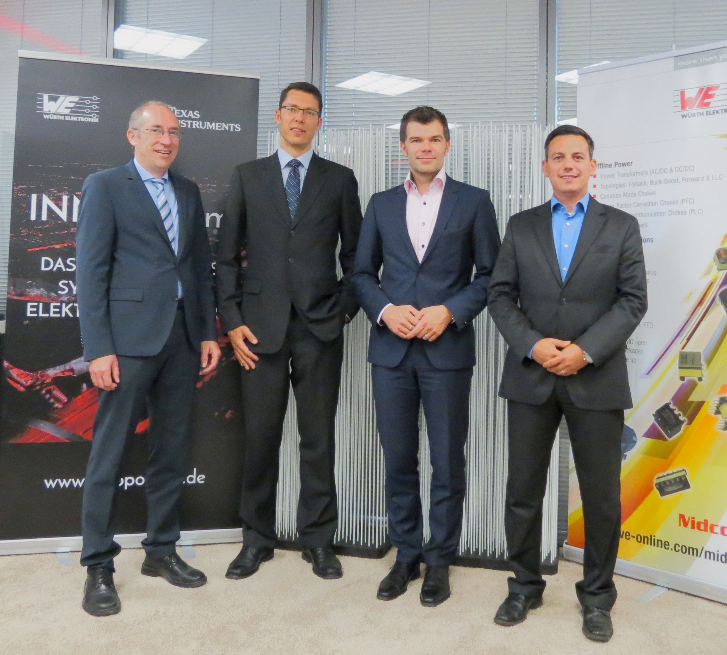
Image source: Würth Elektronik eiSos
Würth Elektronik eiSos and Fraunhofer-Institut have signed a cooperation contract:
(From left to right) Dr. Hans-Peter Hohe, group manager for sensor systems, and Dr. Volker Peters, business field development for the department of integrated sensor systems at Fraunhofer IIS, as well as Oliver Opitz, Division Manager Strategic Product Development, and Cem Som, Groupleader Strategic Product Development, both from Würth Elektronik eiSos.

About Fraunhofer-Institut für Integrierte Schaltungen IIS

Fraunhofer-Institut für Integrierte Schaltungen IIS in Erlangen is a globally leading application-oriented research facility for micro-electronic and information-technical system solutions and services. It is the largest institute of Fraunhofer-Gesellschaft today. Fraunhofer IIS has gained global renown, among others with its essential participation in the development of the audio encoding procedures mp3 and MPEG AAC. In close cooperation with their clients, the scientists conduct international top research in the areas of audio & multimedia, image systems, energy management, IC-design and design automation, communication systems, localization, medicine technology, sensor systems, safety technology, supply chains and non-destructive inspection. About 950 employees work in contract research for industry, service providers and public facilities. Founded in 1985, the institute has 13 sites in 10 towns and cities: in Erlangen (headquarters), Nuremberg, Fürth and Dresden, as well as in Bamberg, Waischenfeld, Coburg, Würzburg, Ilmenau and Deggendorf. The annual budget of 130 million Euro is provided through contracted research, with the exception of a basic financing at 22 percent.

About Würth Elektronik eiSos GmbH & Co. KG

Würth Elektronik eiSos GmbH & Co. KG is a manufacturer of electronic and electromechanical components for the electronics industry. The company is part of the Würth Group, the global market leader for fastener technology. It employs 6,100 people and generated sales of almost 475 million Euros in 2015. Würth Elektronik eiSos is active in 50 countries worldwide.
Manufacturing facilities in Europe, Asia and North America ensure delivery to a customer base that is growing worldwide. The product range covers EMC components, inductors, transformers, HF components, varistors, capacitors, power modules, LEDs, connectors, power elements, switches, assembly technology and fuse holders.
Würth Elektronik eiSos is one of Europe's largest manufacturers of passive components.
Würth Elektronik: more than you expect!
Further information at www.we-online.com

Further information:  Würth Elektronik eiSos GmbH & Co. KG  Sarah Hurst  Max-Eyth-Strasse 1  74638 Waldenburg  Germany  Phone: +49 7942 945-5186  E-mail: sarah.hurst@we-online.de  www.we-online.de | Press contact:  HighTech communications GmbH  Brigitte Basilio  Grasserstrasse 1c  80339 Munich  Germany  Phone: +49 89 500778-20  Fax: +49 89 500778-77  E-mail: b.basilio@htcm.de  www.htcm.de

