PRESS RELEASE

Würth Elektronik eiSos and Texas Instruments hosted the second INNOposium
Electronics executives get together in Stuttgart
Waldenburg (Germany), 20 October 2016 – The INNOposium, a Würth Elektronik and Texas Instruments forum for decision-makers in the electronics sector, was held for the second year running on 4 October 2016 in the Kulturbetrieb Wagenhallen in Stuttgart. This time around, the motto was “Sensorfusion – innovation in automotives and the factory of tomorrow”.
Before the industry experts took to the podium, Dr. Walter Döring, former Minister of Economic Affairs for the state of Baden-Württemberg, held the opening speech titled “Germany, Austria, Switzerland – top global innovation leaders”. He was followed by Dr. André Blum, Innovation Scouting & Project Management Progressive Semiconductor Program at AUDI AG, who talked about “Sensor Innovations in Automotives”. Dr. Blum stressed the significance of radar sensors for driver assistance systems today, and in the future, and predicted that, by 2030, electronic components would account for 50% of the average production costs of an automobile. He also stressed the growing importance of sensor technology for autonomous production processes in automobile manufacturing.
Smart Factory
Next, Dr. Hans Krattenmacher, head of Electronics Development at SEW-Eurodrive GmbH & Co. KG, presented the smart production processes at his company and described the impact of Industry 4.0 on everyday production. Digitization, progressive supply chain planning and lean manufacturing principles are all interlinked in drive production at SEW; also, as Dr. Krattenmacher put it, to achieve “higher collaboration productivity between people and technology”. Benedikt Rauscher, Team Leader R&D at Pepperl+Fuchs GmbH, delivered a further speech on sensor technology and Industry 4.0.
The evening was rounded off with interesting talks and discussions between the assembled decision-makers. A special highlight at the event was a Formula E racing car – next season’s model, in fact, that exemplifies the successful technology partnership between electronics manufacturer Würth Elektronik and the ABT Schaeffler Audi Sport racing team, and also symbolizes the advanced innovation in e-mobility.

INNOposium 2017
The initiators, Würth Elektronik eiSos and Texas Instruments, have established a successful new industry gathering with the INNOposium. A preview of the 2017 agenda will soon be available at www.innoposium.de, which also has lots of information about the events and the latest news posted in the INNOposium blog (currently only available in German).

Available images
The following images can be downloaded from the Internet in printable quality: http://www.htcm.de/kk/wuerth
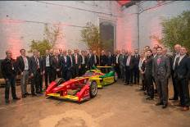  Image source: Würth Elektronik eiSos  INNOposium participants with next season’s Formula E racing car | 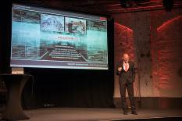  Image source: Würth Elektronik eiSos  Dr. Hans Krattenmacher, head of Electronics Development, SEW-EURODRIVE GmbH & Co. KG, presented the company’s smart production processes.

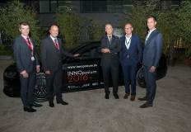Image source: Würth Elektronik eiSos  The motto of this year’s event in Stuttgart's Kulturbetrieb Wagenhallen was “Sensorfusion – innovation in automotives and the factory of tomorrow”. |   Image source: Würth Elektronik eiSos  The INNOposium is a successful new industry get-together.

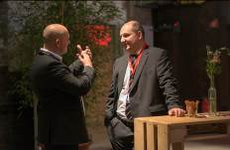
Image source: Würth Elektronik eiSos
Discussions and talks at the second INNOposium

About Würth Elektronik eiSos GmbH & Co. KG

Würth Elektronik eiSos GmbH & Co. KG is a manufacturer of electronic and electromechanical components for the electronics industry. The company is part of the Würth Group, the global market leader for fastener technology. It employs 6,100 people and generated sales of almost 475 million Euros in 2015. Würth Elektronik eiSos is active in 50 countries worldwide.
Manufacturing facilities in Europe, Asia and North America ensure delivery to a customer base that is growing worldwide. The product range covers EMC components, inductors, transformers, HF components, varistors, capacitors, power modules, LEDs, connectors, power elements, switches, assembly technology and fuse holders.
Würth Elektronik eiSos is one of Europe's largest manufacturers of passive components.
Würth Elektronik: more than you expect!
Further information at www.we-online.com

Further information:  Würth Elektronik eiSos GmbH & Co. KG  Sarah Hurst  Max-Eyth-Strasse 1  74638 Waldenburg  Germany  Phone: +49 7942 945-5186  E-mail: sarah.hurst@we-online.de  www.we-online.de | Press contact:  HighTech communications GmbH  Brigitte Basilio  Grasserstrasse 1c  80339 Munich  Germany  Phone: +49 89 500778-20  Fax: +49 89 500778-77  E-mail: b.basilio@htcm.de  www.htcm.de

