PRESS RELEASE
Wurth Electronics Midcom Reveals New Isolated Buck Transformers for Maxim Integrated’s Converter
Watertown (USA), 15 November 2016 – Wurth Electronics Midcom announces the new series of isolated buck transformers for Maxim Integrated’s MAX17681 converter. These pick and placeable transformers, built on self-shielding packages, have small form factor and losses. The high efficiency MAX17681 converter eliminates the need for optocoupler feedback circuits and can deliver up to 3W of output power.
The application of these transformers include isolated fieldbus interfaces, PLC input/output modules, smart meters, medical equipment, and floating power supply generation.
View the transformer family at www.we-online.com/mid-imaxib.
Customers can request free samples at www.we-online.com/midcom.

Available images
The following images can be downloaded from the Internet in printable quality: http://www.htcm.de/kk/wuerth
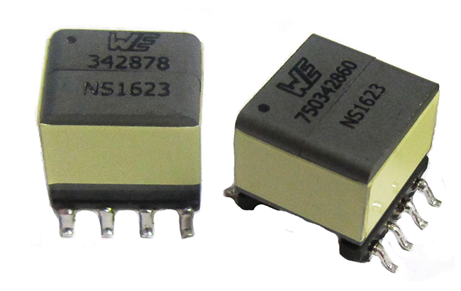
Image source: Wurth Electronics Midcom
MID-IMAXIB Industrial Maxim Iso-Buck Transformers

About Wurth Electronics Midcom, Inc.

Wurth Electronics Midcom is a global leader in the design and manufacture of custom magnetics. A standard line of magnetics is offered, including inductors, ferrites, chokes, and EMI shielding materials. Recently, the electromechanical and interconnect line was added to the product offering, which includes Board-to-Board, Wire-to-Board, Terminal Blocks, and Input/Output Communication.
Customers in Asia, Europe and the Americas are supported through a local direct technical sales network, regional design and applications engineers and manufacturing based in the People’s Republic of China.
Our standard lines and custom-made transformers are used around the world in LED lighting, smart grid and utility metering, industrial controls, telecom (CPE and CO), home automation, and home appliances.
Wurth Electronics Midcom offers all catalog products in stock. Free samples are offered to customers on connectors and both catalog and custom magnetics.
Further information at www.we-online.com

Further information:  Wurth Electronics Midcom, Inc.  Lindsey Esche  121 Airport Drive  PO Box 1330  Watertown, SD 57201 USA  Phone: +1 605 886 4385  Toll-free (in the U.S.):  Phone: +1 800 643 2661  E-mail: lindsey.esche@we-online.com  www.we-online.com | Press contact:  HighTech communications GmbH  Brigitte Basilio  Grasserstrasse 1c  80339 Munich  Germany  Phone: +49 89 500778-20  Fax: +49 89 500778-77  E-mail: b.basilio@htcm.de  www.htcm.de

