PRESS RELEASE
14–16 March 2017
Booth E5.5109

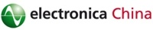
Würth Elektronik eiSos to exhibit at electronica China
Components and Reference Designs
Waldenburg (Germany), 10 March 2017 – Würth Elektronik eiSos will be exhibiting at electronica China on booth E5.5109, at the Shanghai New International Expo Center from 14th to 16th March 2017. The company will present its latest ranges of power modules, SMD power chokes as well as high-current contacts from its REDCUBE product range. The manufacturer of electronic and electromechanical components is exhibiting at the trade fair in China to present the solutions it offers through its strong partnerships with IC manufacturers.
The power module series MagI³C will be a focal point on the Würth Elektronik eiSos booth in Shanghai. This includes synchronous variable step-down regulator modules with variable and fixed output currents, LED-drivers as well as the isolated converter MagI³C-FISM (Fixed Isolated Module).
A further highlight will be the WE-MAPI SMD power choke - the world’s smallest power inductor made of magnetic iron powder. WE-MAPI design enables high saturation currents, low resistance and good thermal behavior. The magnetic iron powder mixture can handle high rated currents, whilst at the same time perfectly magnetically shielding the component. Typical applications include power supply for smartphones, tablet PCs and other mobile devices, DC/DC converters for high current power supplies, Field Programmable Gate Arrays (FPGA), motherboards, graphics cards and power supply for CPU- and RAM- and Wi-Fi communications devices.
Mechanically robust and with low resistance
With REDCUBE PRESS-FIT, Würth Elektronik eiSos offers a high-power contact, which thanks to the accomplishment of a cold-welding process by the press-fit connection, has two key strengths: a mechanically extremely robust connection and minimum transfer resistance. New at electronica China will be REDCUBE PLUG, which expands this product range with an innovative terminal module for removable wire-to-board connections. For this high-current contact, the cable, which is fitted with a connector, is sealed in a glass-fiber-reinforced plastic housing through spring force.
Application
An important example for the application of Würth Elektronik eiSos modules is Digital Power Control. An evaluation board "XMC Digital PowerExplorer Kit" will be shown and a live demonstration will be held by Infineon experts on 15th March at 2.30pm.
Further partner projects will be presented at the booth:
• Semtech 19v dual mode (QI/PMA) WPC transmitter
• ON Semi/Fairchild RD-573 power supply for audio amplifier - 1 kW
• ON Semi 36 W type C USB PD 3.0 / QC 3.0 adapter solution
• Active Semi EP5250 motor control evaluation board
• Intel/Altera Stratix 10 FPGA

A key highlight and visitor attraction at the booth will be the appearances of an award-winning robot: A team from the National Taiwan University was awarded by Würth Elektronik eiSos at Terasic Innovate Asia 2016 and will be showcasing its Altera DE2-115 FPGA-based robot "Alphabot" on the booth.

Available images
The following images can be downloaded from the Internet in printable quality: http://www.htcm.de/kk/wuerth
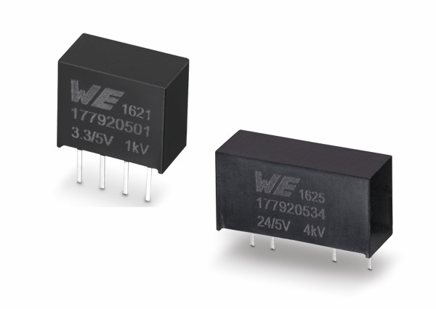  Image source: Würth Elektronik eiSos  Würth Elektronik eiSos presents its Power-Module-Range MagI³C at electronica China. | 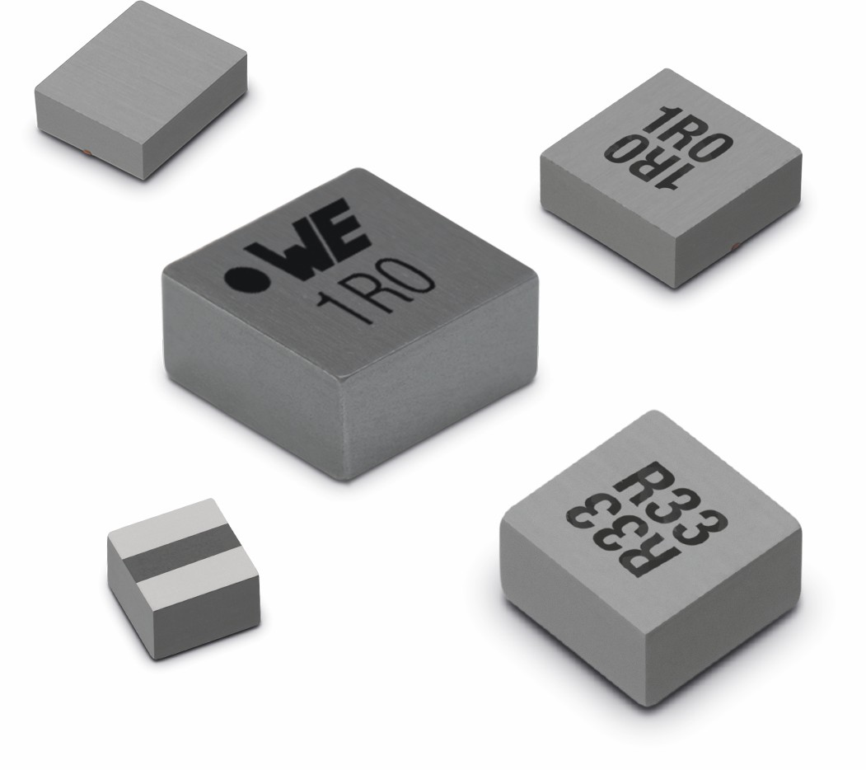  Image source: Würth Elektronik eiSos  SMD power choke WE-MAPI - the world’s smallest metal-alloy power inductor.
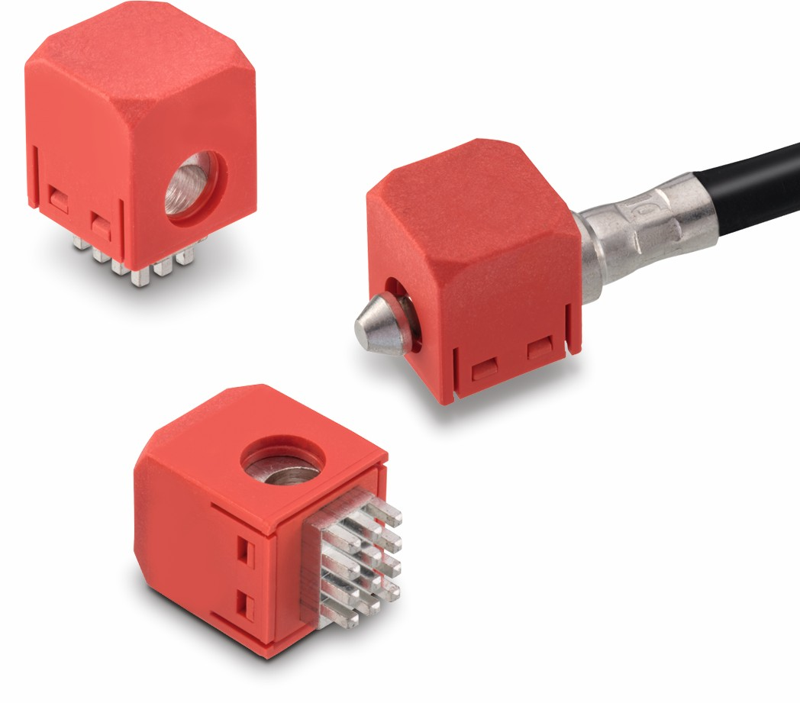
Image source: Würth Elektronik eiSos
REDCUBE Plug is a terminal module for removable wire-to-board connections.

About Würth Elektronik eiSos GmbH & Co. KG

Würth Elektronik eiSos GmbH & Co. KG is a manufacturer of electronic and electromechanical components for the electronics industry. The company is part of the Würth Group, the global market leader for fastener technology. It employs 6,500 people and generated sales of almost 555 million Euros in 2016. Würth Elektronik eiSos is active in 50 countries worldwide.
Manufacturing facilities in Europe, Asia and North America ensure delivery to a customer base that is growing worldwide. The product range covers EMC components, inductors, transformers, HF components, varistors, capacitors, power modules, LEDs, connectors, power elements, switches, assembly technology and fuse holders.
Würth Elektronik eiSos is one of Europe's largest manufacturers of passive components.
Würth Elektronik: more than you expect!
Further information at www.we-online.com

Weitere Informationen:  Würth Elektronik eiSos GmbH & Co. KG  Sarah Hurst  Max-Eyth-Straße 1  74638 Waldenburg  Telefon: +49 7942 945-5186  E-Mail: sarah.hurst@we-online.de  www.we-online.de | Pressekontakt:  HighTech communications GmbH  Brigitte Basilio  Grasserstraße 1c  80339 München  Telefon: +49 89 500778-20  Telefax: +49 89 500778-77  E-Mail: b.basilio@htcm.de  www.htcm.de

