PRESS RELEASE


Würth Elektronik eiSos at the embedded world 2017 exhibition
A big role for small parts
14–16 March 2017
Hall 3, Stand 3-359
Waldenburg (Germany), 2 March 2017 – Würth Elektronik eiSos, one of the leading European suppliers of electronic and electromechanical components, is taking the stage at the embedded world exhibition in Nuremberg (14 to 16 March 2017). The focus of the presentation at Stand 3-359 in Hall 3 will be on miniature components for embedded applications. The appearance at this trade fair also profits from the close cooperation with STMicroelectronics: experts from Würth Elektronik eiSos will also be represented as a partner in the STM32 Fan Zone at Stand 4A-238.
The Würth Elektronik eiSos specialists will use their appearance in the STMicroelectronics “STM32 Fan Zone“ to present details on the spectrum of the company’s electronic and electromechanical components. Visitors will be given details on how to most efficiently choose the products they need and how they can be used in combination with the microcontrollers of STMicroelectronics’ STM32 family.
Passive components in a compact format
This year, the embedded world exhibition is the large stage for the small-sized components supplied by Würth Elektronik eiSos. WE-TMSB, the SMD ferrite in the 0201 design format, is ideally suited for miniaturization in EMC applications. Its impedance range from 10 to 300 Ohm and the operating temperature range from -55°C to +125°C make this ferrite the perfect candidate for demanding industrial applications.
Another star at the show: the WE-MAPI SMD the world’s smallest metal alloy power inductor. Besides this product, a range of other inductors will be presented that are particularly suited for electronic devices with an extremely small profile, for example the WE-PMMI power multilayer metal-alloy inductor and the WE-PMCI power molded chip inductor. The WE-LQSH (SMD Semi-Shielded High Saturation Power Inductor) targets applications such as integrated DC/DC converters with high ripple currents, switching controllers with high efficiency specifications, portable devices, or embedded PC. Also on show: the WE-KIHC high-current ceramic SMD inductor with a high natural resonant frequency, suited for currents up to 2.3 A.
High peak-current capacity
The WE-MPSB EMI multilayer power suppression bead is the world’s first series of SMD ferrites with a specified peak-current capacity. This series has the potential to decisively prolong the service lifetime of applications. The extremely low R_{DC} enables the highest possible rated currents while at the same time keeping the self-heating effect to an absolute minimum. The series is optimized for the filtering of high-efficiency DC/DC switching controllers in raw industrial environments.
Würth Elektronik eiSos will also be presenting a series of polymer capacitors and multilayer ceramic chip capacitors, as well as a variety of power modules. The broad portfolio of electromechanical components on show at the exhibition will include a USB 2.0 A port with integrated ESD protection, diverse USB 3.1 connectors, and SMT ZIF connectors of the extended WR-FPC family for the connection of flat-ribbon cables and flexible circuit boards. Visitors will also be able to gain information on SMD-spacers.
Theme islands
The exhibition stand will comprise a presentation zone and five separate theme islands. The Design & Solutions islands will be the showcase for the Würth Elektronik eiSos company’s self-presentation as a supplier that supports its customers in the optimal application of its products. “Power Management”, “EMC”, “Internet of Things”, “Electromechanical Solutions”, and “Wireless Power & Energy Harvesting” – these are the headlines under which the corresponding ranges of products and services will be presented.
Another stand of the WE Group
In the same aisle as the one in which the Würth Elektronik eiSos has its stand, there will also be the booth of another subsidiary of the WE eiSos Group, AMBER wireless GmbH, one of the leading suppliers of low-power ISM/SRD radio solutions in Europe: Hall 3, Stand 3-331. AMBER Wireless will be presenting its high-efficiency radio modules in the Bluetooth and Wireless M-Bus standards, as well as proprietary items in the 169 MHz, 433 MHz, 868 MHz, 915 MHz, and 2.4 GHz frequency ranges.

Available images
The following images can be downloaded from the Internet in printable quality: http://www.htcm.de/kk/wuerth
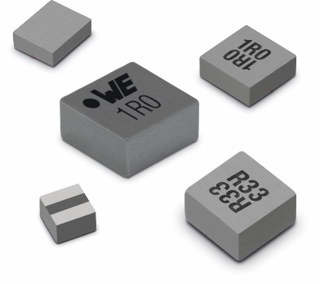  Image source: Würth Elektronik eiSos  At the embedded world, Würth Elektronik eiSos will present the WE-MAPI SMD storage choke, the world’s smallest wrapped metal alloy power inductor. | 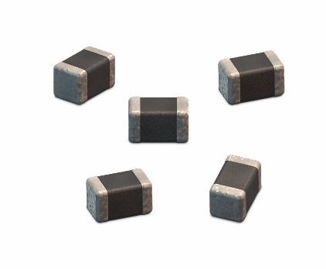  Image source: Würth Elektronik eiSos  Würth Elektronik eiSos will also present a series of polymer capacitors and multilayer ceramic chip capacitors (here: WCAP-CSGP).

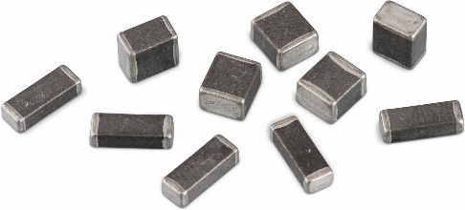
Image source: Würth Elektronik eiSos
The WE-MPSB multilayer power suppression bead EMI series of SMD ferrites will also be on show at the exhibition.

About Würth Elektronik eiSos GmbH & Co. KG

Würth Elektronik eiSos GmbH & Co. KG is a manufacturer of electronic and electromechanical components for the electronics industry. The company is part of the Würth Group, the global market leader for fastener technology. It employs 6,100 people and generated sales of almost 475 million Euros in 2015. Würth Elektronik eiSos is active in 50 countries worldwide.
Manufacturing facilities in Europe, Asia and North America ensure delivery to a customer base that is growing worldwide. The product range covers EMC components, inductors, transformers, HF components, varistors, capacitors, power modules, LEDs, connectors, power elements, switches, assembly technology and fuse holders.
Würth Elektronik eiSos is one of Europe's largest manufacturers of passive components.
Würth Elektronik: more than you expect!
Further information at www.we-online.com

Further information:  Würth Elektronik eiSos GmbH & Co. KG  Sarah Hurst  Max-Eyth-Strasse 1  74638 Waldenburg  Germany  Phone: +49 7942 945-5186  E-mail: sarah.hurst@we-online.de  www.we-online.de | Press contact:  HighTech communications GmbH  Brigitte Basilio  Grasserstrasse 1c  80339 Munich  Germany  Phone: +49 89 500778-20  Fax: +49 89 500778-77  E-mail: b.basilio@htcm.de  www.htcm.de

