PRESS RELEASE
28 – 30 March 2017
Booth C2-511

Würth Elektronik eiSos at EMV 2017 in Stuttgart
Theory and Practice of EMI Suppression
Waldenburg (Germany), 14 March 2017 – Würth Elektronik eiSos, manufacturer of electronic and electromechanical components, participates at EMV 2017, the international trade show with workshops for electromagnetic compatibility. From 28 to 30 March 2017 the company with its experts, products and live demonstrations is located at booth C2-511 at the Messe Stuttgart, Germany convention center. Würth Elektronik eiSos will participate in the forum program (booth C2-125) with three presentations.
Markus Holzbrecher, Product Manager at Würth Elektronik eiSos, kicks off the technical supporting program on Tuesday 28.3.2017 at 10.00 am with the presentation “Application of Pulse Stable SMD Ferrites”. On Wednesday, his colleague, material scientist Florian Roider, speaks at 11.20 am on “Hexagonal Ferrites”. Ismael Molina Alba, Product Manager, delivers a presentation on Thursday 30.3.2017 at 1.40 pm, entitled “High-Speed EMI Prevention Techniques“.
The e in eiSos stands for EMC
Various topics will be elaborated on the exhibition booth: In live filter demonstrations, a selection of commom mode for power lines are combined with X and Y capacitors. Different suppression options are demonstrated with the “Shielding Box”. With RED EXPERT, Würth Elektronik eiSos offers a web-based tool for easy selection of components, precise DC and AC loss determination of power inductors, filter simulation, ordering sample, sharing settings and results with colleagues and much more.
“The e in eiSos stands for EMC – traditionally this show is a home game for us. We are interested in knowledge transfer and the presentation of innovative products”, says Sarah Hurst, PR Manager at Würth Elektronik eiSos.
Product highlights
The WE-MPSB series of multilayer SMD ferrites capable of carrying high current is optimized for filtering high frequency DC/DC switching controllers in harsh industrial environments. The extremely low R_{DC} allows top rated currents along with minimal self-heating and has the potential to prolong the service life of applications. The special feature of the SMD ferrite: It has a specified peak current capability and the DC bias current information in the datasheet.
Snap ferrites are the classics in the Würth Elektronik eiSos product range. The new XXL package size of the WE-StarTec series with 12 to 25 mm diameter will be presented at the show.
WE-TPB HV is a 3-phase common mode choke for power lines for high voltage applications. An innovative and patented design with new plastic housing, separator and grid plate is decisive for the new WE-TPB HV series. It guarantees a rated voltage 760 V_{AC} and therefore 70 percent more than comparable products on the market. All the insulation materials used are UL94-V0 listed. For improved stability on the circuit board, there is the possibility of additionally fixing the choke using a sheet metal screw. The cores of the WE-TPB HV series consist of two different materials: MnZn and nanocrystalline material, which achieve very high insertion loss over a wide bandwidth. Typical application areas include frequency converters and high power charging stations.
WE-CMB HV is a further common mode choke for power lines for high voltage ranges. The series was developed for network applications and is designed for AC voltages up to 760 V. This common mode choke features a rated voltage three times higher than that of the existing WE-CMB series. This is achieved with double air gaps and leakage paths. The new plastic housing and the improved separator achieves an isolation voltage of 3000 V_{AC}. Besides power electronics, the field of application is motor suppression.
Innovative materials
Also with the WE-ExB current-compensated common mode choke, the secret of success lies in the combination of materials: The component has a double core made of manganese-zinc and nickel-zinc. Its insertion loss acts over a wider frequency range than an individual NiZn or MnZn core. This current-compensated common mode choke is aimed at network applications with a broadband interference spectrum in EMC, network or DC filters, especially in power electronics and in motor suppression.
An important product for current-compensated filtering on data lines such as USB 3.0, HDMI, SATA, PCI Express or FireWire is the WE-CNSW HF high frequency line filter.
WE-LPCC is a power line choke for 250 V_{AC} applications in which a high saturation current and rated current are required. The series excels with its package height up to 60% lower than comparable products. These chokes are used in AC/AC converters, LED network drivers and switching controllers.

Available images
The following images can be downloaded from the Internet in printable quality: http://www.htcm.de/kk/wuerth

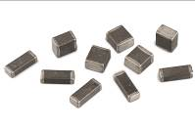  Image source: Würth Elektronik eiSos  Product highlight at the EMV: The WE-MPSB series of high current carrying multilayer SMD ferrites. | 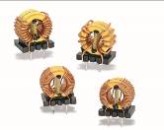  Image source: Würth Elektronik eiSos  The WE-ExB current-compensated common mode choke has a double core made of manganese-zinc and nickel-zinc.

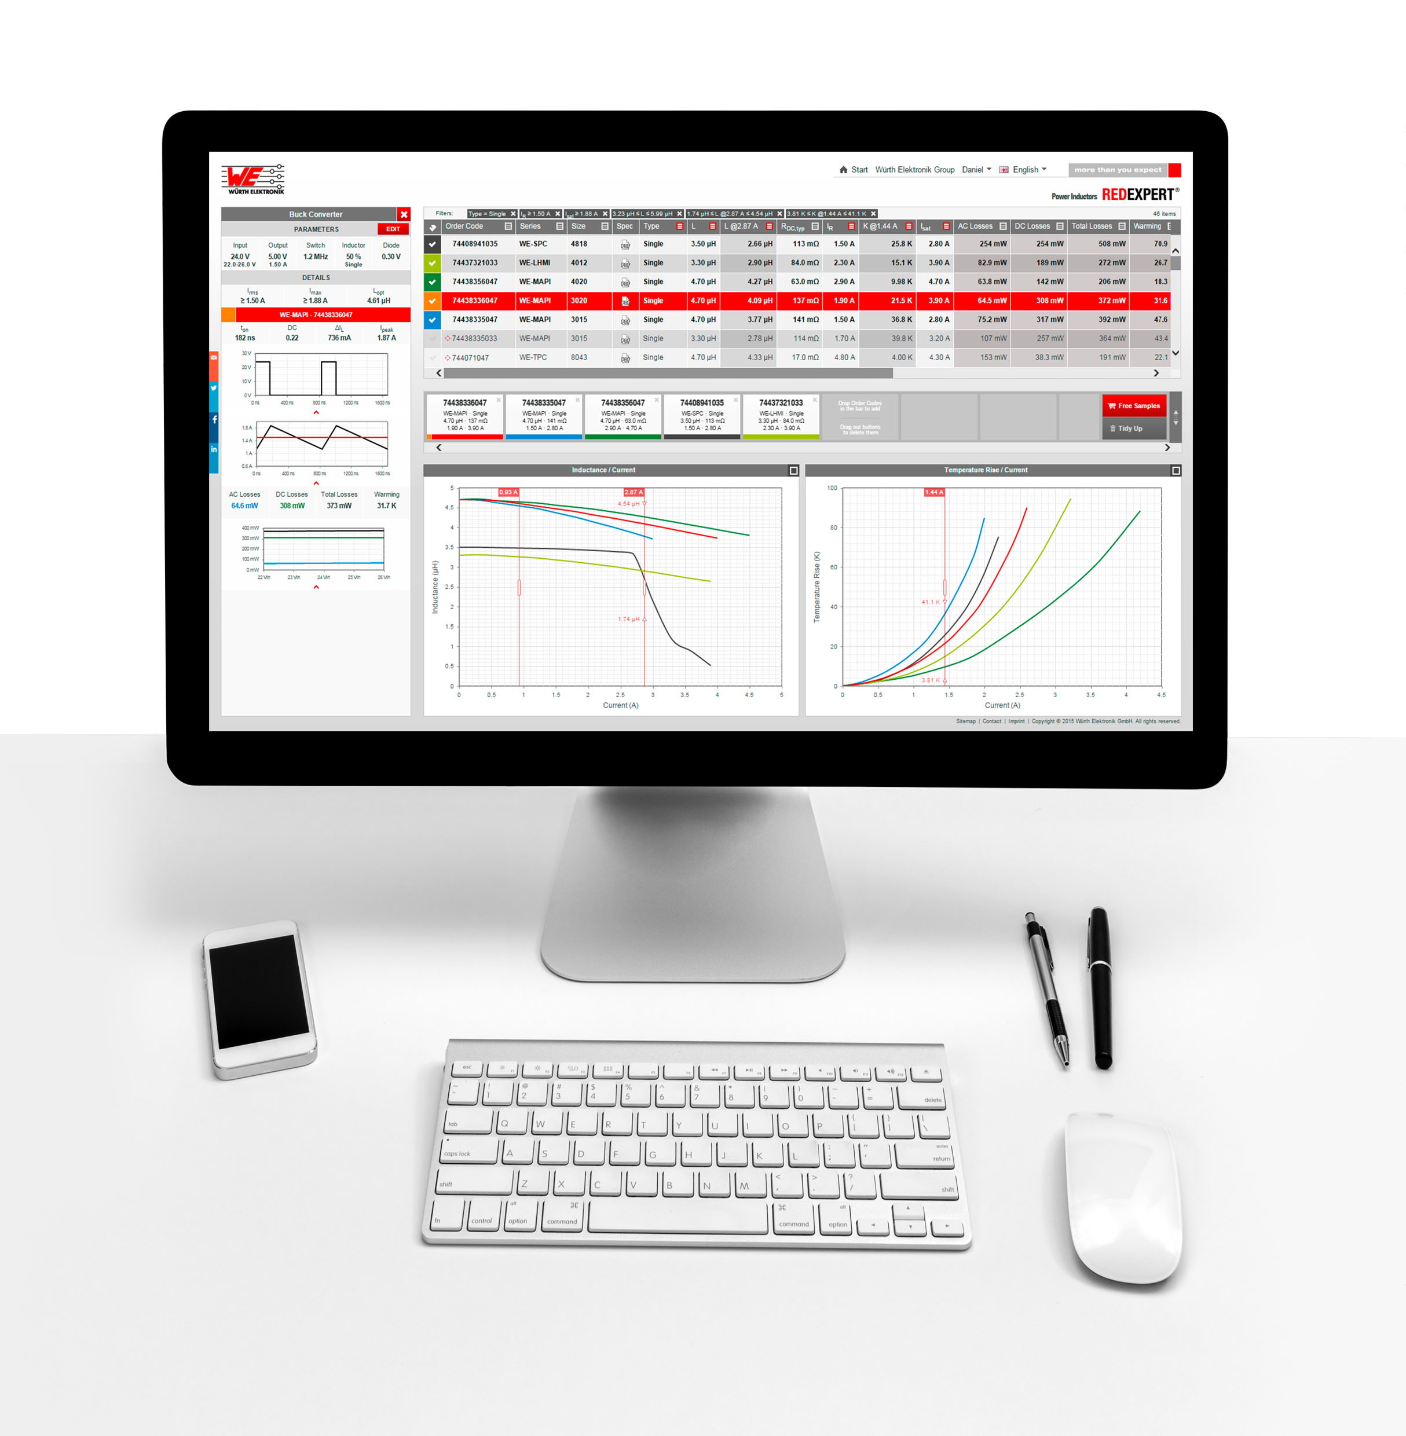
Image source: Würth Elektronik eiSos
Web-based tool RED EXPERT for easy selection, e.g. of components, as well as precise DC and AC loss determination of power inductors.

About Würth Elektronik eiSos GmbH & Co. KG

Würth Elektronik eiSos GmbH & Co. KG is a manufacturer of electronic and electromechanical components for the electronics industry. The company is part of the Würth Group, the global market leader for fastener technology. It employs 6,500 people and generated sales of almost 555 million Euros in 2016. Würth Elektronik eiSos is active in 50 countries worldwide.
Manufacturing facilities in Europe, Asia and North America ensure delivery to a customer base that is growing worldwide. The product range covers EMC components, inductors, transformers, HF components, varistors, capacitors, power modules, LEDs, connectors, power elements, switches, assembly technology and fuse holders.
Würth Elektronik eiSos is one of Europe's largest manufacturers of passive components.
Würth Elektronik: more than you expect!
Further information at www.we-online.com

Further information:  Würth Elektronik eiSos GmbH & Co. KG  Sarah Hurst  Max-Eyth-Strasse 1  74638 Waldenburg  Germany  Phone: +49 7942 945-5186  E-mail: sarah.hurst@we-online.de  www.we-online.de | Press contact:  HighTech communications GmbH  Brigitte Basilio  Grasserstrasse 1c  80339 Munich  Germany  Phone: +49 89 500778-20  Fax: +49 89 500778-77  E-mail: b.basilio@htcm.de  www.htcm.de

