PRESS RELEASE

Wurth Electronics Power Inductors and Capacitors Featured in Monolithic Power Systems, Inc. Module Solutions
Watertown (USA), 6 March 2017 – Carefully selected for the complete high efficiency, company solution, Wurth Electronics power inductors and capacitors are now featured in Monolithic Power Systems, Inc. (MPS)-mEZ Plug & Play Power Module Solutions.
MPS’s open-frame modules provide easy-to-use, plug & play power solutions with pre-programmed output voltage options available. Using proprietary technology processes, MPS’s mEZ products provide simple, high efficiency power solutions for DC/DC step down, step up, PoE, and USB charger applications. Customers can choose from ready-to-use products or 'Do It Yourself' solutions to build customized modules. All design files, including schematic, layout, and bill of materials are provided.
Learn more about these products at the Wurth Electronics Booth #811 at APEC 2017, in Tampa, FL. Yi Sun, MPS Module Product Line Manager, will conduct a free presentation Monday, March 27 at 7:00 pm and Tuesday, March 28 at 1:00 pm. For a full schedule, visit www.we-online.com/apec.
For more information about MPS’s mEZ products, email MEZsupport@monolithicpower.com.

Available images
The following images can be downloaded from the Internet in printable quality: http://www.htcm.de/kk/wuerth
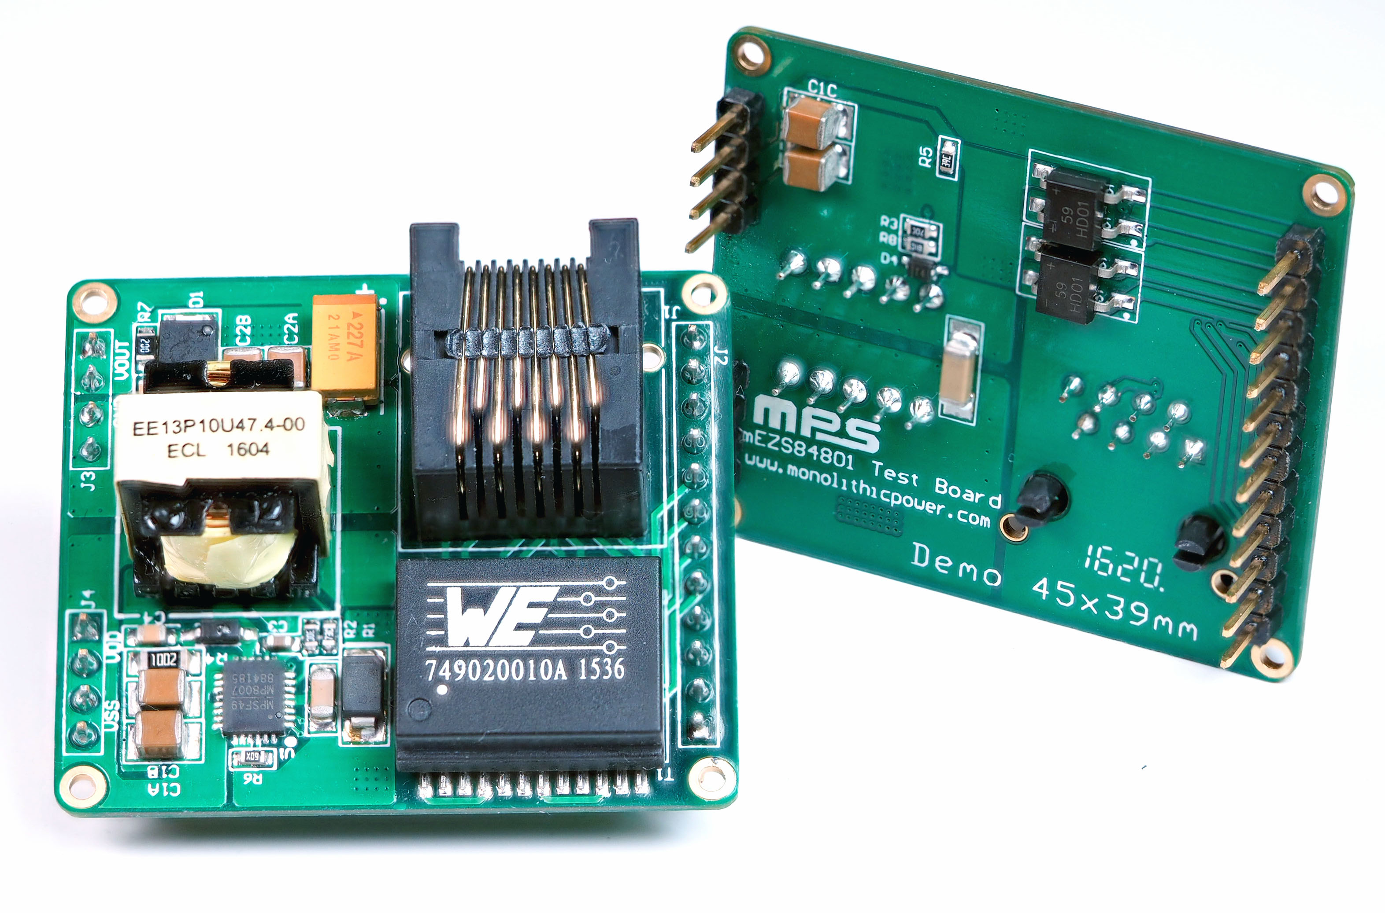
Image source: Wurth Electronics Midcom
Wurth Electronics power inductors and capacitors are now featured in mEZ Plug & Play Power Module Solutions.

About Wurth Electronics Midcom, Inc.

Wurth Electronics Midcom is a global leader in the design and manufacture of custom magnetics. A standard line of magnetics is offered, including inductors, ferrites, chokes, and EMI shielding materials. Recently, the electromechanical and interconnect line was added to the product offering, which includes Board-to-Board, Wire-to-Board, Terminal Blocks, and Input/Output Communication.
Customers in Asia, Europe and the Americas are supported through a local direct technical sales network, regional design and applications engineers and manufacturing based in the People’s Republic of China.
Our standard lines and custom-made transformers are used around the world in LED lighting, smart grid and utility metering, industrial controls, telecom (CPE and CO), home automation, and home appliances.
Wurth Electronics Midcom offers all catalog products in stock. Free samples are offered to customers on connectors and both catalog and custom magnetics.
Further information at www.we-online.com

Further information:  Wurth Electronics Midcom, Inc.  Lindsey Esche  121 Airport Drive  PO Box 1330  Watertown, SD 57201 USA  Phone: +1 605 886 4385  Toll-free (in the U.S.):  Phone: +1 800 643 2661  E-mail: lindsey.esche@we-online.com  www.we-online.com | Press contact:  HighTech communications GmbH  Brigitte Basilio  Grasserstrasse 1c  80339 Munich  Germany  Phone: +49 89 500778-20  Fax: +49 89 500778-77  E-mail: b.basilio@htcm.de  www.htcm.de

