PRESS RELEASE

Wurth Electronics Midcom Transformers Approved for Use with SHDSL- 1 Channel, 2 Channel, and 4 Channel Applications
Watertown (USA), 18 May 2017 – Wurth Electronics Midcom announces new data isolation transformers for use in SHDSL applications. These MID-DSLITL transformers are built on a self-shielding EP package, offer excellent longitudinal balance and very good THD performance. They are designed to meet UL & IEC standards and a dielectric of 1500V_{AC}.
“SHDSL is the best technology available in the Telecom market when it comes to transmitting small to medium data rates on long copper lines. One of the key components for data transmission applications is the data isolation transformer.” explained Swaroop Vaidyanath, Product Marketing Engineer for Telecom Products.
The application of these transformers include infotainment systems in airports and metro stations, video surveillance where PoE is beyond reach, vending machines, banking terminals, traffic controls, industrial communication systems, business use, and reach extenders and repeaters.
To review the transformer family, visit www.we-online.com/shdsl.

Available images
The following images can be downloaded from the Internet in printable quality: http://www.htcm.de/kk/wuerth
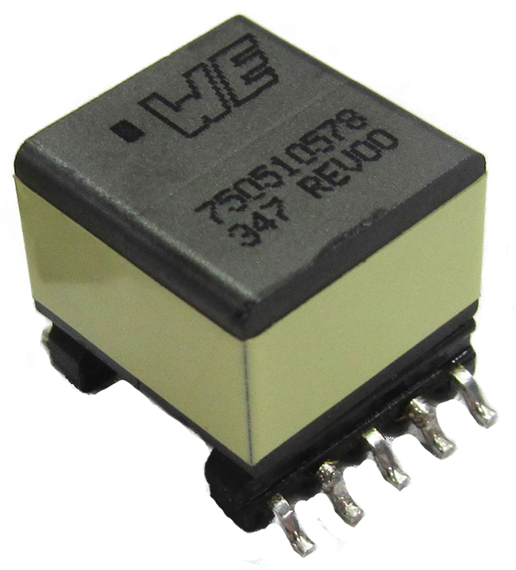
New data isolation transformer for use in SHDSL applications.
Image source:
Wurth Electronics Midcom

About Wurth Electronics Midcom, Inc.

Wurth Electronics Midcom is a global leader in the design and manufacture of custom magnetics. A standard line of magnetics is offered, including inductors, ferrites, chokes, and EMI shielding materials. Recently, the electromechanical and interconnect line was added to the product offering, which includes Board-to-Board, Wire-to-Board, Terminal Blocks, and Input/Output Communication.
Customers in Asia, Europe and the Americas are supported through a local direct technical sales network, regional design and applications engineers and manufacturing based in the People’s Republic of China.
Our standard lines and custom-made transformers are used around the world in LED lighting, smart grid and utility metering, industrial controls, telecom (CPE and CO), home automation, and home appliances.
Wurth Electronics Midcom offers all catalog products in stock. Free samples are offered to customers on connectors and both catalog and custom magnetics.
Further information at www.we-online.com

Further information:  Wurth Electronics Midcom, Inc.  Lindsey Esche  121 Airport Drive  PO Box 1330  Watertown, SD 57201 USA  Phone: +1 605 886 4385  Toll-free (in the U.S.):  Phone: +1 800 643 2661  E-mail: lindsey.esche@we-online.com  www.we-online.com | Press contact:  HighTech communications GmbH  Brigitte Basilio  Grasserstrasse 1c  80339 Munich  Germany  Phone: +49 89 500778-20  Fax: +49 89 500778-77  E-mail: b.basilio@htcm.de  www.htcm.de

