PRESS RELEASE

Expansion of the Executive Board of Würth Elektronik eiSos GmbH & Co. KG
CTO Alexander Gerfer appointed to the Executive Board
Waldenburg (Germany), 10 April 2017 – Alexander Gerfer (51), CTO of the Würth Elektronik eiSos Group, has been appointed to the company’s Executive Board. With immediate effect, together with the CEOs of the Würth Elektronik eiSos Group, Oliver Konz and Thomas Schrott, he would be co-responsible for the future strategies of one of Europe’s largest suppliers of electronic and electromechanical components. Alexander Gerfer’s appointment is an acknowledgment of his excellent services on behalf of the company. At the same time, this reflects the relevance of the areas under his responsibility, namely research and development, product management, and quality and supply-chain management, for the success of the group as a whole.
Besides being appointed to the Executive Board, Alexander Gerfer this year is also celebrating the twentieth anniversary of his employment with the company. Since taking up his job in April 1997, he has been working at the Würth Elektronik eiSos facility in Waldenburg. As is so typical at Würth, the graduate engineer started out on his career as a technical sales representative, soon moving on to the area of product management, where he was employed as departmental director, authorized signatory, managing director, and most recently as CTO.
“Alexander Gerfer has played a major part in the success of Würth Elektronik eiSos, and now it’s time for the company to show its appreciation for his efforts and the enormous positive impact that he’s made on the development of our product portfolio over the past years,” says CEO Oliver Konz. Thomas Schrott, his CEO colleague, goes on to say: “We warmly welcome our CTO Alexander Gerfer as an Executive Director and wish him every success and continued good luck in his decisions.”
Product development – an important cornerstone of success
“I see my appointment to the position of Executive Director as an appreciation of our team effort in the product management area,” says Alexander Gerfer. “Our claim of ‘more than you expect’ traditionally relates to our excellent service and orientation to our customers’ requirements. However, we also want to exceed the expectations of our customers by developing and offering more new products too. Even better components with precisely and reliably specified product features – that’s what we‘re aiming for. Innovative product developments are an important cornerstone of our success, and my appointment to the Executive Board will reinforce this strategic element further still.”
The range of products offered by Würth Elektronik eiSos traditionally comprises EMC components, inductors, transformers, HF components, varistors, capacitors, power modules, LEDs, push connectors, power-supply elements, switches, connection technology, and fuse holders. “But we’ll not be restricting ourselves to just these in future. Right now we’re massively expanding our efforts in the areas of wireless power, energy harvesting, and radio technology, and we’re also making inroads into sensor technology,” reveals the new Executive Director.

Available images
The following images can be downloaded from the Internet in printable quality: http://www.htcm.de/kk/wuerth
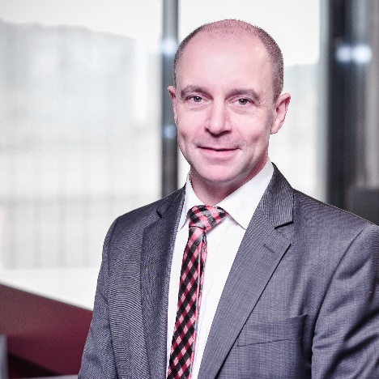Image source: Würth Elektronik eiSos
Alexander Gerfer, the newly appointed member of the Executive Board of Würth Elektronik eiSos GmbH & Co. KG

About Würth Elektronik eiSos GmbH & Co. KG

Würth Elektronik eiSos GmbH & Co. KG is a manufacturer of electronic and electromechanical components for the electronics industry. The company is part of the Würth Group, the global market leader for fastener technology. It employs 6,500 people and generated sales of almost 555 million Euros in 2016. Würth Elektronik eiSos is active in 50 countries worldwide.
Manufacturing facilities in Europe, Asia and North America ensure delivery to a customer base that is growing worldwide. The product range covers EMC components, inductors, transformers, HF components, varistors, capacitors, power modules, LEDs, connectors, power elements, switches, assembly technology and fuse holders.
Würth Elektronik eiSos is one of Europe's largest manufacturers of passive components.
Würth Elektronik: more than you expect!
Further information at www.we-online.com

Further information:  Würth Elektronik eiSos GmbH & Co. KG  Sarah Hurst  Max-Eyth-Strasse 1  74638 Waldenburg  Germany  Phone: +49 7942 945-5186  E-mail: sarah.hurst@we-online.de  www.we-online.de | Press contact:  HighTech communications GmbH  Brigitte Basilio  Grasserstrasse 1c  80339 Munich  Germany  Phone: +49 89 500778-20  Fax: +49 89 500778-77  E-mail: b.basilio@htcm.de  www.htcm.de

