PRESS RELEASE

Wurth Electronics Smart Transformer Selector Now Interacts with STMicroelectronics’ eDesignSuite
Watertown (USA), 21 March 2017 – Wurth Elektronik is proud to announce the interaction of their Smart Transformer Selector (STS) with STMicroelectronics’ eDesignSuite.
The STS is an online tool available to users for searching and selecting flyback transformers.
“For the first time, there’s a design suite that can generate an entire BOM where all components can be purchased off the shelf, including the transformer. Wurth Elektronik is excited to be a part of that development,” said Dean Huumala, Product Marketing & Development Manager at Wurth Elektronik.
STMicroelectronics’ eDesignSuite includes a smart simulator and design engine to create system solutions (power supply, LED lighting, etc.), and will link to the STS database to help the engineer select the best transformer for his design.
Huumala also said, “In addition, the Smart Transformer Selector is now capable of finding solutions tailored for quasi-resonant, flyback controllers. This is a new development for the tool”.
See how these two tools work together at APEC 2017, in Tampa, Florida. Stop by the Wurth Elektronik booth, #811, on Monday, March 27 at 5:30pm to see a live demonstration at no cost.
For more information on the Smart Transformer Selector, visit
www.we-online.com/sts.
To learn more about STMicroelectronics’ eDesignSuite, go to www.st.com/eDesignSuite.

Available images
The following images can be downloaded from the Internet in printable quality: http://www.htcm.de/kk/wuerth
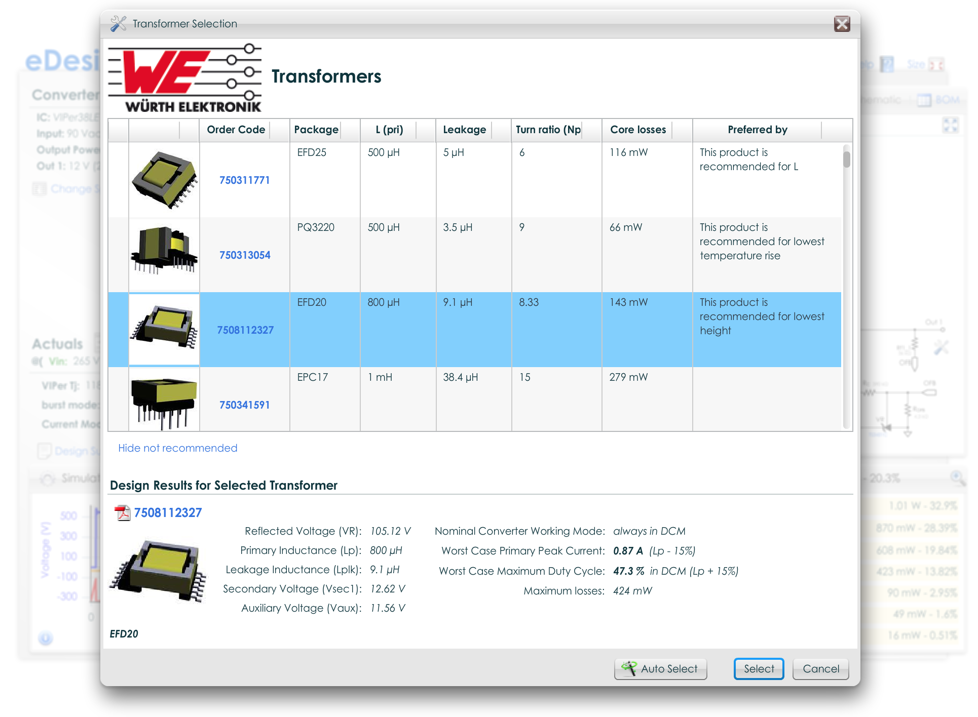
Image source: Wurth Electronics Midcom
STS is an online tool available to users for searching and selecting flyback transformers.

About Wurth Electronics Midcom, Inc.

Wurth Electronics Midcom is a global leader in the design and manufacture of custom magnetics. A standard line of magnetics is offered, including inductors, ferrites, chokes, and EMI shielding materials. Recently, the electromechanical and interconnect line was added to the product offering, which includes Board-to-Board, Wire-to-Board, Terminal Blocks, and Input/Output Communication.
Customers in Asia, Europe and the Americas are supported through a local direct technical sales network, regional design and applications engineers and manufacturing based in the People’s Republic of China.
Our standard lines and custom-made transformers are used around the world in LED lighting, smart grid and utility metering, industrial controls, telecom (CPE and CO), home automation, and home appliances.
Wurth Electronics Midcom offers all catalog products in stock. Free samples are offered to customers on connectors and both catalog and custom magnetics.
Further information at www.we-online.com

Further information:  Wurth Electronics Midcom, Inc.  Lindsey Esche  121 Airport Drive  PO Box 1330  Watertown, SD 57201 USA  Phone: +1 605 886 4385  Toll-free (in the U.S.):  Phone: +1 800 643 2661  E-mail: lindsey.esche@we-online.com  www.we-online.com | Press contact:  HighTech communications GmbH  Brigitte Basilio  Grasserstrasse 1c  80339 Munich  Germany  Phone: +49 89 500778-20  Fax: +49 89 500778-77  E-mail: b.basilio@htcm.de  www.htcm.de

