PRESS RELEASE

Würth Elektronik eiSos and IDT sponsor the Wireless Power Contest
Innovative wireless power ideas – the winners are announced
Waldenburg (Germany), 20 April 2017 – Würth Elektronik eiSos, one of Europe’s leading manufacturers of electronic and electromechanical components, congratulates the winners of the Open Electronics Wireless Power Contest. Over 300 ideas were entered by talented young electronic specialists and hobbyists.
The participants with the most promising concepts were provided with a wireless power developer set by Futura Elettronica, the operator of open-electronics.org, to help them realize their ideas.
Along with the two sponsors of the international competition, Würth Elektronik eiSos and IDT, Futura Elettronica has now awarded the prizes to the winners.
The decisive factors for the assessment of the projects – creativity, originality, project documentation, code, and practicability – have been defined by the jury beforehand.
First prize went to the “Wireless Power Aquarium”. Enclosed in a watertight capsule, the controllable RGB-LED lamp can be operated in the aquarium wirelessly, drawing its power inductively. The winner was awarded a two-channel 200-MHz oscilloscope equipped with a waveform generator. The second prize was awarded for the project “POV bike”, a controllable LED lamp on a turning wheel that with its afterimage effect creates a neon sign. The idea and its realization were rewarded with a two-channel 70 MHz oscilloscope. Third place and a pocket oscilloscope as the prize went to the project “Wireless Powered – NAS Backup System”.
“A wealth of highly original ideas that were realized with the wireless power kits of IDT and our coils. The competition was really fun and once again showed just how much potential wireless power has,” says Jörg Hantschel, Business Development Manager at Würth Elektronik eiSos.

Available images
The following images can be downloaded from the Internet in printable quality: http://www.htcm.de/kk/wuerth
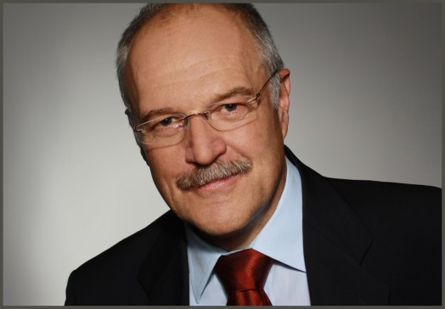
Image source: Würth Elektronik eiSos
Jörg Hantschel, Business Development Manager at Würth Elektronik eiSos

About Würth Elektronik eiSos GmbH & Co. KG

Würth Elektronik eiSos GmbH & Co. KG is a manufacturer of electronic and electromechanical components for the electronics industry. The company is part of the Würth Group, the global market leader for fastener technology. It employs 6,500 people and generated sales of almost 555 million Euros in 2016. Würth Elektronik eiSos is active in 50 countries worldwide.
Manufacturing facilities in Europe, Asia and North America ensure delivery to a customer base that is growing worldwide. The product range covers EMC components, inductors, transformers, HF components, varistors, capacitors, power modules, LEDs, connectors, power elements, switches, assembly technology and fuse holders.
Würth Elektronik eiSos is one of Europe's largest manufacturers of passive components.
Würth Elektronik: more than you expect!
Further information at www.we-online.com

Further information:  Würth Elektronik eiSos GmbH & Co. KG  Sarah Hurst  Max-Eyth-Strasse 1  74638 Waldenburg  Germany  Phone: +49 7942 945-5186  E-mail: sarah.hurst@we-online.de  www.we-online.de | Press contact:  HighTech communications GmbH  Brigitte Basilio  Grasserstrasse 1c  80339 Munich  Germany  Phone: +49 89 500778-20  Fax: +49 89 500778-77  E-mail: b.basilio@htcm.de  www.htcm.de

