PRESS RELEASE

Würth Elektronik eiSos Expands its WE-HCF Product Family
High Current Flat Wire Power Inductor with Higher Saturation Current
Waldenburg (Germany), 22 June 2017 – Würth Elektronik eiSos presents WE-HCF in a 2815 package, a flat wire power inductor with very high current loading capacity and efficiency. The latest member of the WE-HCF series is loadable up to 36 A and attains saturation currents up to 125 A. With its large wire cross-section, the inductor offers a 13 percent lower resistance than comparable products on the market and attains an up to 82 percent higher saturation current.
WE-HCF in the 2815 package fills the gap between the previously available 2013 and 2818 packages and represents a further improvement of the SMT-mountable inductors – with up to 50 percent higher nominal currents than the 2013 series. The flat wire coil has a resistance of just 1.31 mΩ and with its manganese-zinc-ferrite core, the magnetically shielded power choke shows very low core losses. The component specified up to 125°C is suitable as a highly efficient DC/DC converter for individual and multiphase converters or for filtering audio applications. WE-HCF is also especially suitable for high current step-up converters.
WE-HCF is available in any quantities from stock. Free samples are available.

Available images
The following images can be downloaded from the Internet in printable quality: http://www.htcm.de/kk/wuerth

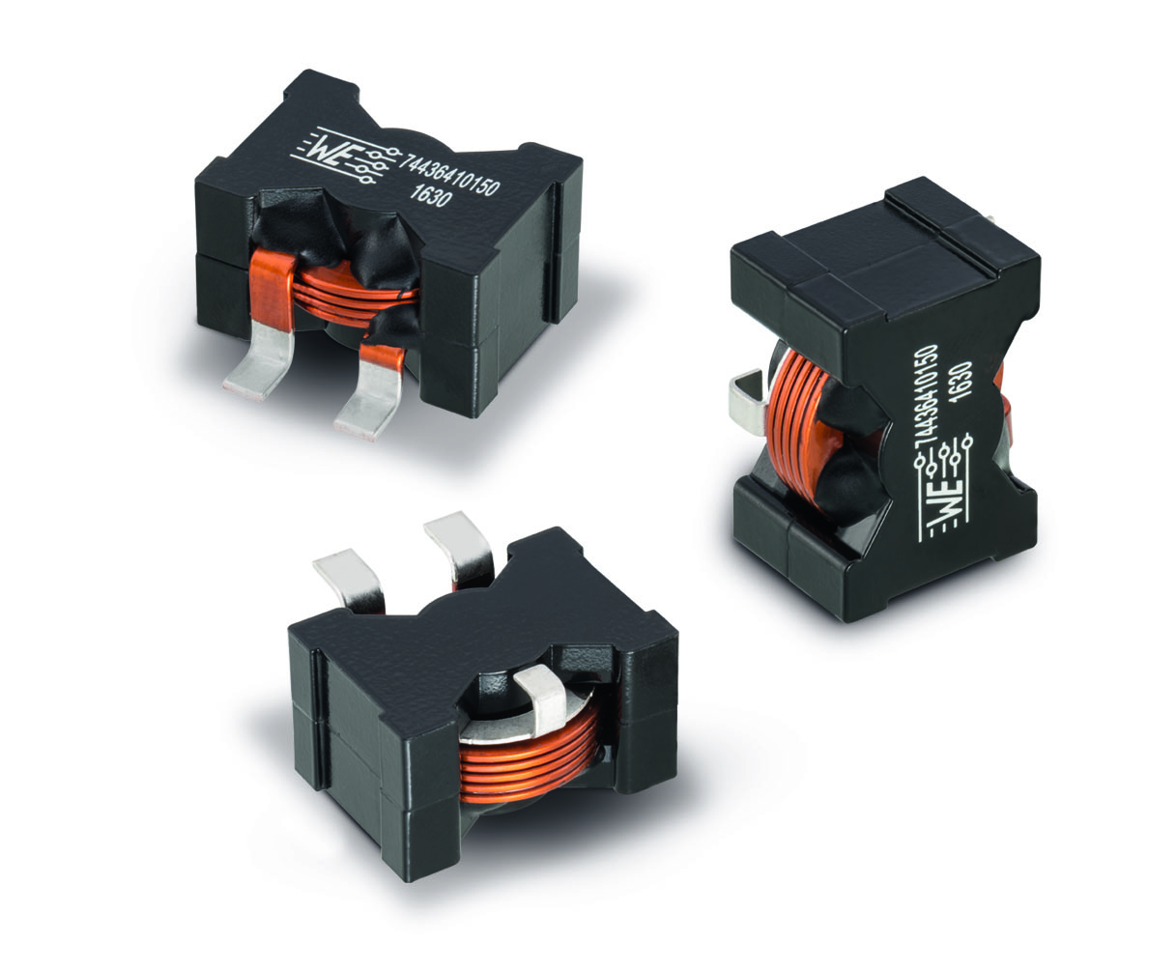
Image source: Würth Elektronik eiSos
WE-HCF in 2815 package - a flat wire power inductor with very high current loading capacity and efficiency

About Würth Elektronik eiSos

Würth Elektronik eiSos is a manufacturer of electronic and electromechanical components for the electronics industry. The company is part of the Würth Group, the global market leader for fastener technology. It employs 6,500 people and generated sales of almost 555 million Euros in 2016. Würth Elektronik eiSos is active in 50 countries worldwide.
Manufacturing facilities in Europe, Asia and North America ensure delivery to a customer base that is growing worldwide. The product range covers EMC components, inductors, transformers, HF components, varistors, capacitors, power modules, LEDs, connectors, power elements, switches, assembly technology and fuse holders.
Würth Elektronik eiSos is one of Europe’s largest manufacturers of passive components. The company’s innovative power in the field of e-mobility is reflected in its technology partnership with the Formula E team ABT Schaeffler Audi Sport and its support for the Formula E racing series (www.we-speed-up-the-future.com). Würth Elektronik eiSos also addresses other global growth markets, such as energy harvesting, the Internet of Things, wireless communication, and sensors, with a rapidly growing offer of innovative products.
Würth Elektronik: more than you expect!
Further information at www.we-online.com

Further information:  Würth Elektronik eiSos GmbH & Co. KG  Sarah Hurst  Max-Eyth-Strasse 1  74638 Waldenburg  Germany  Phone: +49 7942 945-5186  E-mail: sarah.hurst@we-online.de  www.we-online.de | Press contact:  HighTech communications GmbH  Brigitte Basilio  Grasserstrasse 1c  80339 Munich  Germany  Phone: +49 89 500778-20  Fax: +49 89 500778-77  E-mail: b.basilio@htcm.de  www.htcm.de

