PRESS RELEASE

Würth Elektronik eiSos hosts customers and partners at the Formula E event in Berlin
Fascination awakened for future technology: E-mobility
Waldenburg (Germany), 14 June 2017 – On the 10–11 of June 2017, Berlin Tempelhof was transformed into the Formula E race track and the must-attend event for customers and partners of the Würth Elektronik eiSos Group. On Saturday, the manufacturer of electronic and electromechanical components set up their own racing suite for over 100 guests in the former airport building. From here, customers visited the e-mobility exhibition "eVillage", the pit lane and of course got close to "their" team: Würth Elektronik eiSos is technology partner and supporter of the ABT Schaeffler Audi Sport team.
Double-header race in Berlin – the Formula E hosted two races in the German capital. The drivers of the ABT Schaeffler Audi Sport team made the most of their chances in front of their own audience: Lucas di Grassi took 2nd place on Saturday and 3rd place on Sunday. With this, di Grassi defended his second place on the overall leader board after this race weekend, keeping the championship wide open. His team-mate Daniel Abt also scored points and in 4th place achieved his best result of the season on Sunday.
"It was exciting to experience this race so close to the action. The supporting program of interesting activities offered fascinating insights into the Formula E racing business and our host’s commitment to e-mobility”, a business partner of the electronics manufacturer commented. Alexander Gerfer, CTO at Würth Elektronik eiSos Group, underlined his company’s passion for e-mobility. The technology partnership with the racing team offers the possibility to test components under extreme conditions. At the same time, their commitment to Formula E helps to make the E-mobility growth market more popular and the next generation of engineers with an interest, for example, in power electronics, are made aware of Würth Elektronik eiSos as an employer.
Exciting Highlights
In addition to the Formula E-related event program, such as the tour of the pit lane, there were also short talks about other future technologies. Lorandt Foelkel, who is also known for his presentations and webinars as #askLorandt, provided a short introduction into energy harvesting and wireless power. "This was a successful event which generated a lot of enthusiasm for e-racing and e-mobility from our guests, including many representatives of innovative electronics companies," says Oliver Opitz, Executive Strategic Product Development at Würth Elektronik eiSos.
The pictures and videos of the event can be viewed on the Blog and on Instagram. Further information about the technology partnership can be found here. Pictures and videos from the Blog and Instagram are royalty-free and may be used further.

Available images
The following images can be downloaded from the Internet in printable quality: http://www.htcm.de/kk/wuerth
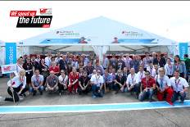Image source: ABT Schaeffler Audi Sport  Group picture with customers and partners in the pit lane of the garage of the ABT Schaeffler Audi Sport Team | 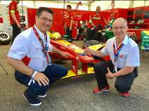  Image source: Würth Elektronik eiSos  (front left) Lorandt Foelkel (#askLorandt), technology ambassador, and Alexander Gerfer, CTO (both Würth Elektronik eiSos Group) in the garage of the German racing team

 Image source: ABT Schaeffler Audi Sport  Racing driver Lucas di Grassi took 2nd place on Saturday, 10 June 2017, and 3rd place on Sunday, 11 June 2017. | 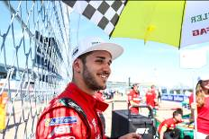  Image source: ABT Schaeffler Audi Sport  With 4th place, racing driver Daniel Abt achieved his best result of the season so far on Sunday, 11 June 2017.

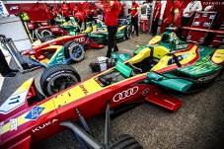  Image source: ABT Schaeffler Audi Sport  View of the pit lane of the German ABT Schaeffler Audi Sport team. | 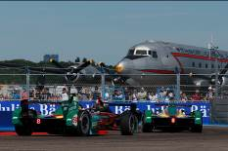  Image source: ABT Schaeffler Audi Sport  Lucas di Grassi and Daniel Abt on the race track against a historic backdrop.

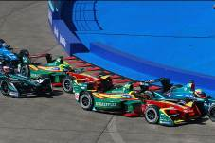  Image source: ABT Schaeffler Audi Sport  Lucas di Grassi and Daniel Abt during the race on the racetrack in Berlin. | 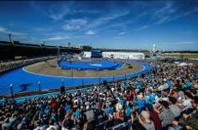IImage source: ABT Schaeffler Audi Sport  The former Tempelhof airport was the venue for the Formula E double-header race in Berlin.

About Würth Elektronik eiSos

Würth Elektronik eiSos is a manufacturer of electronic and electromechanical components for the electronics industry. The company is part of the Würth Group, the global market leader for fastener technology. It employs 6,500 people and generated sales of almost 555 million Euros in 2016. Würth Elektronik eiSos is active in 50 countries worldwide.
Manufacturing facilities in Europe, Asia and North America ensure delivery to a customer base that is growing worldwide. The product range covers EMC components, inductors, transformers, HF components, varistors, capacitors, power modules, LEDs, connectors, power elements, switches, assembly technology and fuse holders.
Würth Elektronik eiSos is one of Europe’s largest manufacturers of passive components. The company’s innovative power in the field of e-mobility is reflected in its technology partnership with the Formula E team ABT Schaeffler Audi Sport and its support for the Formula E racing series (www.we-speed-up-the-future.com). Würth Elektronik eiSos also addresses other global growth markets, such as energy harvesting, the Internet of Things, wireless communication, and sensors, with a rapidly growing offer of innovative products.
Würth Elektronik: more than you expect!
Further information at www.we-online.com

Further information:  Würth Elektronik eiSos GmbH & Co. KG  Sarah Hurst  Max-Eyth-Strasse 1  74638 Waldenburg  Germany  Phone: +49 7942 945-5186  E-mail: sarah.hurst@we-online.de  www.we-online.de | Press contact:  HighTech communications GmbH  Brigitte Basilio  Grasserstrasse 1c  80339 Munich  Germany  Phone: +49 89 500778-20  Fax: +49 89 500778-77  E-mail: b.basilio@htcm.de  www.htcm.de

