PRESS RELEASE

Würth Elektronik eiSos speeds up access to component libraries
Get to your virtual component faster
Waldenburg (Germany), 6 September 2017 – Würth Elektronik eiSos has integrated component libraries for Altium, Cadence OrCAD & Allegro, CADSTAR, Eagle, LTspice, Modelithics and S-Parameter to create a special service for electronics developers. Whereas up to now the data models have been available as downloads on the individual product pages of the online catalogue, Würth Elektronik eiSos now provides them centrally in a clearly arranged fashion, accessible by the target software. For Altium, Cadence OrCAD & Allegro, CADSTAR, Eagle and S-Parameters, there is also an easy to use search function available, enabling the items to be researched by article number and the product or library name. Besides the individual products, there are libraries of entire product families that can now be downloaded as well.
The component library can be downloaded via the following link:
www.we-online.de/libraries

Available image material
The following image can be downloaded from the Internet in printable quality: http://www.htcm.de/kk/wuerth
Component libraries available at Würth Elektronik eiSos with a comfortable search function
Image source: Würth Elektronik eiSos

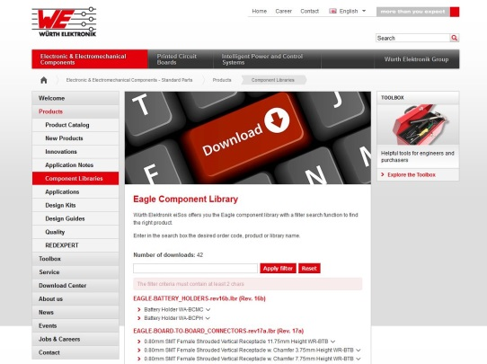

About Würth Elektronik eiSos

Würth Elektronik eiSos is a manufacturer of electronic and electromechanical components for the electronics industry. The company is part of the Würth Group, the global market leader for fastener technology. It employs 6,500 people and generated sales of almost 555 million Euros in 2016. Würth Elektronik eiSos is active in 50 countries worldwide.
Manufacturing facilities in Europe, Asia and North America ensure delivery to a customer base that is growing worldwide. The product range covers EMC components, inductors, transformers, HF components, varistors, capacitors, power modules, LEDs, connectors, power elements, switches, assembly technology and fuse holders.
Würth Elektronik eiSos is one of Europe’s largest manufacturers of passive components. The company’s innovative power in the field of eMobility is reflected in its technology partnership with the Formula E team ABT Schaeffler Audi Sport and its support for the Formula E racing series (www.we-speed-up-the-future.com). Würth Elektronik eiSos also addresses other global growth markets, such as energy harvesting, the Internet of Things, wireless communication, and sensors, with a rapidly growing offer of innovative products.
Würth Elektronik: more than you expect!
Further information at www.we-online.com

Further information:  Würth Elektronik eiSos GmbH & Co. KG  Sarah Hurst  Max-Eyth-Strasse 1  74638 Waldenburg  Germany  Phone: +49 7942 945-5186  E-mail: sarah.hurst@we-online.de  www.we-online.de | Press contact:  HighTech communications GmbH  Brigitte Basilio  Grasserstrasse 1c  80339 Munich  Germany  Phone: +49 89 500778-20  Fax: +49 89 500778-77  E-mail: b.basilio@htcm.de  www.htcm.de

