PRESS RELEASE

Würth Elektronik eiSos and Audi sign new partnership agreement in Formula E
Würth Elektronik eiSos and Audi
use Electric Power to drive into the Future
Waldenburg (Germany), 9 October 2017 – Würth Elektronik eiSos has been a technology partner to the Formula E racing team founded by ABT Sportsline from the very outset. Now it’s official: Following the takeover of the team led by FIA Formula E world champion Lucas di Grassi by Audi, Würth Elektronik eiSos has become technology partner of the new team under the name of Audi Sport ABT Schaeffler. The new partnership agreement was signed by Dieter Gass, Head of Motorsport, AUDI AG, and the three managing directors of Würth Elektronik eiSos, Oliver Konz, Thomas Schrott and Alexander Gerfer on 27 September 2017 as part of the premium manufacturer’s exclusive team presentation of the first purely electric racing team in Neuburg.
Audi Sport takes over the starting position from ABT Sportsline. The team from the Allgäu region in Bavaria has successfully participated in Formula E since the electric racing series was founded and in the future, will support the Audi racing cars as an operative team. Audi Sport ABT Schaeffler starts its fourth season of the Formula E racing series on 2-3 December 2017 in Hong Kong. The Würth Elektronik eiSos Group will also continue to shape the success of the team as a technology partner. The agreement with Audi runs until 2021.
“Our passion for Formula E and our technological support for the team’s success has grown from season to season. With the racing event in Berlin and the world championship title of our driver Lucas di Grassi, this enthusiasm has reached a new peak”, explains Alexander Gerfer, CTO Würth Elektronik eiSos Group. “With Audi joining as the first German car manufacturer, Formula E now receives a decisive boost as an innovation driver for eMobility. We are proud and happy to be part of this exciting development as a technology partner”, says Oliver Konz, CEO Würth Elektronik eiSos Group. Audi, a Volkswagen subsidiary and Würth Elektronik eiSos, a Würth Group company, are an ideal match. Both companies stand for visionary thinking, pioneering concepts and for future-oriented technologies.
“I’m pleased Würth Elektronik eiSos has extended the existing successful partnership and will continue to contribute to our project”, says Dieter Gass, Head of Motorsport at AUDI AG.

Strong partners
Audi has lent its name to the team since the first Formula E season in 2014 and provides one of its factory drivers - the Brazilian Lucas di Grassi. Lucas di Grassi crowned the season with the Formula E championship title. Based on his performance, Daniel Abt looks well placed to become a Top 5 driver in the coming season. Taking an overall average of all races from Season 1 to 3, with 24 podium places in 33 races, ABT Schaeffler Audi Sport was the team to appear most often on the podium in the series.

World premier of the Audi e-tron FE04 and tests in Valencia
The vehicle that will take to the track in Season 4 has been under development with the technology partners since November 2016. Audi together with world champion di Grassi presented the corporation's first purely electric racing car at the world premier in Neuburg. The new racing car for the coming season with the illustrious name Audi e-tron FE04 has a completely newly developed drive train with just one gear. A progressive new design in the primary colors of white, metallic green and black, immediately makes the Audi e-tron FE04 stand out from other cars. On the day of the team presentation, a new chapter will begin in Daniel Abt’s career. Abt will officially become an Audi factory driver and the former FIA WEC world champion Allan McNish will become team manager of the new Formula E racing team.
So the fourth Formula E season promises to be even more exciting. The race series originally started with the same car for all teams, but with each season more areas were opened up giving teams optimization opportunities through their own innovations. Extensive tests are currently in progress in Valencia before all four Audi e-tron FE04’s set off on their journey to Hong Kong at the beginning of November for the start of the new Season on 2 December at 4pm local time.

Technological support
Würth Elektronik eiSos managed to put innovative solutions onto the race track in the past. For example, high current ‘REDCUBE’ terminals have been installed on the inverter boards since the second season. In the third season, Würth Elektronik eiSos and ABT Sportsline jointly optimized the backup battery for the cockpit. The associated battery charger was also jointly developed as part of the technology partnership. Würth Elektronik eiSos views the fact that it can be specifically involved in the development of the Audi Sport ABT Schaeffler Team racing car as an outstanding opportunity to deploy components under extreme conditions and to advance solutions for eMobility.

Available images
The following images can be downloaded from the Internet in printable quality: http://www.htcm.de/kk/wuerth
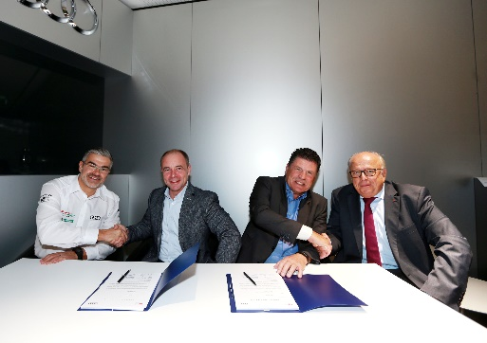Image source: Würth Elektronik eiSos and AUDI AG  Signing of the new partnership agreement on 27 September 2017 in Neuburg: Dieter Gass, Head of Motorsport, AUDI AG as well as Alexander Gerfer, Oliver Konz, managing directors of Würth Elektronik eiSos and Siegfried Krause, Head of Partnerships, AUDI AG (from left) | 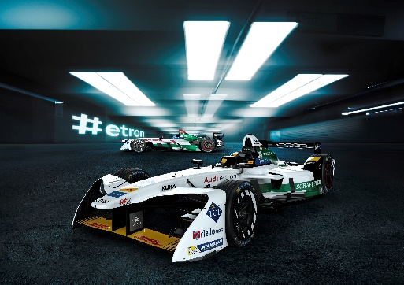Image source: AUDI AG  World premier: The new Audi e-tron FE04 with progressive design and highly efficient gearbox with just one gear.

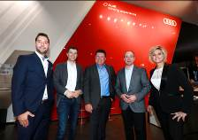  Image source: Würth Elektronik eiSos  Representatives of the Würth Elektronik eiSos Group Formula E Team at the world premiere of the Audi e-tron FE04 in Neuburg: Christopher Becht, Senior Manager Digital Communications, Oliver Opitz, Technical Coordinator & Executive, Oliver Konz, CEO, Alexander Gerfer, CTO, Marion Wagner, Marketing Professional & Head of Formula E Project (from left) | 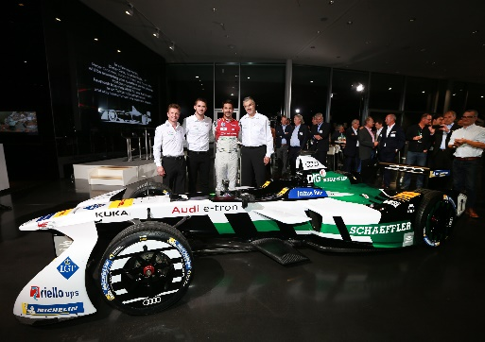Image source: Würth Elektronik eiSos and AUDI AG  Ready to go: The Audi Sport ABT Schaeffler Team is looking forward to the new fourth season 2017/2018 of the Formula E racing series.

About Audi

The Audi Group, with its brands Audi, Ducati and Lamborghini, is one of the most successful manufacturers of automobiles and motorcycles in the premium segment. It is present in more than 100 markets worldwide and produces at 16 locations in 12 countries. 100 percent subsidiaries of AUDI AG include Audi Sport GmbH (Neckarsulm), Automobili Lamborghini S.p.A. (Sant’Agata Bolognese, Italy) and Ducati Motor Holding S.p.A. (Bologna, Italy).
In 2016, the Audi Group delivered to customers about 1.868 million automobiles of the Audi brand, 3,457 sports cars of the Lamborghini brand and 55,451 motorcycles of the Ducati brand. In the 2016 fiscal year, AUDI AG achieved total revenue of €59.3 billion and an operating profit of €3.1 billion. At present, approximately 88,000 people work for the company all over the world, more than 60,000 of them in Germany. Audi focuses on sustainable products and technologies for the future of mobility.

About Würth Elektronik eiSos GmbH & Co. KG
Würth Elektronik eiSos GmbH & Co. KG is a manufacturer of electronic and electromechanical components for the electronics industry. Production sites in Europe, Asia and America supply a growing number of customers worldwide. The product program encompasses EMC components, inductors, transformers, HF components, varistors, capacitors, power modules, LEDs, plug connectors, power supply elements, wireless power coils, switches, connection technology and fuse holders. Würth Elektronik eiSos GmbH & Co. KG together with its specialized affiliated companies form the Würth Elektronik eiSos Group.

About the Würth Elektronik eiSos Group
Würth Elektronik eiSos GmbH & Co. KG (Focus: standard components), Würth Elektronik iBE GmbH (Focus: customized passive components for the automotive industry), Wurth Electronics Midcom Inc. (Focus: customized inductive components for electromagnetic shielding), Würth Elektronik Stelvio Kontek S.p.A. (Focus: customized plug connectors) and AMBER wireless GmbH (Focus: wireless data transmission solutions) form the Würth Elektronik eiSos Group. The group of companies with 6,750 employees generated sales of approx. € 555 million in 2016. The Würth Elektronik eiSos Group is one of the biggest European manufacturers of passive components and operates in 50 countries.
Through its technology partnership with the Audi Sport ABT Schaeffler Formula E Team and its support for the Formula E racing series, the Group demonstrates its innovative strength in eMobility (www.we-speed-up-the-future.com). Other global growth markets, such as Energy Harvesting, Internet of Things and Wireless Communication, are addressed with innovative products.
The Würth Elektronik eiSos Group is part of the Würth Group, the world market leader for assembly and fastening technology.
Würth Elektronik: more than you expect!
Further info at www.we-online.de

More information:  Würth Elektronik eiSos GmbH & Co. KG  Sarah Hurst  Max-Eyth-Strasse 1  74638 Waldenburg  Phone: +49 7942 945-5186  E-mail: sarah.hurst@we-online.de  www.we-online.de | Press contact:  HighTech communications GmbH  Brigitte Basilio  Grasserstrasse 1c  80339 Munich  Phone: +49-89-500778-20  Telefax: +49-89-500778-77  E-mail: b.basilio@htcm.de  www.htcm.de

