PRESS RELEASE
Würth Elektronik eiSos crowns e-mobility commitment
Formula E Team World Champion
Waldenburg (Germany), 30 July 2018 – At the close of the fourth Formula E season, Team Audi Sport ABT Schaeffler has finished at the top of the team standings. To Würth Elektronik eiSos GmbH & Co. KG – a team technology partner from the outset of Formula E – this achievement confirms the company’s commitment to e-mobility initiatives. The electronics manufacturer supplies high-performance, robust electronic components and jointly engineered systems. Projects aimed at further enhancing the vehicles are currently ongoing. In the run-up to next season, scheduled to begin on 15 December in Riyadh, Saudi Arabia, Würth Elektronik eiSos will also be participating in the Team Audi Sport ABT Schaeffler tests. In addition to these activities, Würth Elektronik eiSos is due to announce an e-scooters cooperation and a battery charging infrastructure project, at the upcoming electronica trade fair.
The fourth Formula E season was a particularly exciting one for fans of last year’s champion. Lucas di Grassi (this year finished in second place) and Daniel Abt (fifth). After scoring no points at all in the first four races, the Audi Sport ABT Schaeffler drivers launched an unprecedented fight to catch up. The team recorded the fastest laps in seven of the 12 races, and Daniel Abt notched up two wins, two more podium finishes and 120 points in his best season to date.
To Würth Elektronik eiSos, winning the team standings in the world championship validates the company’s future plans for e-mobility. Yet again, the close cooperation this season between all the technology partners paid off. Joint reliability tests and the use of combined capacities in the labs and quality centers resulted in podium places from the fourth race on, as well as most of the fastest laps and uncontested top positions in the Formula E tables.
Würth Elektronik customers also stand to benefit from the successes and experiences gained from the intensive use of Würth components in e-racing cars. Any and all findings from the racing series flow into component development and further improvements.
Right from the outset, Würth Elektronik eiSos has counted on the racing series’ clear message about e-mobility. Jaguar, BMW and Nissan joining in next season has also given a significant boost to Formula E’s reputation and standing. An important side note is that, from next season on, mid-race car changes will no longer be necessary as improved battery capacities will provide sufficient energy for a full race and race lengths will be slightly shorter.

Available images
The following images can be downloaded from the Internet in printable quality: http://www.htcm.de/kk/wuerth
  Image source: Würth Elektronik eiSos  Reasons enough to celebrate: the Audi Sport Abt Schaeffler Formula E team after its win. | 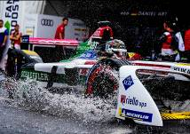  Image source: Würth Elektronik eiSos  Team Audi Sport ABT Schaeffler worked its way to the top despite the occasional adverse conditions.

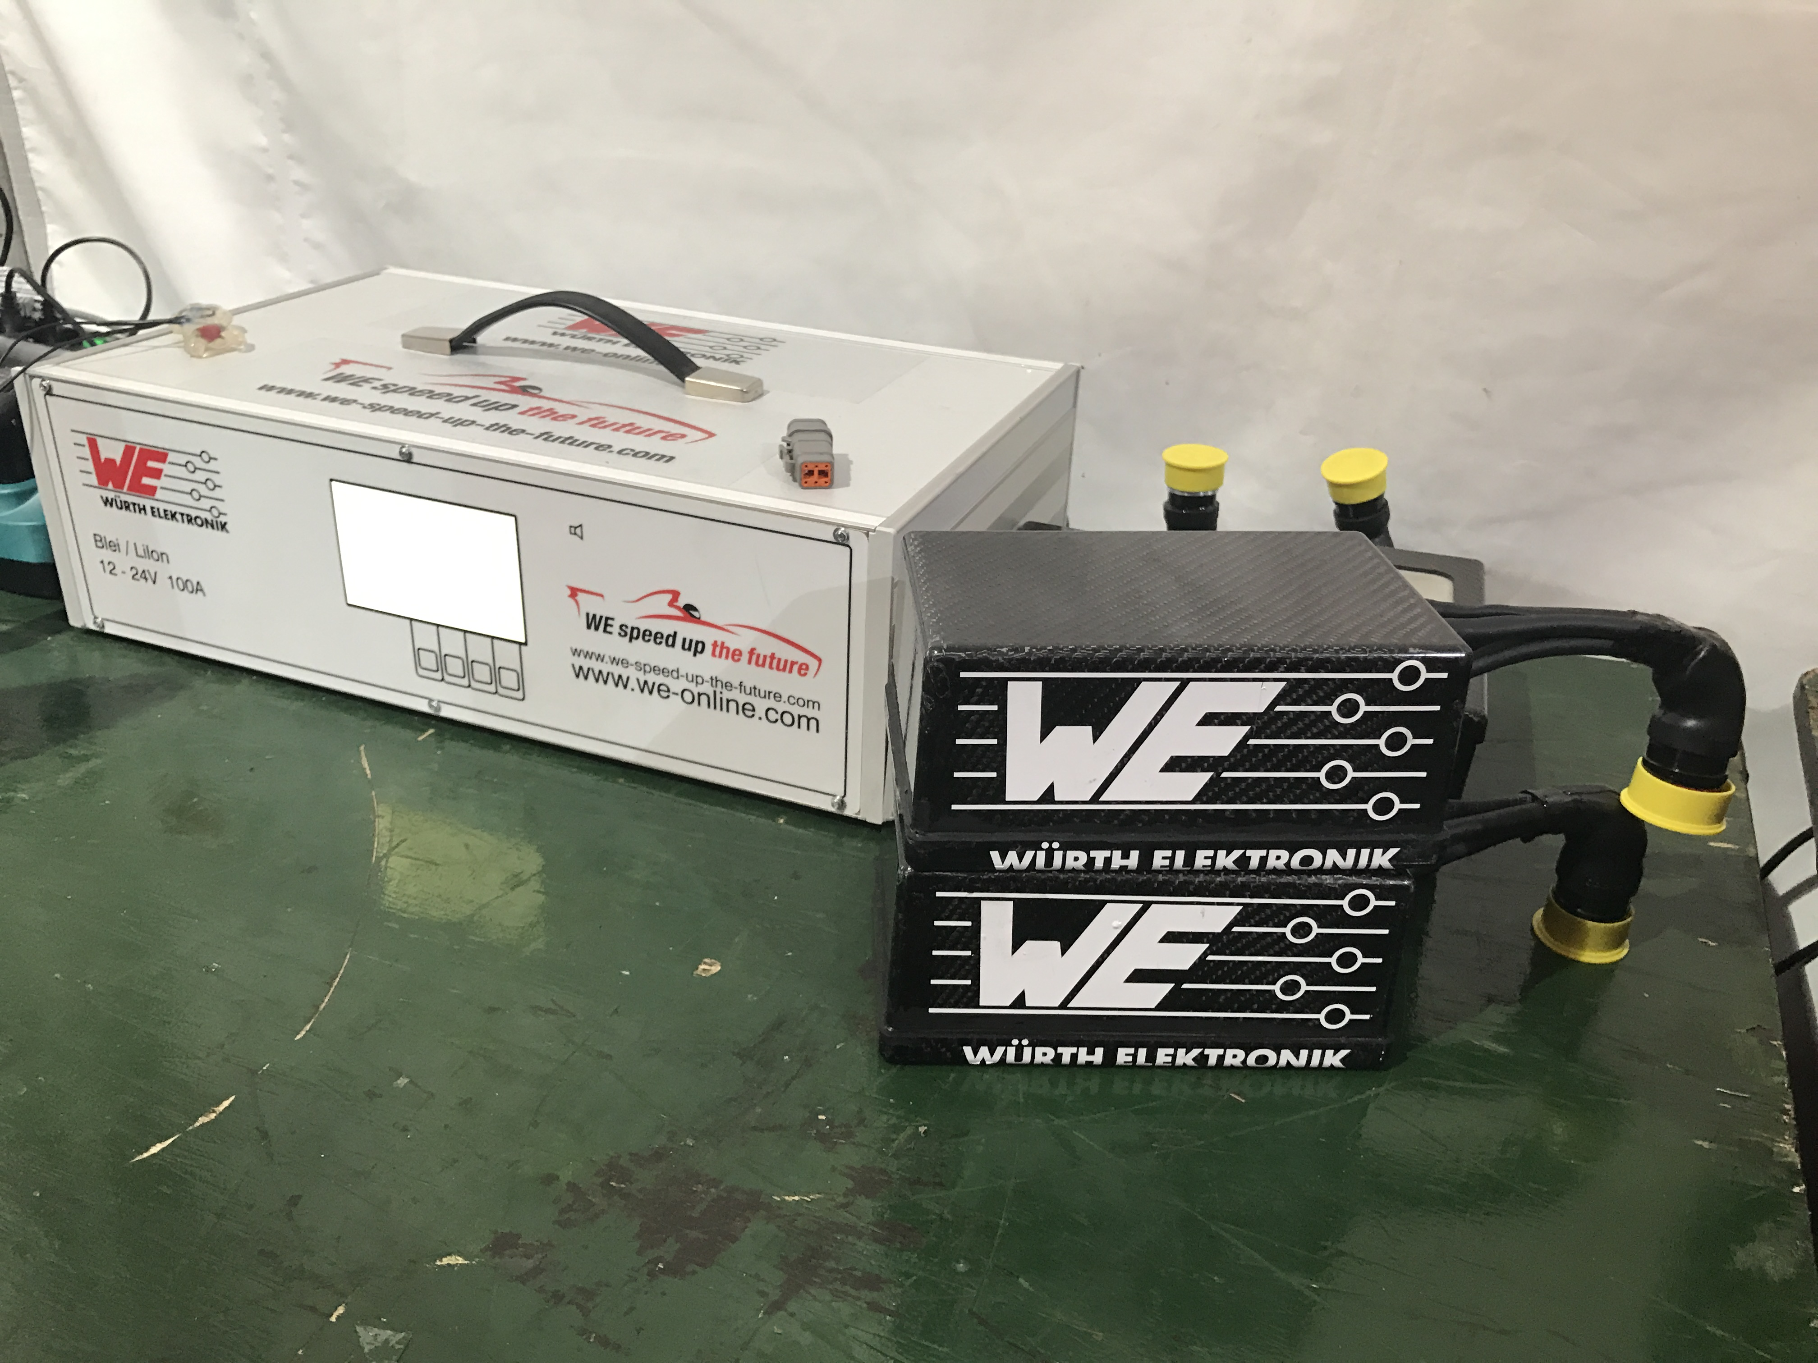
Image source: Würth Elektronik eiSos
Battery and battery charger: Würth Elektronik eiSos and Abt Sportsline jointly developed a power supply in the cockpit.

About Würth Elektronik eiSos GmbH & Co. KG
Würth Elektronik eiSos GmbH & Co. KG is a manufacturer of electronic and electromechanical components for the electronics industry. Production sites in Europe, Asia and North America supply a growing number of customers worldwide. The product program encompasses EMC components, inductors, transformers, HF components, varistors, capacitors, power modules, LEDs, wireless technology, plug connectors, power supply elements, wireless power coils, switches, connection technology and fuse holders. Würth Elektronik eiSos GmbH & Co. KG together with its specialized affiliated companies form the Würth Elektronik eiSos Group.

About the Würth Elektronik eiSos Group
Würth Elektronik eiSos GmbH & Co. KG (Focus: standard components), Würth Elektronik iBE GmbH (Focus: customized passive components for the automotive industry), Wurth Electronics Midcom Inc. (Focus: transformers and custom magnetics), Würth Elektronik Stelvio Kontek S.p.A. (Focus: customized plug connectors) and IQD Frequency Products Ltd (Focus: frequency-producing devices) form the Würth Elektronik eiSos Group. The former subsidiary AMBER wireless GmbH with a focus on solutions for wireless data transmission became the Wireless Connectivity and Sensors division of Würth Elektronik eiSos GmbH & Co. KG in 2018. The group of companies with 6,700 employees generated sales of approx. € 653 million in 2017. The Würth Elektronik eiSos Group is one of the biggest European manufacturers of passive components and operates in 50 countries.
Through its technology partnership with the Audi Sport ABT Schaeffler Formula E Team and its support for the Formula E racing series, the Group demonstrates its innovative strength in eMobility
(www.we-speed-up-the-future.com). Other global growth markets, such as Energy Harvesting, Internet of Things and Wireless Communication, are addressed with innovative products.
The Würth Elektronik eiSos Group is part of the Würth Group, the world market leader for assembly and fastening technology.
Würth Elektronik: more than you expect!
Further info at www.we-online.com

More information:  Würth Elektronik eiSos GmbH & Co. KG  Sarah Hurst  Max-Eyth-Strasse 1  74638 Waldenburg  Germany  Phone: +49 7942 945-5186  E-mail: sarah.hurst@we-online.de  www.we-online.de | Press contact:  HighTech communications GmbH  Brigitte Basilio  Brunhamstrasse 21  81249 Munich  Germany  Phone: +49 89 500778-20  Telefax: +49 89 500778-77  E-mail: b.basilio@htcm.de  www.htcm.de

