PRESS RELEASE

Würth Elektronik eiSos Supplies Wireless Power Coil for Semtech’s LinkCharge® LP Multi-Device Wireless Charging Solution

Waldenburg (Germany), 27 October 2017 – Würth Elektronik eiSos, a manufacturer of electronic and electromechanical components, announced its collaboration with Semtech Corporation (Nasdaq: SMTC) by integrating its transmission coil, WE-WPCC, with Semtech’s LinkCharge® LP (low power) platform, an innovative wireless charging solution that concurrently charges multiple, low-power devices using a single transmitter.
The WE-WPCC series transmission coil excels with its NiZn ferrite shielding to protect sensitive electronics and concentrate the magnetic field. The coil is specially designed for resonant inductive coupling and allows several receivers to be used at the same time. Semtech’s LinkCharge LP (TSWITX-5V-2RX-EVM), featuring Würth’s transmission coil, provides positioning and spatial freedom that allows for charging of multiple devices. The platform delivers one-watt of output power to charging devices and specifically targets low-power applications including hearing aids, activity trackers, smart headphones, smart jewelry and clothing, low power industrial, portable medical equipment, and LED fixtures.
“The Semtech LinkCharge LP wireless charger represents exemplary use of our high-grade coils and we are pleased about this important reference,” explains Jörg Hantschel, Business Development Manager Wireless Power at Würth Elektronik eiSos. “The coil used in LinkCharge LP is also suitable beyond the Qi standards, which primarily focus on consumer electronics.”
"Semtech's LinkCharge LP platform was designed to enhance the overall user experience by allowing people to charge multiple devices at once without the hassle of cables," said Ruwanga Dassanayake, Power Management Product Line Manager for Semtech's Power and High-Reliability Products Group. "Würth Elektronik's WE-WPCC transmission coil is a key component of LinkCharge LP and makes it possible for our solution to give our customers a unique experience.”
The windings of the WE-WPCC coil consist of high frequency stranded wire with high permeability shielding. The coil also scores a far lower resistance and higher Q factor than all those comparable products previously on the market. WE-WPCC 760 308 102 308 for resonance solutions is available from stock, with a design kit and free sample service likewise.

Available images
The following images can be downloaded from the Internet in printable quality: http://www.htcm.de/kk/wuerth
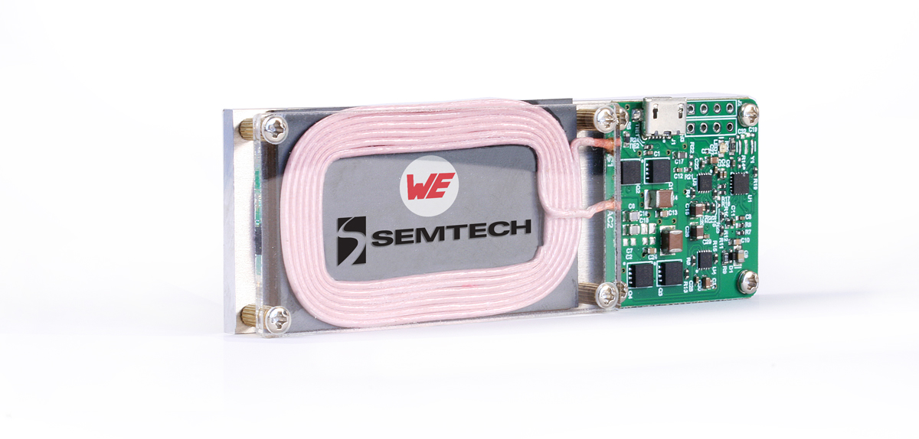Image source: Würth Elektronik eiSos
Wireless power coil from Würth Elektronik eiSos for the Semtech charging station

About Semtech
Semtech Corporation is a leading supplier of high performance analog and mixed-signal semiconductors and advanced algorithms for high-end consumer, enterprise computing, communications, and industrial equipment. Products are designed to benefit the engineering community as well as the global community. The Company is dedicated to reducing the impact it, and its products, have on the environment. Internal green programs seek to reduce waste through material and manufacturing control, use of green technology and designing for resource reduction. Publicly traded since 1967, Semtech is listed on the Nasdaq Global Select Market under the symbol SMTC. For more information, visit www.semtech.com.
Press Contact:
Semtech Corporation
Ronda Grech
Phone: +1-805-480-2193
E-mail: rgrech@semtech.com

About Würth Elektronik eiSos GmbH & Co. KG
Würth Elektronik eiSos GmbH & Co. KG is a manufacturer of electronic and electromechanical components for the electronics industry. Production sites in Europe, Asia and North America supply a growing number of customers worldwide. The product program encompasses EMC components, inductors, transformers, HF components, varistors, capacitors, power modules, LEDs, plug connectors, power supply elements, wireless power coils, switches, connection technology and fuse holders. Würth Elektronik eiSos GmbH & Co. KG, together with its specialized affiliated companies, form the Würth Elektronik eiSos Group.

About the Würth Elektronik eiSos Group
Würth Elektronik eiSos GmbH & Co. KG (Focus: standard components), Würth Elektronik iBE GmbH (Focus: customized passive components for the automotive industry), Wurth Electronics Midcom Inc. (Focus: transformers and custom magnetics), Würth Elektronik Stelvio Kontek S.p.A. (Focus: customized plug connectors) and AMBER wireless GmbH (Focus: wireless data transmission solutions) form the Würth Elektronik eiSos Group. The group of companies with 6,750 employees generated sales of approx. € 555 million in 2016. The Würth Elektronik eiSos Group is one of the biggest European manufacturers of passive components and operates in 50 countries.
Through its technology partnership with the Audi Sport ABT Schaeffler Formula E Team and its support for the Formula E racing series, the Group demonstrates its innovative strength in eMobility (www.we-speed-up-the-future.com). Other global growth markets, such as Energy Harvesting, Internet of Things and Wireless Communication, are addressed with innovative products.
The Würth Elektronik eiSos Group is part of the Würth Group, the world market leader for assembly and fastening technology.
Würth Elektronik: more than you expect!
Further info at www.we-online.de

More information:  Würth Elektronik eiSos GmbH & Co. KG  Sarah Hurst  Max-Eyth-Strasse 1  74638 Waldenburg  Germany  Phone: +49 7942 945-5186  E-mail: sarah.hurst@we-online.de  www.we-online.de | Press contact:  HighTech communications GmbH  Brigitte Basilio  Brunhamstrasse 21  81249 Munich  Germany  Phone: +49-89-500778-20  Telefax: +49-89-500778-77  E-mail: b.basilio@htcm.de  www.htcm.de

Forward-Looking and Cautionary Statements
All statements contained herein that are not statements of historical fact, including statements that use the words “designed to,” make possible,” or other similar words or expressions, that describe Semtech Corporation’s or its management’s future plans, objectives or goals are “forward-looking statements” and are made pursuant to the Safe-Harbor provisions of the Private Securities Litigation Reform Act of 1995, as amended. Such forward-looking statements involve known and unknown risks, uncertainties and other factors that could cause the actual results of Semtech Corporation to be materially different from the historical results and/or from any future results or outcomes expressed or implied by such forward-looking statements. Such factors are further addressed in Semtech Corporation’s annual and quarterly reports, and in other documents or reports, filed with the Securities and Exchange Commission (www.sec.gov) including, without limitation, information under the captions “Management’s Discussion and Analysis of Financial Condition and Results of Operations” and “Risk Factors.” Semtech Corporation assumes no obligation to update any forward-looking statements in order to reflect events or circumstances that may arise after the date of this release, except as required by law.

Semtech and the Semtech logo are registered trademarks or service marks, and LinkCharge is a registered trademark or service mark, of Semtech Corporation or its affiliates.

