MEDIA INFORMATION

Würth Elektronik iBE picks Digi-Key Electronics distribution channel
Automotive Products via Distribution Partner
Thyrnau (Germany), 9 March 2018 – In line with its parent company Würth Elektronik eiSos and their US sister company Wurth Electronics Midcom, now another sister company, Würth Elektronik iBE too offers selected products via the distributor Digi-Key Electronics. Both companies agreed to make standard products - such as SMD rod core chokes, molded SMD power chokes, SMD flat wire power inductors and design kits - available worldwide through Digi-Key Electronics with immediate effect. In addition to these and other high-grade standard products, Würth Elektronik iBE also develops customized solutions for the demanding automotive market.
“We are pleased that our automotive components are now distributed globally via Digi-Key Electronics. This is an important step and makes it easier for many customers to access our products,” said Benjamin Doerr, Director New Business Development at Würth Elektronik iBE. “Digi-Key Electronics, with its outstanding customer service and broad customer base, is the ideal distribution partner to make our range of products known and accessible to a larger number of potential customers."
The complete range of Würth Elektronik iBE products through Digi-Key Electronics is available here:
https://www.digikey.com/en/supplier-centers/w/wurth-electronics-ibe

Available images
The following images can be downloaded from the Internet in printable quality: http://www.htcm.de/kk/wuerth

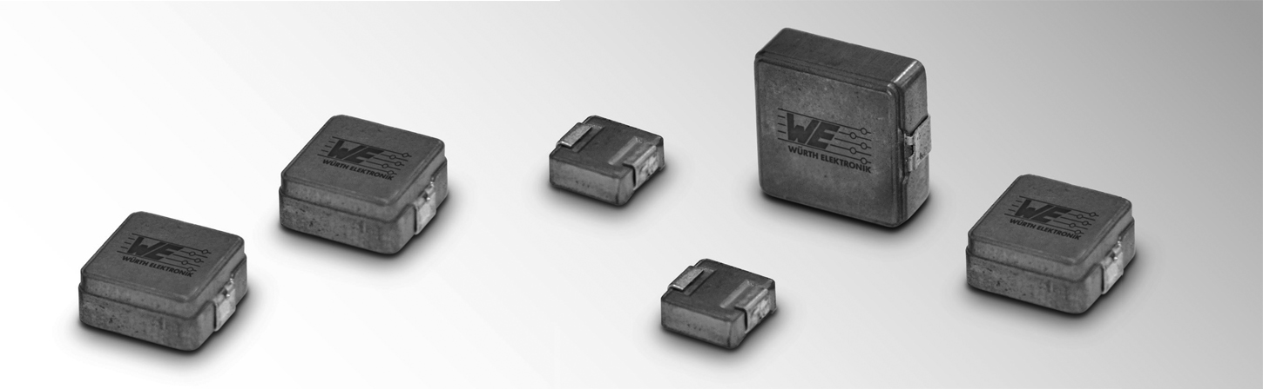Image source: Würth Elektronik iBE
The WE-MASH-I series of molded SMD power chokes is the latest product range now available through Digi-Key Electronics.

About Digi-Key Electronics
Digi-Key Electronics, headquartered in Thief River Falls (Minnesota, USA), is an authorized global distributor of electronic components offering over 6 million products from more than 650 renowned brand manufacturers of which over 1.3 million products are immediately available from stock. Furthermore, Digi-Key offers a wealth of online resources, such as EDA and design tools, data sheets, reference designs, informative articles and videos, multimedia libraries and much more besides. Technical Customer Support is available daily around the clock via e-mail, phone and web chat.
Further information: www.digikey.de

About Würth Elektronik iBE GmbH
Würth Elektronik iBE GmbH manufactures customer-specific rod core chokes for automotive applications. The company employs over 1,500 staff worldwide and produced over 1.1 milliard components in 2017, generating sales of 80 million euros. With its six production sites, Würth Elektronik iBE is represented on all the important markets and continents: Thyrnau and Esslingen (Germany), Budweis (Czech Republic), Belozem (Bulgaria), Irapuato (Mexico) and Shenyang (China). The product portfolio extends from customer-specific rod core and special chokes to high current inductors, ferrites, air coils, as well as flat wire and power inductors, which are used in automobiles. Würth Elektronik iBE is part of the Würth Elektronik eiSos Group.

About the Würth Elektronik eiSos Group
Würth Elektronik eiSos GmbH & Co. KG (Focus: standard components), Würth Elektronik iBE GmbH (Focus: customized passive components for the automotive industry), Wurth Electronics Midcom Inc. (Focus: transformers and custom magnetics), Würth Elektronik Stelvio Kontek S.p.A. (Focus: customized plug connectors), AMBER wireless GmbH (Focus: wireless data transmission solutions) and IQD Frequency Products Ltd (Focus: frequency-control components form the Würth Elektronik eiSos Group. The group of companies with 6,700 employees generated sales of approx. € 653 million in 2017. The Würth Elektronik eiSos Group is one of the biggest European manufacturers of passive components and operates in 50 countries.
Through its technology partnership with the Audi Sport ABT Schaeffler Formula E Team and its support for the Formula E racing series, the Group demonstrates its innovative strength in eMobility (www.we-speed-up-the-future.com). Other global growth markets, such as Energy Harvesting, Internet of Things and Wireless Communication, are addressed with innovative products.
The Würth Elektronik eiSos Group is part of the Würth Group, the world market leader for assembly and fastening technology.
Würth Elektronik: more than you expect!
Further info at www.we-online.com

Further information:  Würth Elektronik iBE GmbH  Constanze Frescura  Gewerbepark 8  94136 Thyrnau  Germany  Phone: +49 8501 9001-123  E-mail: constanze.frescura@we-online.de  www.we-online.de | Press contact:  HighTech communications GmbH  Brigitte Basilio  Brunhamstrasse 21  81249 Munich  Germany  Phone: +49 89 500778-20  Fax: +49 89 500778-77  E-mail: b.basilio@htcm.de  www.htcm.de

