PRESS RELEASE

Würth Elektronik eiSos presents its WE-MCRI SMT double choke
First Double Choke with Molding Technology
Waldenburg (Germany), 17 July 2018 – Würth Elektronik eiSos, manufacturer of electronic and electromechanical components, unveils WE-MCRI - a novel double choke: It is the first of its kind on the market with molding technology. With its soft saturation characteristics, a WE-MCRI is above all suited for DC/DC converter applications.
WE-MCRI consists of two identical round wire-windings compacted in a metal powder material. The double chokes for SMT assembly with outstanding electrical power and improved EMC performance are extremely compact (10 x 11.5 x 9 mm) and offer attractive options in PCB design. The new series is designed for a rated current up to 17 A and a saturation current up to 43.5 A. Thanks to their special winding style, the WE-MCRI series components excel with their outstanding coupling coefficient of up to 0.995 which means much lower leakage inductance than similar coupled inductors. These double power chokes are the perfect solution for SEPIC and Ćuk converters for which a high rated current and saturation current with a high coupling coefficient are called for. Further applications include flyback converters with a 1:1 turn ratio as well as step-up / step-down converters with isolated secondary output voltage.
The WE-MCRI series is available from stock in any quantities. You can request free samples.
More information at https://katalog.we-online.de/en/pbs/WE-MCRI

Available images
The following images can be downloaded from the Internet in printable quality: http://www.htcm.de/kk/wuerth

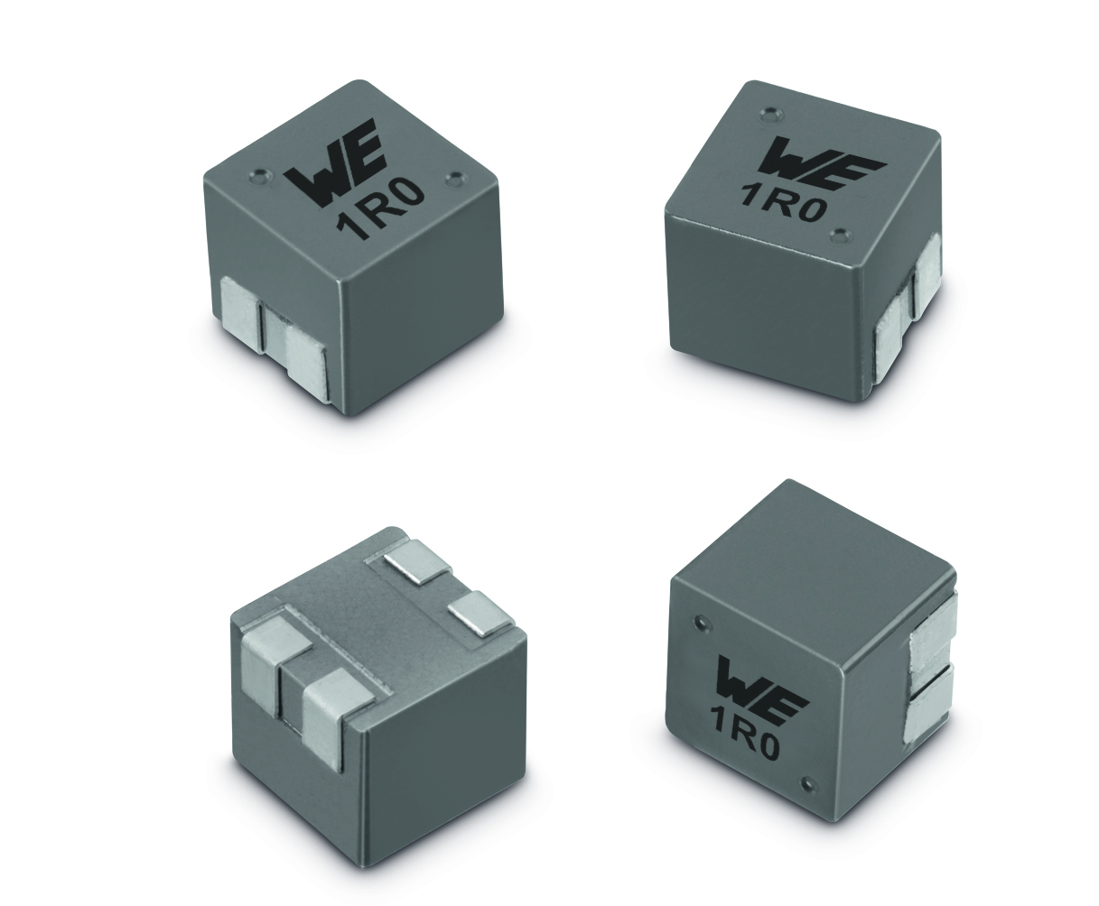
Image source: Würth Elektronik eiSos
WE-MCRI double chokes for SMT assembly

About Würth Elektronik eiSos GmbH & Co. KG
Würth Elektronik eiSos GmbH & Co. KG is a manufacturer of electronic and electromechanical components for the electronics industry. Production sites in Europe, Asia and North America supply a growing number of customers worldwide. The product program encompasses EMC components, inductors, transformers, HF components, varistors, capacitors, power modules, LEDs, wireless technology, plug connectors, power supply elements, wireless power coils, switches, connection technology and fuse holders. Würth Elektronik eiSos GmbH & Co. KG together with its specialized affiliated companies form the Würth Elektronik eiSos Group.

About the Würth Elektronik eiSos Group
Würth Elektronik eiSos GmbH & Co. KG (Focus: standard components), Würth Elektronik iBE GmbH (Focus: customized passive components for the automotive industry), Wurth Electronics Midcom Inc. (Focus: transformers and custom magnetics), Würth Elektronik Stelvio Kontek S.p.A. (Focus: customized plug connectors) and IQD Frequency Products Ltd (Focus: frequency-producing devices) form the Würth Elektronik eiSos Group. The former subsidiary AMBER wireless GmbH with a focus on solutions for wireless data transmission became the Wireless Connectivity and Sensors division of Würth Elektronik eiSos GmbH & Co. KG in 2018. The group of companies with 6,700 employees generated sales of approx. € 653 million in 2017. The Würth Elektronik eiSos Group is one of the biggest European manufacturers of passive components and operates in 50 countries.
Through its technology partnership with the Audi Sport ABT Schaeffler Formula E Team and its support for the Formula E racing series, the Group demonstrates its innovative strength in eMobility
(www.we-speed-up-the-future.com). Other global growth markets, such as Energy Harvesting, Internet of Things and Wireless Communication, are addressed with innovative products.
The Würth Elektronik eiSos Group is part of the Würth Group, the world market leader for assembly and fastening technology.
Würth Elektronik: more than you expect!
Further info at www.we-online.com

More information:  Würth Elektronik eiSos GmbH & Co. KG  Sarah Hurst  Max-Eyth-Strasse 1  74638 Waldenburg  Germany  Phone: +49 7942 945-5186  E-mail: sarah.hurst@we-online.de  www.we-online.de | Press contact:  HighTech communications GmbH  Brigitte Basilio  Brunhamstrasse 21  81249 Munich  Germany  Phone: +49 89 500778-20  Telefax: +49 89 500778-77  E-mail: b.basilio@htcm.de  www.htcm.de

