PRESS RELEASE
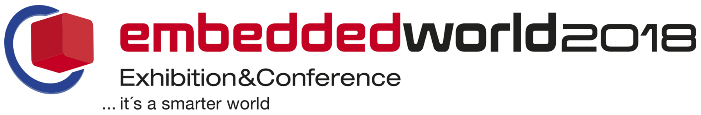
Würth Elektronik eiSos at embedded world 2018
Component Solutions for Embedded Applications
February 27 – March 1, 2018
Hall 3, booth 3-247
Waldenburg (Germany), 26 January 2018 – Würth Elektronik eiSos, manufacturer of electronic and electromechanical components, exhibits at embedded world (Nuremberg, February 27 – March 1, 2018). At booth 3-247, one of the biggest in hall 3 of the Nuremberg Exhibition Center, the company presents the smallest components. With numerous new products in 0402 and 0603 packages, the manufacturer supports the advancing miniaturization of assemblies. Another key topic at the Würth Elektronik eiSos exhibition booth is suppression – one example of use is for signal lines with the help of high frequency optimized multilayer ferrites.
WE-MPSB is among the stars. This worldwide first series of SMT ferrites with specified peak current capability is optimized for filtering high frequency DC/DC switching controllers in harsh industrial environments. Additional important products in the trade show program are the WE-MAPI, some of the world’s smallest wound metal alloy storage inductors, the WE-LAN-AQ-10/100 Base-T transformers with improved return loss and crosstalk properties, as well as the new MagI³C power modules. With MagI³C-VDMM (Variable Step Down MicroModule), Würth Elektronik eiSos extends its product series of power modules with high power density, very few external components and excellent electromagnetic compatibility with a specially compact solution in the LGA-6EP housing. The MagI³C-VDRM (Variable Step Down Regulator Module) is now available in the TO263-7EP package – ideal for prototype construction.
In the field of electromechanics, high quality WE-COM-USB-3.1 type C connectors are unveiled. These and other developments reflect Würth Elektronik’s expectation that USB is set to make rapid gains in industrial applications.
“LED it grow”
Illuminating examples in the true sense for outstanding product design are found in the field of LEDs. In the spotlight: WL-SMDC Horticultural Ceramic LEDs 3535. With its light spectrum, this new series of compact LEDs is ideal for lighting plants in breeding and laboratory facilities. More news from this division of Würth Elektronik eiSos: WL-SMCW 0402 and 0603 compact – miniature LEDs for SMT assembly. WL-SFTW PLCC-6 RGB is a powerful combination of red, green and blue LEDs for displaying any colors in applications such as decoration and background illumination. Of particular interest, especially for sensor manufacturers, are infrared LEDs of which there are no fewer than four new models to be seen on the Würth Elektronik eiSos booth.
Subsidiaries also on the booth
The subsidiary Amber wireless showcases, among other things, AMB2621, an ultra low power 2.4 GHz wireless module, as well as the 868 MHz long-range wireless module AMB8826 and the 2.4 GHz long-range wireless module AMB2220. Also on display at the show: the 2.4 GHz all-in-one wireless module AMB2524 with integrated antenna, as well as various M-Bus wireless modules. With AMB2301, an integrated Bluetooth solution is presented, which is available soon for the first time. The chipset needs no external control unit and allows devices to be made Bluetooth-enabled without any further cost or effort.
At embedded world, the latest addition to the Würth Elektronik eiSos Group, IQD Frequency Products Inc., will also present its portfolio of quartz and oscillator products ranging from the tiny 1.2 × 1 mm IGXC-240, including GPS Disciplined OCXOs, through to rubidium oscillators for the most demanding applications. The highlight is the IQOV-114 OCXO, accommodated in a 20 × 12.7 mm SMD housing. It offers extraordinary frequency stability up to ±1 ppb over the entire industrial temperature range of -40 to +85°C. It is, for instance, ideal for stratum 3, 4G/LTE/5G base stations or satellite communication applications.
Standard component program rounded off
In the presentation of its broad portfolio of capacitors, Würth Elektronik eiSos places special importance on aluminum electrolyte capacitors. A product highlight here is the WCAP-PSHP aluminum-polymer capacitor: miniaturized, with high permissible ripple current, temperature-insensitive and reflow solderable. In the field of such standard components, Würth Elektronik eiSos scores not only with its comprehensive product range, but also with its special service orientation. Free samples, free refilled design kits, design-in support and prompt delivery, even of smaller quantities, from stock – these are all advantages with which Würth Elektronik eiSos positions itself with visitors to embedded world as a powerful partner, also in the field of developer support.

Available images
The following images can be downloaded from the Internet in printable quality: http://www.htcm.de/kk/wuerth
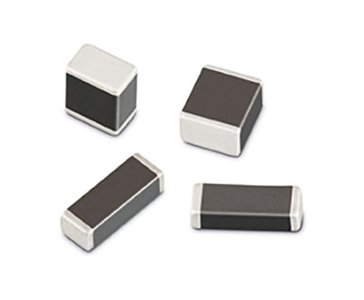  Image source: Würth Elektronik eiSos  WE-MPSB, SMT ferrites with specified peak current capability | 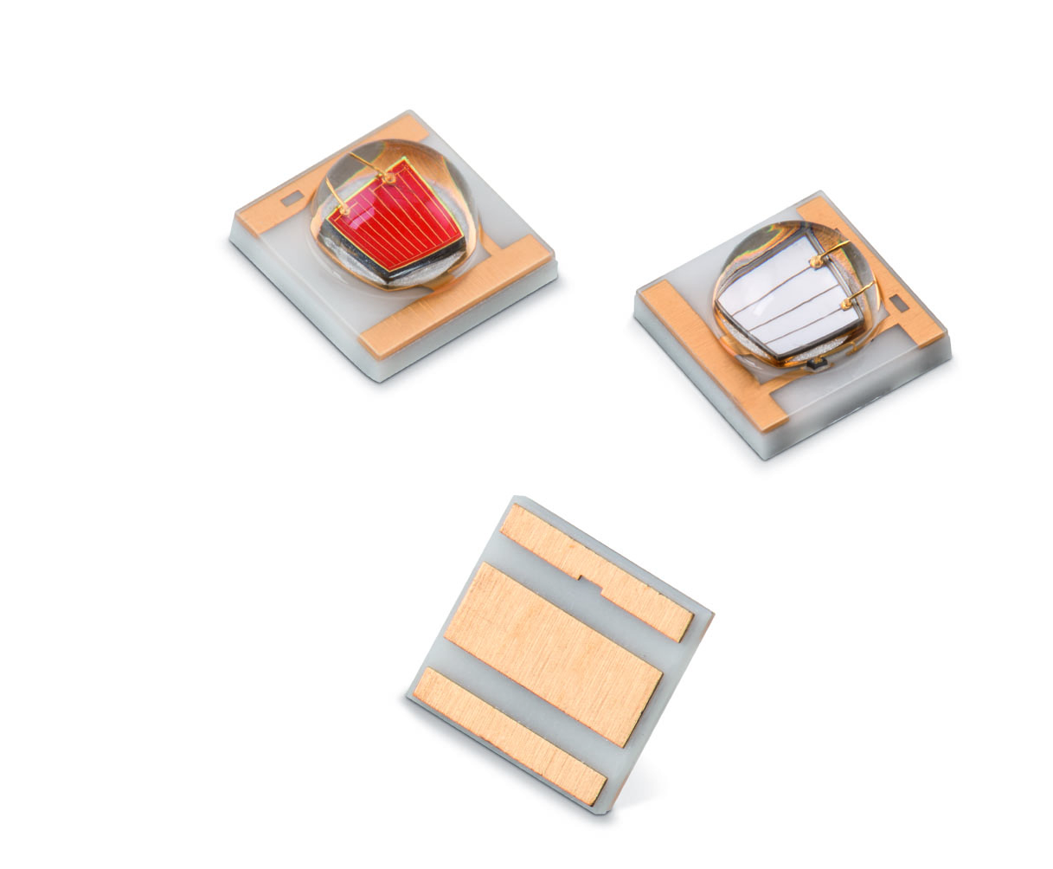  Image source: Würth Elektronik eiSos  WL-SMDC Horticultural Ceramic LEDs 3535 for lighting plants in breeding and laboratory facilities.
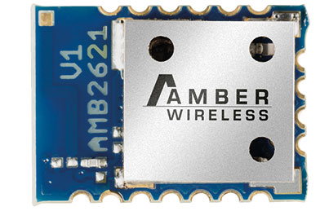  Image source: Würth Elektronik eiSos  AMB2621 is a 2.4 GHz BLE wireless module compliant with the Bluetooth Smart 4.2 standard. | 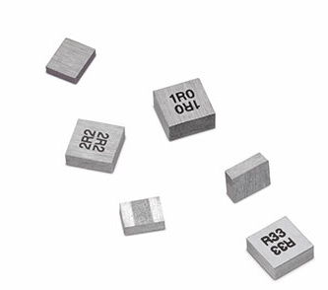  Image source: Würth Elektronik eiSos  WE-MAPI – some of the world’s smallest wound metal alloy storage inductors

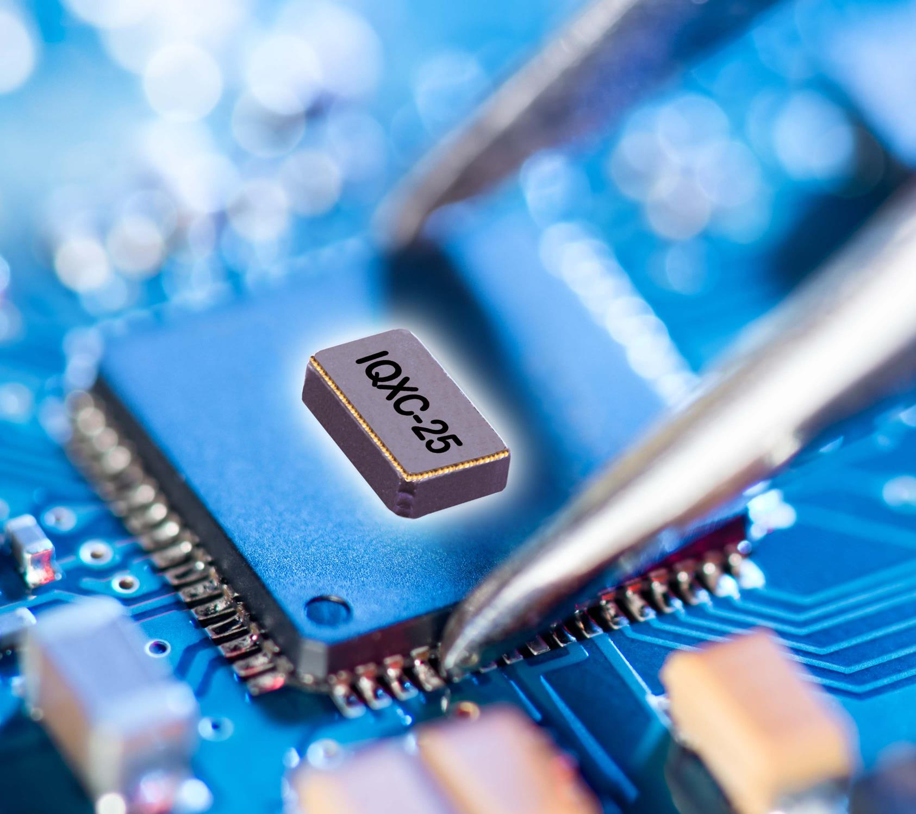

Image source: Würth Elektronik eiSos
IQXC-25, Ultra-Miniature Watch Crystal for IoT Applications

About Würth Elektronik eiSos GmbH & Co. KG
Würth Elektronik eiSos GmbH & Co. KG is a manufacturer of electronic and electromechanical components for the electronics industry. Production sites in Europe, Asia and North America supply a growing number of customers worldwide. The product program encompasses EMC components, inductors, transformers, HF components, varistors, capacitors, power modules, LEDs, plug connectors, power supply elements, wireless power coils, switches, connection technology and fuse holders. Würth Elektronik eiSos GmbH & Co. KG, together with its specialized affiliated companies, form the Würth Elektronik eiSos Group.

About the Würth Elektronik eiSos Group
Würth Elektronik eiSos GmbH & Co. KG (Focus: standard components), Würth Elektronik iBE GmbH (Focus: customized passive components for the automotive industry), Wurth Electronics Midcom Inc. (Focus: transformers and custom magnetics), Würth Elektronik Stelvio Kontek S.p.A. (Focus: customized plug connectors) and AMBER wireless GmbH (Focus: wireless data transmission solutions) form the Würth Elektronik eiSos Group. The group of companies with 6,700 employees generated sales of approx. € 653 million in 2017. The Würth Elektronik eiSos Group is one of the biggest European manufacturers of passive components and operates in 50 countries.
Through its technology partnership with the Audi Sport ABT Schaeffler Formula E Team and its support for the Formula E racing series, the Group demonstrates its innovative strength in eMobility (www.we-speed-up-the-future.com). Other global growth markets, such as Energy Harvesting, Internet of Things and Wireless Communication, are addressed with innovative products.
The Würth Elektronik eiSos Group is part of the Würth Group, the world market leader for assembly and fastening technology.
Würth Elektronik: more than you expect!
Further info at www.we-online.com
More information:  Würth Elektronik eiSos GmbH & Co. KG  Sarah Hurst  Max-Eyth-Strasse 1  74638 Waldenburg  Germany  Phone: +49 7942 945 5186  E-mail: sarah.hurst@we-online.de  www.we-online.de | Press contact:  HighTech communications GmbH  Brigitte Basilio  Brunhamstrasse 21  81249 Munich  Germany  Phone: +49-89-500778-20  Telefax: +49-89-500778-77  E-mail: b.basilio@htcm.de  www.htcm.de

