PRESS RELEASE
Hall 7, Booth 7-229
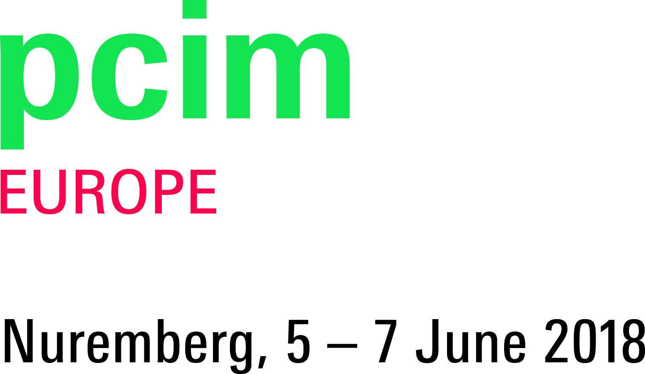
Würth Elektronik eiSos at PCIM Europe
Intelligent Solutions for Power Electronics
Waldenburg (Germany), 9 May 2018 – Würth Elektronik eiSos exhibits at PCIM Europe in Nuremberg – the internationally leading trade show for power electronics, intelligent drive technology, renewable energy and energy management – from 5 to 7 June, 2018. On booth 229 in Hall 7, the manufacturer of electronic and electromechanical components presents four thematic areas: discrete power management solutions, power modules, wireless power, LEDs and EMC, and on the fourth theme area electromagnetic products.
The product highlights include the high performance WE-HCF high current inductor for SMT assembly, the WE-CMBNC and WE-TPB HV current-compensated mains chokes, as well as the WE-XHMI power choke with flat-wire windings. With WE-CFWI, WE-MCRI and WE-MTCI, further double chokes and coupled power chokes are presented on the Würth Elektronik eiSos booth. Surge protection in switch mode power supplies also plays an important role – here the WE-VD varistor will be on display.
Energy harvesting demonstrations
The technology ambassador Lorandt Fölkel – known from #askLorandt YouTube videos and seminars – informs about energy harvesting at the PCIM. Based on demo kits from Würth Elektronik eiSos, the possibilities of supplying devices with energy from body heat or movement are highlighted. Florian Blum, Product Manager at Würth Elektronik eiSos, presents a poster session on Wednesday, 6 June at 3.15 PM, Foyer NCC Centre, entitled “From Feasibility to SoP in a 6 Steps Process Described on a SiP DC-DC Buck Converter Power Module”.
Reliable high current connections
Würth Elektronik eiSos will be dedicating its fourth themed display area to electromechanical products. It's focus: REDCUBE terminals offer highly reliable high-current connections on printed circuit boards. Low contact resistance guarantees minimal inherent heat generation. Four models cover all leading placement technologies: press-fit technology, plug-in, surface mount technology and through-hole reflow. The current carrying capacity reaches up to 500A depending on version. The terminals allow maximum flexibility for wire-to-board or board-to-board applications. All components are available from stock. Free samples are available upon request.

Available images
The following images can be downloaded from the Internet in printable quality: http://www.htcm.de/kk/wuerth
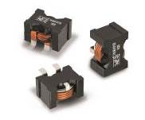  Image source: Würth Elektronik eiSos  WE-HCF high current inductor for SMT assembly | 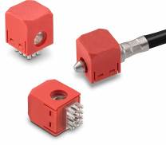  Image source: Würth Elektronik eiSos  REDCUBE terminals offer highly reliable high-current connections on printed circuit boards.

About Würth Elektronik eiSos GmbH & Co. KG
Würth Elektronik eiSos GmbH & Co. KG is a manufacturer of electronic and electromechanical components for the electronics industry. Production sites in Europe, Asia and North America supply a growing number of customers worldwide. The product program encompasses EMC components, inductors, transformers, HF components, varistors, capacitors, power modules, LEDs, plug connectors, power supply elements, wireless power coils, switches, connection technology and fuse holders. Würth Elektronik eiSos GmbH & Co. KG, together with its specialized affiliated companies, form the Würth Elektronik eiSos Group.

About the Würth Elektronik eiSos Group
Würth Elektronik eiSos GmbH & Co. KG (Focus: standard components), Würth Elektronik iBE GmbH (Focus: customized passive components for the automotive industry), Wurth Electronics Midcom Inc. (Focus: transformers and custom magnetics), Würth Elektronik Stelvio Kontek S.p.A. (Focus: customized plug connectors), AMBER wireless GmbH (Focus: wireless data transmission solutions) and IQD Frequency Products Ltd (Focus: frequency-control components) form the Würth Elektronik eiSos Group. The group of companies with 6,700 employees generated sales of approx. € 653 million in 2017. The Würth Elektronik eiSos Group is one of the biggest European manufacturers of passive components and operates in 50 countries.
Through its technology partnership with the Audi Sport ABT Schaeffler Formula E Team and its support for the Formula E racing series, the Group demonstrates its innovative strength in eMobility (www.we-speed-up-the-future.com). Other global growth markets, such as Energy Harvesting, Internet of Things and Wireless Communication, are addressed with innovative products.
The Würth Elektronik eiSos Group is part of the Würth Group, the world market leader for assembly and fastening technology.
Würth Elektronik: more than you expect!
Further info at www.we-online.com

More information:  Würth Elektronik eiSos GmbH & Co. KG  Sarah Hurst  Max-Eyth-Strasse 1  74638 Waldenburg  Germany  Phone: +49 7942 945-5186  E-mail: sarah.hurst@we-online.de  www.we-online.de | Press contact:  HighTech communications GmbH  Brigitte Basilio  Brunhamstrasse 21  81249 Munich  Germany  Phone: +49 89 500778-20  Telefax: +49 89 500778-77  E-mail: b.basilio@htcm.de  www.htcm.de

