PRESS RELEASE

Würth Elektronik eiSos presents its 2018 Product Catalog
New & Innovative Passive Components
Waldenburg (Germany), 13 February 2018 – Over 1000 pages long, the new “Passive Components 2018” catalog is now available from Würth Elektronik eiSos. The manufacturer of electronic and electromechanical components presents its broad and significantly extended range in the categories of EMC Components, Power Magnetics and Signal & Communications – some of which are AEC-Q200 qualified. All the products listed in the catalog are available from stock, also as free samples. The catalog can be requested via www.we-online.com/newcatalog.
The new products in the field of EMC components in the 2018 catalog include additions to the TVS diode series. Extremely low capacitances and high ESD voltage stability up to ±30 kV (air/contact) make the new transient voltage suppressor diodes perfect for protecting fast data lines like USB 3.1 and their supply voltages. Among the Power Magnetics, three SMT products are in the limelight: The flat wire power inductor WE-HCF has been extended to include litz and round wire versions. Thanks to their plastic base, the high current inductors have better coplanarity and higher mechanical stability. The round wire variant is available with inductance values up to 680 μH and the litz wire variant up to 150 μH. WE-MCRI is the first double choke of its kind with molding technology: Two identical round wire-wound windings encapsulated with metal powder material produce an extremely compact component with outstanding electrical performance in conjunction with improved EMC properties. WE-MTCI is at last a double choke with different winding ratios (1:1.5; 1:2; 1:3).
Components with AEC-Q200 qualification
The Würth Elektronik eiSos product portfolio is also enhanced with an AEC-Q200 qualified series. The first high current inductor in the Q+ product range bears the name WE-CHSA. The patented component design ensures an optimally centered air gap inside the component and enables a saturation current of up to 57 A.
The 2018 catalog presents the new WE-LAN AQ series in the communication component range. Besides the standard LAN products like routers and switches, the LAN transformers are especially well suited for industrial Ethernet systems such as EtherCAT or Profinet and are characterized by a particularly high transmission range.

Available images
The following images can be downloaded from the Internet in printable quality: http://www.htcm.de/kk/wuerth

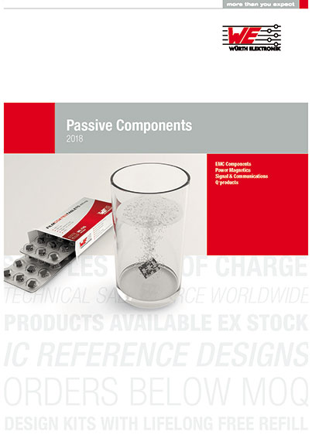
Image source: Würth Elektronik eiSos
Cover of the “Passive Components 2018” catalog.

About Würth Elektronik eiSos GmbH & Co. KG
Würth Elektronik eiSos GmbH & Co. KG is a manufacturer of electronic and electromechanical components for the electronics industry. Production sites in Europe, Asia and North America supply a growing number of customers worldwide. The product program encompasses EMC components, inductors, transformers, HF components, varistors, capacitors, power modules, LEDs, plug connectors, power supply elements, wireless power coils, switches, connection technology and fuse holders. Würth Elektronik eiSos GmbH & Co. KG, together with its specialized affiliated companies, form the Würth Elektronik eiSos Group.

About the Würth Elektronik eiSos Group
Würth Elektronik eiSos GmbH & Co. KG (Focus: standard components), Würth Elektronik iBE GmbH (Focus: customized passive components for the automotive industry), Wurth Electronics Midcom Inc. (Focus: transformers and custom magnetics), Würth Elektronik Stelvio Kontek S.p.A. (Focus: customized plug connectors), AMBER wireless GmbH (Focus: wireless data transmission solutions) and IQD Frequency Products Ltd (Focus: frequency-control components) form the Würth Elektronik eiSos Group. The group of companies with 6,700 employees generated sales of approx. € 653 million in 2017. The Würth Elektronik eiSos Group is one of the biggest European manufacturers of passive components and operates in 50 countries.
Through its technology partnership with the Audi Sport ABT Schaeffler Formula E Team and its support for the Formula E racing series, the Group demonstrates its innovative strength in eMobility (www.we-speed-up-the-future.com). Other global growth markets, such as Energy Harvesting, Internet of Things and Wireless Communication, are addressed with innovative products.
The Würth Elektronik eiSos Group is part of the Würth Group, the world market leader for assembly and fastening technology.
Würth Elektronik: more than you expect!
Further info at www.we-online.com

More information:  Würth Elektronik eiSos GmbH & Co. KG  Sarah Hurst  Max-Eyth-Strasse 1  74638 Waldenburg  Germany  Phone: +49 7942 945 5186  E-mail: sarah.hurst@we-online.de  www.we-online.de | Press contact:  HighTech communications GmbH  Brigitte Basilio  Brunhamstrasse 21  81249 Munich  Germany  Phone: +49-89-500778-20  Telefax: +49-89-500778-77  E-mail: b.basilio@htcm.de  www.htcm.de

