PRESS RELEASE

New Finished Magnetic Components Catalog from Wurth Electronics Midcom Released
Watertown (USA), 11 January 2018 – Released to the public in December 2017, Wurth Electronics Midcom is proud to announce the publication of the newest Finished Magnetic Components Catalog. The 2018 Finished Magnetic Components Catalog is the first edition from Wurth Electronics Midcom, and includes all finished transformer and toroid series available in our online catalog.
This comprehensive catalog includes all finished components for signal and communications, power magnetics, and EMC components.
This catalog also includes descriptions of products, including characteristics about the packages and applications in which the components can be included.
Download your copy of the 2018 Finished Magnetic Components Catalog at www.we-online.com/finishedcomponentscatalog.
Free component samples can requested at www.we-online.com.

Available images
The following images can be downloaded from the Internet in printable quality: http://www.htcm.de/kk/wuerth
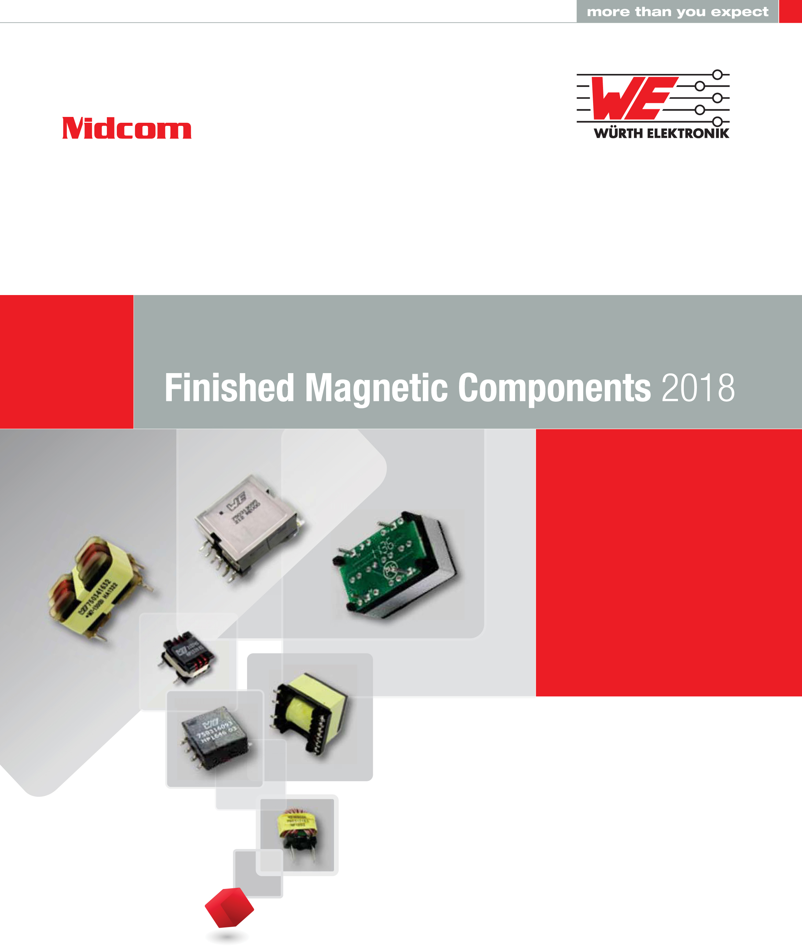
Image source:
Wurth Electronics Midcom
The newest Finished Magnetic Components Catalog is released.

About Wurth Electronics Midcom, Inc.
Wurth Electronics Midcom is a global leader in the design and manufacture of custom magnetics. A standard line of magnetics is offered, including inductors, ferrites, chokes, and EMI shielding materials. Recently, the electromechanical and interconnect line was added to the product offering, which includes Board-to-Board, Wire-to-Board, Terminal Blocks, and Input/Output Communication.
Customers in Asia, Europe and the Americas are supported through a local direct technical sales network, regional design and applications engineers and manufacturing based in the People’s Republic of China.
Our standard lines and custom-made transformers are used around the world in LED lighting, smart grid and utility metering, industrial controls, telecom (CPE and CO), home automation, and home appliances.
Wurth Electronics Midcom offers all catalog products in stock. Free samples are offered to customers on connectors and both catalog and custom magnetics.
Further information at www.we-online.com

Further information:  Wurth Electronics Midcom, Inc.  Lindsey Esche  121 Airport Drive  PO Box 1330  Watertown, SD 57201 USA  Phone: +1 605 886 4385  Toll-free (in the U.S.):  Phone: +1 800 643 2661  E-mail: lindsey.esche@we-online.com  www.we-online.com | Press contact:  HighTech communications GmbH  Brigitte Basilio  Brunhamstrasse 21  81249 Munich  Germany  Phone: +49 89 500778-20  Fax: +49 89 500778-77  E-mail: b.basilio@htcm.de  www.htcm.de

