PRESS RELEASE
Würth Elektronik eiSos establishes subsidiary in Australia
Great Success Down Under
Waldenburg (Germany), 14 March 2018 – Wurth Electronics Australia Pty was ceremonially opened in Footscray, West Melbourne on February 2, 2018. The change of the company name for the Australian sales office of Würth Elektronik eiSos is the result of the great successes on the Australian continent that the company can look back to since 2011. On the occasion of the opening ceremony, the team, currently comprised of eight staff positions received a visit from Alexander Gerfer, CTO of the Würth Elektronik eiSos Group.
The manufacturer of electronic and electromechanical components started in Australia in 2011 with one sales employee. Soon important customers were acquired, including two important manufacturers from the medical technology sector. Today the Australian team from Würth Elektronik eiSos is the world’s strongest sales driver in Wireless Power. Almost as much sales volume is generated with coils for wireless transmission from Melbourne than from Germany and the US together.
“The colleagues here really understand how to develop markets and acquire customers. The company foundation is a milestone and I wish Wurth Electronics Australia Pty continued success”, says Alexander Gerfer, CTO of the Würth Elektronik eiSos Group.
Growth course
Ruth Poon, Managing Director Wurth Electronics Australia Pty, explains: “Boosting the team with two more colleagues in March and April is already scheduled and that won’t be the end. We are a small dedicated team and we have good arguments for the customers: We offer an extremely broad portfolio of high-grade components, which we can provide directly and without minimum order quantities – something not to be taken for granted in the industry. Additionally, we can always call upon the R&D departments in Germany to develop special components for individual customer requirements. This allowed us to win over one of our big medical technology customers, for example.”

Available images
The following images can be downloaded from the Internet in printable quality: http://www.htcm.de/kk/wuerth
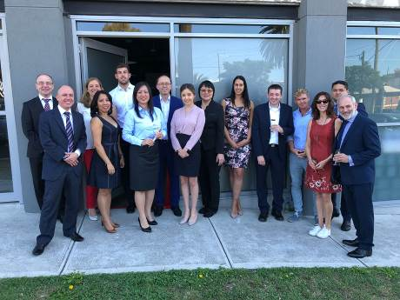  Image source:  Würth Elektronik eiSos  The team from Wurth Electronics Australia Pty and guests at the grand opening | 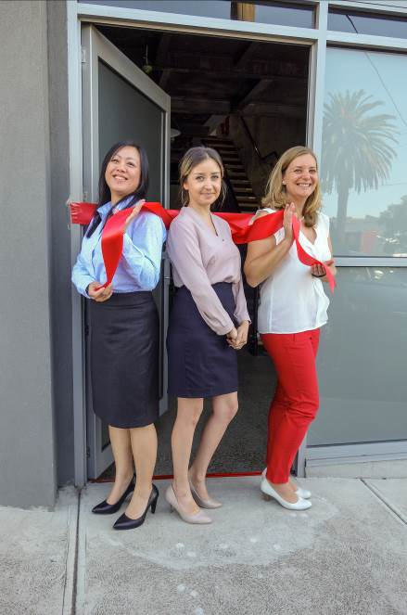IImage source:  Würth Elektronik eiSos  Subsidiary opened: The red ribbon was cut for Wurth Electronics Australia Pty (from l. to r.: Ruth Poon, Managing Director, Julia Safonova, Finance Manager, Martina Seitz, Office Manager).

About Würth Elektronik eiSos GmbH & Co. KG
Würth Elektronik eiSos GmbH & Co. KG is a manufacturer of electronic and electromechanical components for the electronics industry. Production sites in Europe, Asia and North America supply a growing number of customers worldwide. The product program encompasses EMC components, inductors, transformers, HF components, varistors, capacitors, power modules, LEDs, plug connectors, power supply elements, wireless power coils, switches, connection technology and fuse holders. Würth Elektronik eiSos GmbH & Co. KG, together with its specialized affiliated companies, form the Würth Elektronik eiSos Group.

About the Würth Elektronik eiSos Group
Würth Elektronik eiSos GmbH & Co. KG (Focus: standard components), Würth Elektronik iBE GmbH (Focus: customized passive components for the automotive industry), Wurth Electronics Midcom Inc. (Focus: transformers and custom magnetics), Würth Elektronik Stelvio Kontek S.p.A. (Focus: customized plug connectors), AMBER wireless GmbH (Focus: wireless data transmission solutions) and IQD Frequency Products Ltd (Focus: frequency-control components) form the Würth Elektronik eiSos Group. The group of companies with 6,700 employees generated sales of approx. € 653 million in 2017. The Würth Elektronik eiSos Group is one of the biggest European manufacturers of passive components and operates in 50 countries.
Through its technology partnership with the Audi Sport ABT Schaeffler Formula E Team and its support for the Formula E racing series, the Group demonstrates its innovative strength in eMobility (www.we-speed-up-the-future.com). Other global growth markets, such as Energy Harvesting, Internet of Things and Wireless Communication, are addressed with innovative products.
The Würth Elektronik eiSos Group is part of the Würth Group, the world market leader for assembly and fastening technology.
Würth Elektronik: more than you expect!
Further info at www.we-online.com

More information:  Würth Elektronik eiSos GmbH & Co. KG  Sarah Hurst  Max-Eyth-Strasse 1  74638 Waldenburg  Germany  Phone: +49 7942 945-5186  E-mail: sarah.hurst@we-online.de  www.we-online.de | Press contact:  HighTech communications GmbH  Brigitte Basilio  Brunhamstrasse 21  81249 Munich  Germany  Phone: +49 89 500778-20  Telefax: +49 89 500778-77  E-mail: b.basilio@htcm.de  www.htcm.de

