PRESS RELEASE

New G.Fast Transformers Now Available at Würth Elektronik
Watertown (USA), 11 April 2019 – Würth Elektronik is proud to announce the release of additional G.FAST transformers to the MID-DSLSCK family approved for use with Sckipio chipsets.
“These transformers cover both the 106Mhz & 212Mhz G.fast profiles and have low insertion loss over the entire frequency range, allowing data rates up to 1Gb/sec on lines less than 300 meters long”, explained Swaroop Vaidyanath, Product Manager for Telecom products at Würth Elektronik.
These low profile transformers are surface mount with maximum heights between 3.7mm and 5mm, and offer low interwinding capacitance and low insertion loss. Featuring 1875V isolation, and having an operating temperature of -40°C to 85°C, these pick-and-placeable transformers are designed to meet IEC60950-1, EN60950-1, UL60950-1/CSA60950-1 and AS/NZS60950.1 supplementary insulation with 6kV surge or functional insulation.
In addition to providing isolation, the new MID-DSLSCK transformers maintain the quality of the signal over a maximum transmission distance. These transformers enable Sckipio’s SCK1002 AFE and SCK1001 DFE chipsets to deliver high speed broadband access for G.FAST modems, present in consumer residences or CPE, Central Office (CO), distribution point units, and supporting data speeds up to 1Gb/s on phone lines or coax lines.
Free samples can be requested at www.we-online.com.

Available images
The following images can be downloaded from the Internet in printable quality: http://www.htcm.de/kk/wuerth
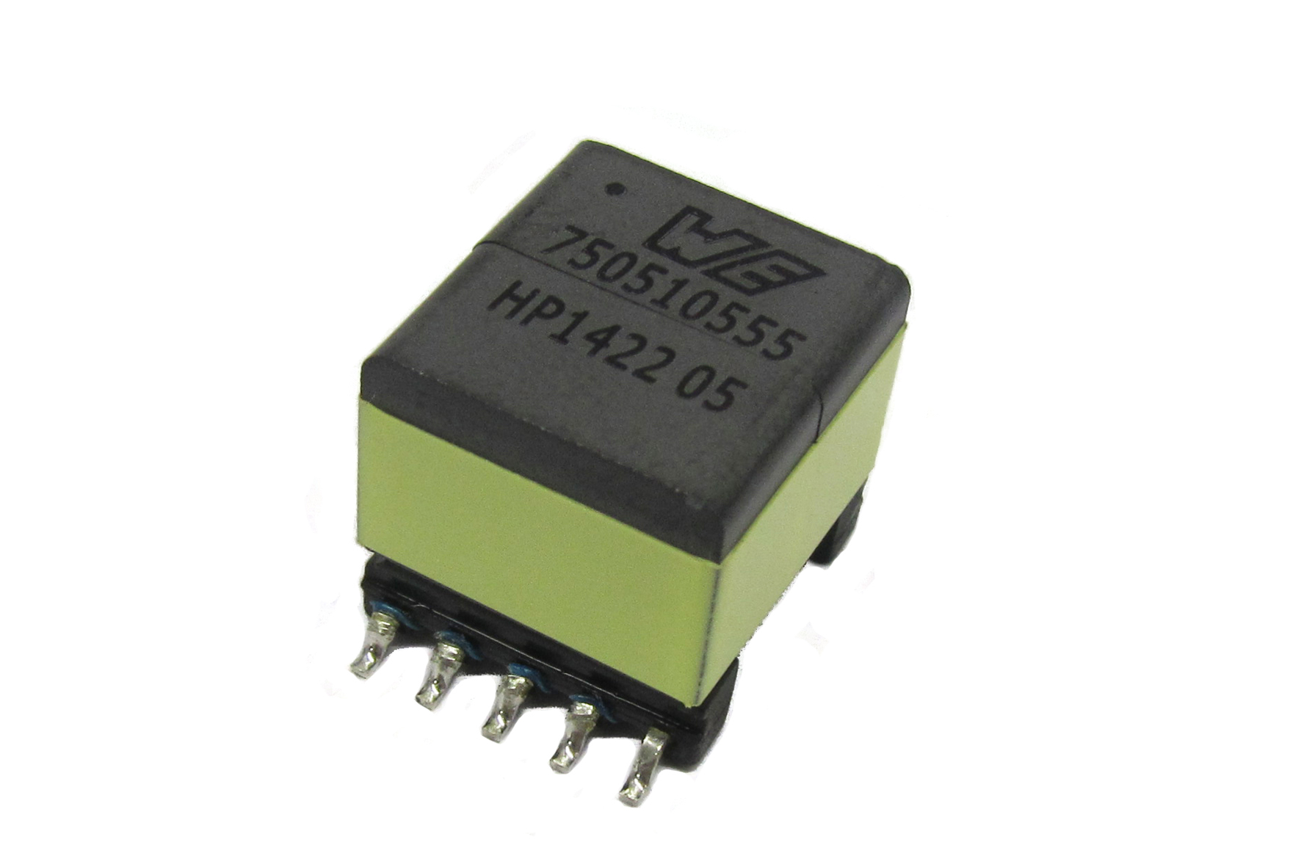
Image source: Würth Elektronik
New G.Fast Transformers now available

About Würth Elektronik eiSos Group
Würth Elektronik eiSos Group is a manufacturer of electronic and electromechanical components for the electronics industry and a technology company that spearheads pioneering electronic solutions. The company currently employs 8,300 staff and generated sales of 848 million euros in 2018. Würth Elektronik eiSos is one of the largest European manufacturers of passive components and is active in 50 countries. Production sites in Europe, Asia and North America supply a growing number of customers worldwide.
The product range includes EMC components, inductors, transformers, RF components, varistors, capacitors, resistors, quartz crystals, oscillators, power modules, Wireless Power Transfer, LEDs, sensors, connectors, power supply elements, switches, push-buttons, connection technology, fuse holders and solutions for wireless data transmission.
The unrivaled service orientation of the company is characterized by the availability of all catalog components from stock without minimum order quantity, free samples and extensive support through technical sales staff and selection tools.
Through its technology partnership with the Audi Sport ABT Schaeffler Formula E Team and its support for the Formula Student racing series, the company demonstrates its innovative strength in eMobility
(www.we-speed-up-the-future.com).
Würth Elektronik eiSos is part of the Würth Group, the world market leader for assembly and fastening technology.
Würth Elektronik: more than you expect!
Further information at www.we-online.com

Further information:  Wurth Electronics Midcom, Inc.  Lindsey Esche  121 Airport Drive  PO Box 1330  Watertown, SD 57201 USA  Phone: +1 605 886 4385  Toll-free (in the U.S.):  Phone: +1 800 643 2661  E-mail: lindsey.esche@we-online.com  www.we-online.com | Press contact:  HighTech communications GmbH  Brigitte Basilio  Brunhamstrasse 21  81249 Munich  Germany  Phone: +49 89 500778-20  Fax: +49 89 500778-77  E-mail: b.basilio@htcm.de  www.htcm.de

