PRESS RELEASE
Würth Elektronik eiSos presents further VDRM MagI³C power modules
Power Stage, Regulator and Inductor in a Robust Package
Waldenburg (Germany), 8 August 2018 – With the MagI³C VDRM, Würth Elektronik eiSos introduces a new DC/DC voltage converter in the MagI³C power module family in a TO263-7EP package. The input voltage range of the converter covers the range from 6 to 42 V to allow conversion from the 9 V, 12 V or 24 V industry bus.
The product family is expanded with two new modules for 1 A and 3 A with an adjustable output voltage in the low range of 0.8 to 6 V. The robust modules can be operated at an ambient temperature up to 105° C. They are characterized by high efficiency up to 97 percent. The easy-to-solder TO263-7EP package measures 10.16 × 13.77 × 4.57 mm. The entire product family of MagI³C VDRM power modules is available from stock. Free samples can be requested.

Available images
The following images can be downloaded from the Internet in printable quality: http://www.htcm.de/kk/wuerth
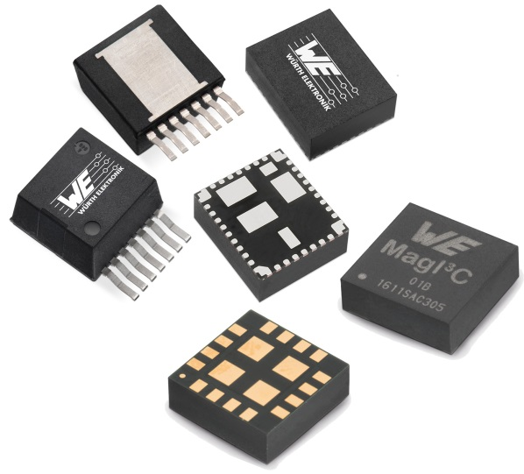
Image source: Würth Elektronik eiSos
The VDRM series of MagI³C power module family in a TO263 package realizes a fully integrated DC/DC voltage converter.

About Würth Elektronik eiSos GmbH & Co. KG
Würth Elektronik eiSos GmbH & Co. KG is a manufacturer of electronic and electromechanical components for the electronics industry. Production sites in Europe, Asia and North America supply a growing number of customers worldwide. The product program encompasses EMC components, inductors, transformers, HF components, varistors, capacitors, power modules, LEDs, wireless technology, plug connectors, power supply elements, wireless power coils, switches, connection technology and fuse holders. Würth Elektronik eiSos GmbH & Co. KG together with its specialized affiliated companies form the Würth Elektronik eiSos Group.

About the Würth Elektronik eiSos Group
Würth Elektronik eiSos GmbH & Co. KG (Focus: standard components), Würth Elektronik iBE GmbH (Focus: customized passive components for the automotive industry), Wurth Electronics Midcom Inc. (Focus: transformers and custom magnetics), Würth Elektronik Stelvio Kontek S.p.A. (Focus: customized plug connectors) and IQD Frequency Products Ltd (Focus: frequency-producing devices) form the Würth Elektronik eiSos Group. The former subsidiary AMBER wireless GmbH with a focus on solutions for wireless data transmission became the Wireless Connectivity and Sensors division of Würth Elektronik eiSos GmbH & Co. KG in 2018. The group of companies with 6,700 employees generated sales of approx. € 653 million in 2017. The Würth Elektronik eiSos Group is one of the biggest European manufacturers of passive components and operates in 50 countries.
Through its technology partnership with the Audi Sport ABT Schaeffler Formula E Team and its support for the Formula E racing series, the Group demonstrates its innovative strength in eMobility
(www.we-speed-up-the-future.com). Other global growth markets, such as Energy Harvesting, Internet of Things and Wireless Communication, are addressed with innovative products.
The Würth Elektronik eiSos Group is part of the Würth Group, the world market leader for assembly and fastening technology.
Würth Elektronik: more than you expect!
Further info at www.we-online.com

More information:  Würth Elektronik eiSos GmbH & Co. KG  Sarah Hurst  Max-Eyth-Strasse 1  74638 Waldenburg  Germany  Phone: +49 7942 945-5186  E-mail: sarah.hurst@we-online.de  www.we-online.de | Press contact:  HighTech communications GmbH  Brigitte Basilio  Brunhamstrasse 21  81249 Munich  Germany  Phone: +49 89 500778-20  Telefax: +49 89 500778-77  E-mail: b.basilio@htcm.de  www.htcm.de

