PRESS RELEASE
Cooperation between Würth Elektronik eiSos and Modelithics
WE-KI HC and WE-CAIR Inductive Component Series in Simulation
Waldenburg (Germany), 22 March 2018 – As part of their Microwave Global Models™ cooperation, Würth Elektronik eiSos and Modelithics make two more Würth Elektronik eiSos product series available. This means that developers can simulate the high frequency response of WE-KI HC high current ceramic inductors and the WE-CAIR air coils in models. The models offer advanced functions to improve accuracy and to accelerate HF simulations: scalable parameters for substrate properties, pad dimensions and inductance values. The models are compatible with numerous EDA tuning and optimization tools
The new Modelithics Microwave Global Models™ are available for WE-KI-HC series 0402 and 0603, which cover the inductance values from 1.0 to 51 nH and 1.8 to 390 nH. Moreover, five WE-CAIR air coil series are modeled: 1322, 1340, 3136, 3168 and 4248, which together cover inductance values from 1.65 nH to 120 nH. All models are validated up to 30 GHz. The models were developed to provider RF developers with a powerful analysis function and very accurate simulations in the first run.
The inductor models are created for seamless integration in common design tools like Keysight ADS and Genesys, NI AWR Design Environment, ANSYS HFSS and Sonnet Suites. Würth Elektronik eiSos, as a Modelithics Vendor Partner, sponsors free 90-day tests of the component models, which are available from Modelithics at www.modelithics.com/MVP/Wurth. More information on WE-KI-HC is available here and on WE-CAIR here. The components are available at any time in any quantities from stock, free samples can be requested.

Available images
The following images can be downloaded from the Internet in printable quality: http://www.htcm.de/kk/wuerth
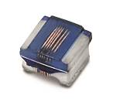  Image source:  Würth Elektronik eiSos  WE-KI HC high current ceramic inductors | 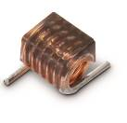  Image source:  Würth Elektronik eiSos  WE-CAIR air coils

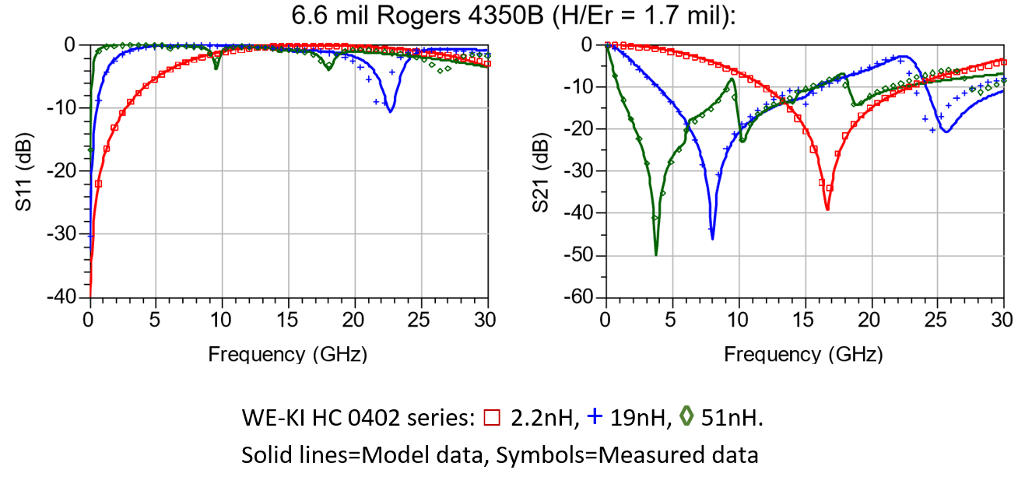

Image source: Würth Elektronik eiSos
Model and measurement data in direct comparison

About Modelithics, Inc.
Modelithics, Inc. (www.Modelithics.com) was founded in 2001 to address the industry-wide demand for high precision active and passive RF and microwave simulation models for use in Electronic Design Automation (EDA). Modelithics’ premium product is Modelithics® COMPLETE Library, which contains the CLR Library™ with measurement-based Microwave Global Models™ for a wide range of commercially available passive component families, as well as the NLD Library™ (non-linear diode models), the NLT Library™ (non-linear transistor models) and the SLC Library™ (component models on the system level). The services from Modelithics cover a wealth of customer-specific requirements for HF and microwave measurement and modeling. The Modelithics Vendor Partner Program enables cooperation and open communication during the development of advanced data records and models for commercially available microwave components and devices.
About Würth Elektronik eiSos GmbH & Co. KG
Würth Elektronik eiSos GmbH & Co. KG is a manufacturer of electronic and electromechanical components for the electronics industry. Production sites in Europe, Asia and North America supply a growing number of customers worldwide. The product program encompasses EMC components, inductors, transformers, HF components, varistors, capacitors, power modules, LEDs, plug connectors, power supply elements, wireless power coils, switches, connection technology and fuse holders. Würth Elektronik eiSos GmbH & Co. KG, together with its specialized affiliated companies, form the Würth Elektronik eiSos Group.

About the Würth Elektronik eiSos Group
Würth Elektronik eiSos GmbH & Co. KG (Focus: standard components), Würth Elektronik iBE GmbH (Focus: customized passive components for the automotive industry), Wurth Electronics Midcom Inc. (Focus: transformers and custom magnetics), Würth Elektronik Stelvio Kontek S.p.A. (Focus: customized plug connectors), AMBER wireless GmbH (Focus: wireless data transmission solutions) and IQD Frequency Products Ltd (Focus: frequency-control components) form the Würth Elektronik eiSos Group. The group of companies with 6,700 employees generated sales of approx. € 653 million in 2017. The Würth Elektronik eiSos Group is one of the biggest European manufacturers of passive components and operates in 50 countries.
Through its technology partnership with the Audi Sport ABT Schaeffler Formula E Team and its support for the Formula E racing series, the Group demonstrates its innovative strength in eMobility (www.we-speed-up-the-future.com). Other global growth markets, such as Energy Harvesting, Internet of Things and Wireless Communication, are addressed with innovative products.
The Würth Elektronik eiSos Group is part of the Würth Group, the world market leader for assembly and fastening technology.
Würth Elektronik: more than you expect!
Further info at www.we-online.com
More information:  Würth Elektronik eiSos GmbH & Co. KG  Sarah Hurst  Max-Eyth-Strasse 1  74638 Waldenburg  Germany  Phone: +49 7942 945-5186  E-mail: sarah.hurst@we-online.de  www.we-online.de | Press contact:  HighTech communications GmbH  Brigitte Basilio  Brunhamstrasse 21  81249 Munich  Germany  Phone: +49 89 500778-20  Telefax: +49 89 500778-77  E-mail: b.basilio@htcm.de  www.htcm.de

