PRESS RELEASE

Würth Elektronik eiSos opens subsidiary in Slovenia
On Course for Growth in Central Europe
Waldenburg (Germany), 23 January 2019 – Continuous double-digit growth and most favorable prospects for the future were essential for the expansion of Würth Elektronik eiSos. The manufacturer of electronic and electromechanical components has founded a subsidiary in Slovenia. In Trbovlje, 60 km east of Ljubljana, nine employees serve the Slovenian market and a growing number of customers in Croatia and Serbia.
The managing director of the new Würth Elektronik eiSos subsidiary is Matjaž Popotnik who, as the first sales representative, has grown business for Würth Elektronik eiSos in Slovenia since 2012. The team in Slovenia supports local electronics developers with technical solutions, free samples and high availability of components.
After opening a subsidiary in Israel in 2018, Slovenia is the second spin-off from the Würth Elektronik eiSos Group within a short period. This clearly illustrates the increasingly international focus of Würth Elektronik eiSos and the success the company has in the process.

Available images
The following images can be downloaded from the Internet in printable quality: http://www.htcm.de/kk/wuerth

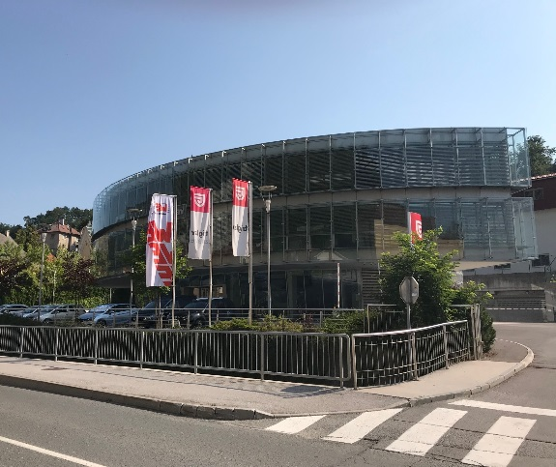  Image source:  Würth Elektronik eiSos  Würth Elektronik eiSos subsidiary in Slovenia | 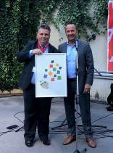  Image source:  Würth Elektronik eiSos  Thomas Schrott, CEO, and Matjaž Popotnik, managing director of the new Würth Elektronik eiSos subsidiary (both Würth Elektronik eiSos), while handing over a present from Gaisbach

About Würth Elektronik eiSos
Würth Elektronik eiSos GmbH & Co. KG is a manufacturer of electronic and electromechanical components for the electronics industry. In 2017, the company employed 6 700 people. Würth Elektronik eiSos is one of the largest European manufacturers of passive components and is active in 50 countries. Production sites in Europe, Asia and North America supply a growing number of customers worldwide.
The product range includes EMC components, inductors, transformers, RF components, varistors, capacitors, resistors, quartz crystals, oscillators, power modules, Wireless Power Transfer, LEDs, sensors, connectors, power supply elements, switches, push-buttons, connection technology, fuse holders and solutions for wireless data transmission.
Through its technology partnership with the Audi Sport ABT Schaeffler Formula E Team and its support for the Formula E racing series, the company demonstrates its innovative strength in eMobility
(www.we-speed-up-the-future.com).
Würth Elektronik eiSos is part of the Würth Group, the world market leader for assembly and fastening technology.
Würth Elektronik: more than you expect!
Further information at www.we-online.com

Further information:  Würth Elektronik eiSos GmbH & Co. KG  Sarah Hurst  Max-Eyth-Strasse 1  74638 Waldenburg  Germany  Phone: +49 7942 945-5186  E-mail: sarah.hurst@we-online.de  www.we-online.de | Press contact:  HighTech communications GmbH  Brigitte Basilio  Brunhamstrasse 21  81249 Munich  Germany  Phone: +49 89 500778-20  Telefax: +49 89 500778-77  E-mail: b.basilio@htcm.de  www.htcm.de

