MEDIA INFORMATION
Würth Elektronik eiSos distributes further products via Digi-Key
Now Wireless Connectivity Too
Waldenburg, August 16, 2018 – The global electronics distributor Digi-Key is a longstanding distribution partner of Würth Elektronik eiSos. Digi-Key now distributes another product group from the Würth Elektronik eiSos range: wireless modules. The product range encompasses highly efficient wireless transmission solutions in the Bluetooth or Wireless M-Bus standard as well as proprietary wireless modules in the frequency ranges 169, 433, 868, 915 MHz and 2.4 GHz. Thanks to their low power consumption, these high-quality, compact components are ideal solutions for decentralized IoT and smart metering applications.
Digi-Key is supplied by the Würth Elektronik eiSos “Wireless Connectivity and Sensors” division. This strategic business unit was formed at the beginning of April 2018 through the integration of the previously autonomous subsidiary Amber wireless GmbH. This formation made Würth Elektronik eiSos, a manufacturer of components, also a dependable partner for low-power ISM/SRD wireless solutions worldwide. Here the Wireless Team contributes two decades of experience in the development of wireless solutions to the newly founded division.
New products for longstanding partner
“Digi-Key is excited to continue to expand the Würth Elektronik portfolio into the wireless modules space” says David Stein, Vice President, Global Supplier Management at Digi-Key. “These products will bolster our offering of Bluetooth products, radios and M-Bus technologies. We look forward to serving the global engineering community with this exciting technology.”
Lars Fahrbach, Executive and responsible for the field of Global Distribution & New Markets, is convinced that Digi-Key, together with Würth Elektronik eiSos, will advance the new Wireless Connectivity product line: “Digi-Key’s global presence and excellent added values and services enable us to make our wireless modules accessible to an even broader audience.”

Available images
The following images can be downloaded from the Internet in printable quality: http://www.htcm.de/kk/wuerth
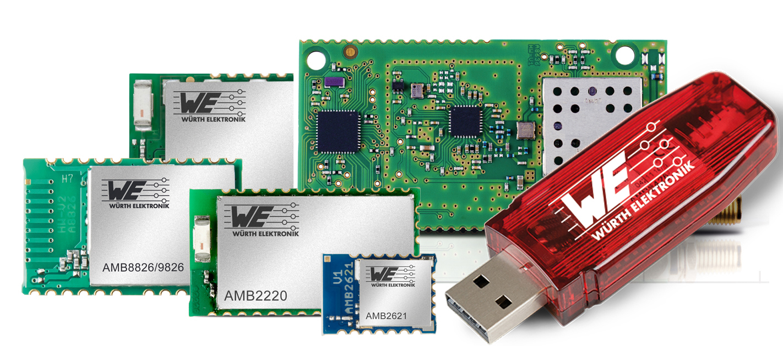
Image source: Würth Elektronik eiSos
Würth Elektronik eiSos now distributes its wireless data transmission solutions via the Digi-Key Electronics.

About Digi-Key Electronics
Digi-Key Electronics, headquartered in Thief River Falls (Minnesota, USA), is an authorized global distributor of electronic components offering over 6 million products from more than 650 renowned brand manufacturers of which over 1.3 million products are immediately available from stock. Furthermore, Digi-Key offers a wealth of online resources, such as EDA and design tools, data sheets, reference designs, informative articles and videos, multimedia libraries and much more besides. Technical Customer Support is available daily around the clock via e-mail, phone and web chat.
Further information: www.digikey.de

About Würth Elektronik eiSos GmbH & Co. KG
Würth Elektronik eiSos GmbH & Co. KG is a manufacturer of electronic and electromechanical components for the electronics industry. Production sites in Europe, Asia and North America supply a growing number of customers worldwide. The product program encompasses EMC components, inductors, transformers, HF components, varistors, capacitors, power modules, LEDs, wireless technology, plug connectors, power supply elements, wireless power coils, switches, connection technology and fuse holders. Würth Elektronik eiSos GmbH & Co. KG together with its specialized affiliated companies form the Würth Elektronik eiSos Group.

About the Würth Elektronik eiSos Group
Würth Elektronik eiSos GmbH & Co. KG (Focus: standard components), Würth Elektronik iBE GmbH (Focus: customized passive components for the automotive industry), Wurth Electronics Midcom Inc. (Focus: transformers and custom magnetics), Würth Elektronik Stelvio Kontek S.p.A. (Focus: customized plug connectors) and IQD Frequency Products Ltd (Focus: frequency-producing devices) form the Würth Elektronik eiSos Group. The former subsidiary AMBER wireless GmbH with a focus on solutions for wireless data transmission became the Wireless Connectivity and Sensors division of Würth Elektronik eiSos GmbH & Co. KG in 2018. The group of companies with 6,700 employees generated sales of approx. € 653 million in 2017. The Würth Elektronik eiSos Group is one of the biggest European manufacturers of passive components and operates in 50 countries.
Through its technology partnership with the Audi Sport ABT Schaeffler Formula E Team and its support for the Formula E racing series, the Group demonstrates its innovative strength in eMobility
(www.we-speed-up-the-future.com). Other global growth markets, such as Energy Harvesting, Internet of Things and Wireless Communication, are addressed with innovative products.
The Würth Elektronik eiSos Group is part of the Würth Group, the world market leader for assembly and fastening technology.
Würth Elektronik: more than you expect!
Further info at www.we-online.com

More information:  Würth Elektronik eiSos GmbH & Co. KG  Sarah Hurst  Max-Eyth-Strasse 1  74638 Waldenburg  Germany  Phone: +49 7942 945-5186  E-mail: sarah.hurst@we-online.de  www.we-online.de | Press contact:  HighTech communications GmbH  Brigitte Basilio  Brunhamstrasse 21  81249 Munich  Germany  Phone: +49 89 500778-20  Telefax: +49 89 500778-77  E-mail: b.basilio@htcm.de  www.htcm.de

