PRESS RELEASE
Würth Elektronik eiSos distributes products via Farnell
Source of Supply for Low-power Wireless Solutions
Waldenburg (Germany), 20 June 2018 – Würth Elektronik eiSos now distributes its wireless data transmission solutions via the Farnell Group. The manufacturer of electronic and electromechanical components thus entrusts this product segment to an experienced distributor of the former Amber wireless GmbH. Amber wireless GmbH became fully integrated in the Würth Elektronik eiSos Group as of 1 April 2018 and now forms the core of the new Wireless Connectivity and Sensors division.
“The good experience with Farnell offers the best credentials for continued successful collaboration in the field of our newly formed Wireless Connectivity & Sensors division,” says Patrick Becker, Head of Sales at the Wireless Connectivity and Sensors division. “We are pleased to have a strong channel partner in Farnell.” Ross Murgatroyd, Senior Global Product Manager at Premier Farnell is delighted to announce the portfolio expansion of RF products from Würth Elektronik eiSos: “This adds tremendous value and increased choice for our customers who are looking to accelerate development efforts and reduce time-to-market.”
The integration of Amber wireless makes Würth Elektronik eiSos a reliable partner for low-power ISM/SRD wireless solutions worldwide. The portfolio encompasses highly efficient wireless modules in the Bluetooth and Wireless M-Bus standards, as well as proprietary ones in the frequency ranges 169 MHz, 433 MHz, 868 MHz, 915 MHz and 2.4 GHz.

Available images
The following images can be downloaded from the Internet in printable quality: http://www.htcm.de/kk/wuerth
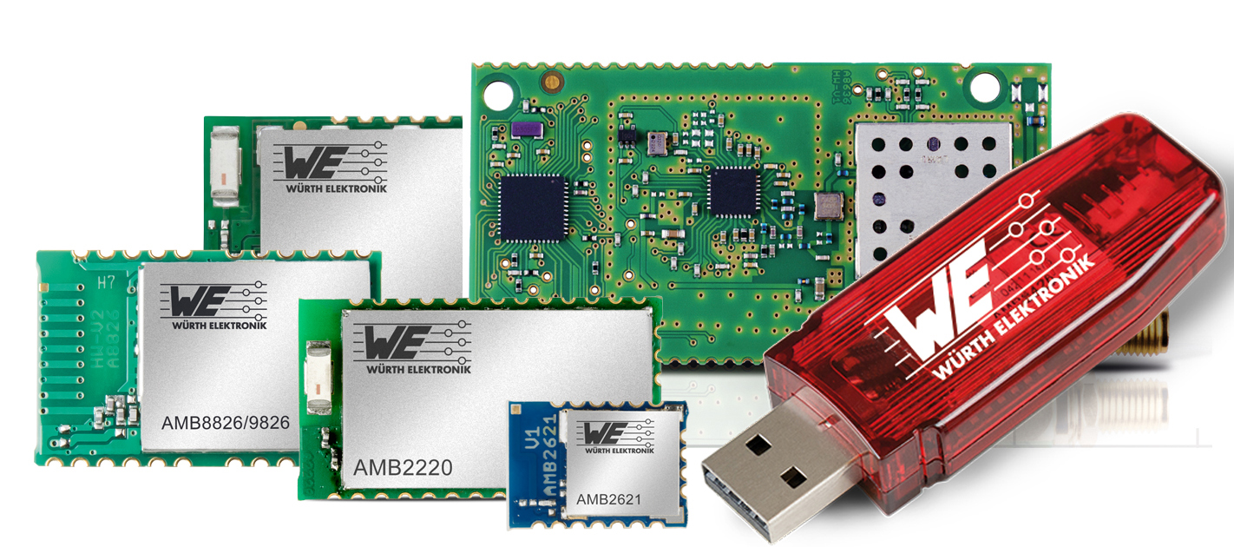
Image source: Würth Elektronik eiSos
Würth Elektronik eiSos now distributes its wireless data transmission solutions via the Farnell Group.

About Farnell Group
Premier Farnell is a business unit within Avnet, Inc., (NYSE: AVT). Premier Farnell acts as Farnell element14 in Europe, as Newark element14 in North America and as Element14 in the Asia-Pacific region. Farnell element14 is a high service distributor of technology products, services and solutions for electronic system development, maintenance and repair. Farnell element14 operates sites throughout Europe which are supported by regional distribution centers in Great Britain and Belgium.
More information at http://de.farnell.com/

About Würth Elektronik eiSos GmbH & Co. KG
Würth Elektronik eiSos GmbH & Co. KG is a manufacturer of electronic and electromechanical components for the electronics industry. Production sites in Europe, Asia and North America supply a growing number of customers worldwide. The product program encompasses EMC components, inductors, transformers, HF components, varistors, capacitors, power modules, LEDs, wireless technology, plug connectors, power supply elements, wireless power coils, switches, connection technology and fuse holders. Würth Elektronik eiSos GmbH & Co. KG together with its specialized affiliated companies form the Würth Elektronik eiSos Group.

About the Würth Elektronik eiSos Group
Würth Elektronik eiSos GmbH & Co. KG (Focus: standard components), Würth Elektronik iBE GmbH (Focus: customized passive components for the automotive industry), Wurth Electronics Midcom Inc. (Focus: transformers and custom magnetics), Würth Elektronik Stelvio Kontek S.p.A. (Focus: customized plug connectors) and IQD Frequency Products Ltd (Focus: frequency-producing devices) form the Würth Elektronik eiSos Group. The former subsidiary AMBER wireless GmbH with a focus on solutions for wireless data transmission became the Wireless Connectivity and Sensors division of Würth Elektronik eiSos GmbH & Co. KG in 2018. The group of companies with 6,700 employees generated sales of approx. € 653 million in 2017. The Würth Elektronik eiSos Group is one of the biggest European manufacturers of passive components and operates in 50 countries.
Through its technology partnership with the Audi Sport ABT Schaeffler Formula E Team and its support for the Formula E racing series, the Group demonstrates its innovative strength in eMobility
(www.we-speed-up-the-future.com). Other global growth markets, such as Energy Harvesting, Internet of Things and Wireless Communication, are addressed with innovative products.
The Würth Elektronik eiSos Group is part of the Würth Group, the world market leader for assembly and fastening technology.
Würth Elektronik: more than you expect!
Further info at www.we-online.com

More information:  Würth Elektronik eiSos GmbH & Co. KG  Regina Fingerhut  Max-Eyth-Strasse 1  74638 Waldenburg  Germany  Phone: +49 89 242936-101  E-Mail: regina.fingerhut@we-online.de  www.we-online.com | Press contact:  HighTech communications GmbH  Brigitte Basilio  Brunhamstrasse 21  81249 Munich  Germany  Phone: +49 89 500778-20  Telefax: +49 89 500778-77  E-Mail: b.basilio@htcm.de  www.htcm.de

