PRESS RELEASE
Success for the Würth Elektronik eiSos eRacing technology partnership
University of Nottingham eMotorbike Picks up 2nd Place in the Isle of Man TT Zero Cup
Waldenburg (Germany), 26 June 2018 – The electric super bike from the student developer team at the University of Nottingham won second place in the all-electric TT Zero Cup at the legendary Tourist Trophy motorcycle race on the Isle of Man. On the 60.73 km circuit, with a lap time of 18:58:294 minutes and an average speed of 191 km/h, Daley Mathison finished just 24 seconds behind Michael Rutter from Team Mugen Honda.
What makes this ranking so valuable: The team from the University of Nottingham (UoN Super Bike) is the only student/professor team among professional corporate teams. In Würth Elektronik eiSos, UoN Super Bike has a technology partner highly committed to promoting electromobility.
Representatives of the Würth Elektronik eiSos technology partner followed the race in fever-pitch excitement together with its UoN Super Bike team. They were justifiably proud when the rider Daley Mathison received the laurel wreath and Silver Lady trophy on the podium from His Royal Highness Prince William. Prince William visited the student racing team in the garage where he was shown the impressive eMotorbike. The 280 kg bike accelerates from 0 to 100 km/h in 2.2 seconds, attains a top speed of 287 km/h, and a maximum torque of 1,200 Nm. The team managed to improve on the previous best times at the TT Zero Cup.
Cooperation and technology partner Würth Elektronik eiSos
Several particularly robust and high-performance passive components from Würth Elektronik eiSos are already installed in the current version of the electric motorbike.
“The electric super bike team receives all the support it needs from us in terms of components and expertise,” says Alexander Gerfer, CTO of the Würth Elektronik eiSos Group. “We have been active since the inception of the Formula E racing series and we are a technology partner of the Audi Sport ABT Schaeffler Formula E team. All the more reason for the motorbike fans among us in particular to take pleasure in supporting the team from the University of Nottingham - another innovative eRacing team - in pioneering developments in the field of electromobility and such a successful one at that. Congratulations!” Technology partnerships in eRacing form a pillar for Würth Elektronik eiSos in its wide-ranging commitment to eMobility, and one the manufacturer of electronic and electromechanical components has adopted as its credo.

Available images
The following images can be downloaded from the Internet in printable quality: http://www.htcm.de/kk/wuerth
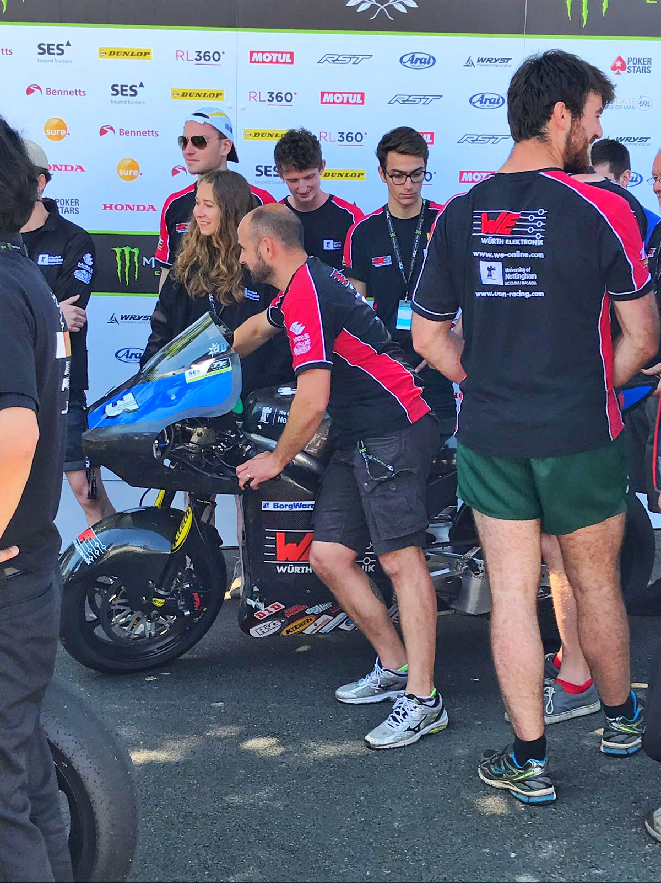  Image source: Würth Elektronik eiSos  The electric super bike from a student developer team at the University of Nottingham achieved second place in the TT Zero Cup on the legendary Isle of Man course. | 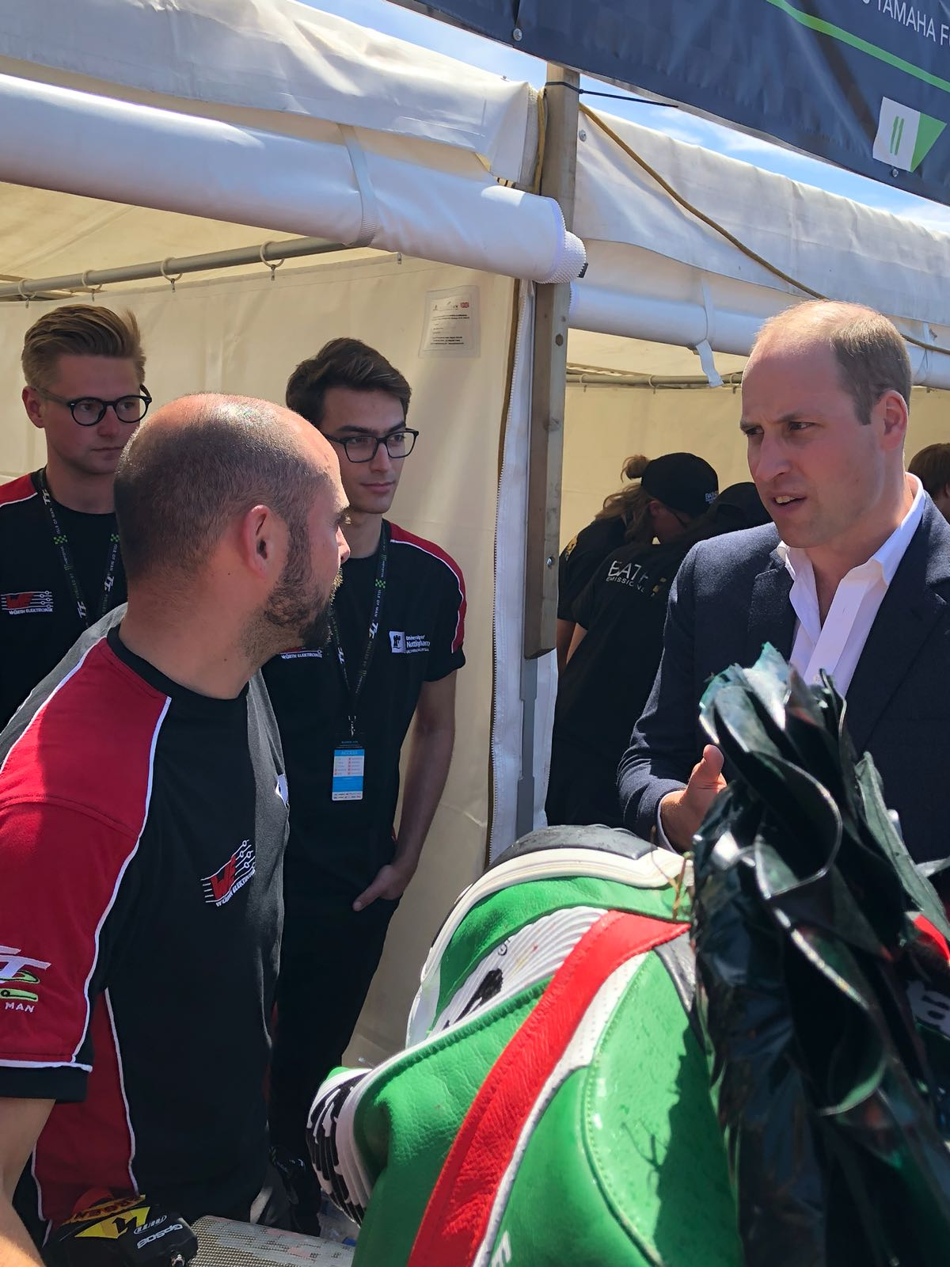  Image source: Würth Elektronik eiSos  His Royal Highness Prince William in conversation with Professor Miquel Gimeno-Fabra (UoN)

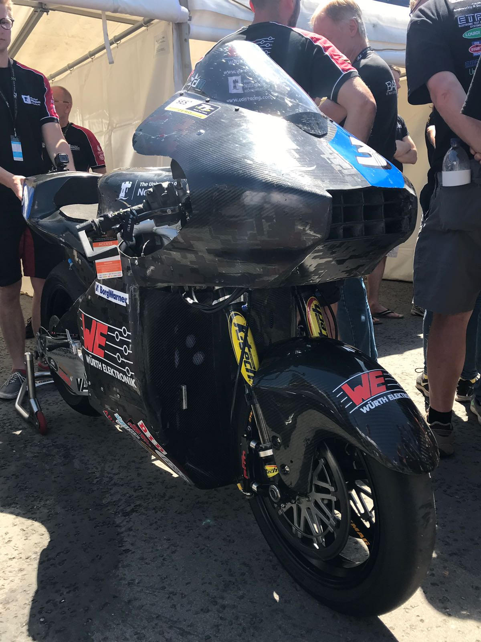  Image source:  Würth Elektronik eiSos  The eMotorbike from the University of Nottingham with a torque of 1,200 Nm! | 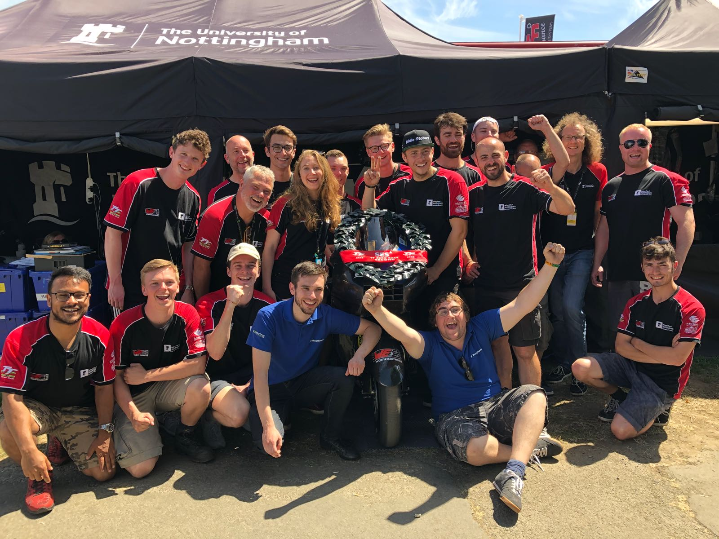  Image source:  Würth Elektronik eiSos  The engineers are proud to have achieved 2nd place.

About Würth Elektronik eiSos GmbH & Co. KG
Würth Elektronik eiSos GmbH & Co. KG is a manufacturer of electronic and electromechanical components for the electronics industry. Production sites in Europe, Asia and North America supply a growing number of customers worldwide. The product program encompasses EMC components, inductors, transformers, HF components, varistors, capacitors, power modules, LEDs, wireless technology, plug connectors, power supply elements, wireless power coils, switches, connection technology and fuse holders. Würth Elektronik eiSos GmbH & Co. KG together with its specialized affiliated companies form the Würth Elektronik eiSos Group.

About the Würth Elektronik eiSos Group
Würth Elektronik eiSos GmbH & Co. KG (Focus: standard components), Würth Elektronik iBE GmbH (Focus: customized passive components for the automotive industry), Wurth Electronics Midcom Inc. (Focus: transformers and custom magnetics), Würth Elektronik Stelvio Kontek S.p.A. (Focus: customized plug connectors) and IQD Frequency Products Ltd (Focus: frequency-producing devices) form the Würth Elektronik eiSos Group. The former subsidiary AMBER wireless GmbH with a focus on solutions for wireless data transmission became the Wireless Connectivity and Sensors division of Würth Elektronik eiSos GmbH & Co. KG in 2018. The group of companies with 6,700 employees generated sales of approx. € 653 million in 2017. The Würth Elektronik eiSos Group is one of the biggest European manufacturers of passive components and operates in 50 countries.
Through its technology partnership with the Audi Sport ABT Schaeffler Formula E Team and its support for the Formula E racing series, the Group demonstrates its innovative strength in eMobility
(www.we-speed-up-the-future.com). Other global growth markets, such as Energy Harvesting, Internet of Things and Wireless Communication, are addressed with innovative products.
The Würth Elektronik eiSos Group is part of the Würth Group, the world market leader for assembly and fastening technology.
Würth Elektronik: more than you expect!
Further info at www.we-online.com

More information:  Würth Elektronik eiSos GmbH & Co. KG  Sarah Hurst  Max-Eyth-Strasse 1  74638 Waldenburg  Germany  Phone: +49 7942 945-5186  E-mail: sarah.hurst@we-online.de  www.we-online.de | Press contact:  HighTech communications GmbH  Brigitte Basilio  Brunhamstrasse 21  81249 Munich  Germany  Phone: +49 89 500778-20  Telefax: +49 89 500778-77  E-mail: b.basilio@htcm.de  www.htcm.de

