PRESS RELEASE
Würth Elektronik eiSos: New firmware for Bluetooth Low Energy Module AMB2621-TR
Faster and Fully Individualizable
Waldenburg (Germany), 12 July 2018 – The Wireless Connectivity and Sensors division at Würth Elektronik eiSos GmbH & Co. KG presents firmware version 3.4.0 for the Bluetooth Module AMB2621-TR. The most important new feature is the increase in the UART (Universal Asynchronous Receiver Transmitter) baud rate. The speed of the module’s device-side interface has more than doubled the maximum data throughput from 36 kbps to 80 kbps. The newly introduced UART flow control at the same time guarantees that no data packets get lost on the UART. The data throughput of 80 kbps can be achieved with a single BLE (Bluetooth Low Energy) packet per connection interval and is therefore compatible with all BLE 4.2 devices on the market. Further improvements relate to how the module presents itself in wireless communication – customers now have maximum freedom to adapt the identification of their application’s wireless interface.
Manufacturers that make their products Bluetooth-enabled using the Bluetooth Smart Module AMB2621-TR can now completely determine how it appears to the communication partner. This starts with its appearance, i.e. the device name and icon displayed to the user in the list of possible Bluetooth connections. An additional profile can be added with the Device Information Service (DIS) to make more of the device’s information available through the wireless connection – for example the name of the device manufacturer or the serial number.
Selectable UUID (Universally Unique Identifier)
The AMB2621-TR BLE wireless module with dimensions of only 11 x 8 x 1.8 mm has something which is actually no longer part of the Bluetooth Low Energy standard: The serial port profile (SPP) to emulate a serial cable connection. Data transmission is enabled with the AMBER SPP-like profile, which is based on the optional Bluetooth 4.2 feature “data length extension” and increases the data throughput. Users can make this BLE profile their own by assigning their own UUID, for example to register the profile with the Bluetooth Special Interest Group (SIG). Würth Elektronik eiSos further supports customers with the individualization of their own firmware.
The firmware version 3.4.0 for AMB2621-TR (art. no. 2608011024000) is now available for updating, which can be done wireless by using a smartphone.

Available images
The following images can be downloaded from the Internet in printable quality: http://www.htcm.de/kk/wuerth
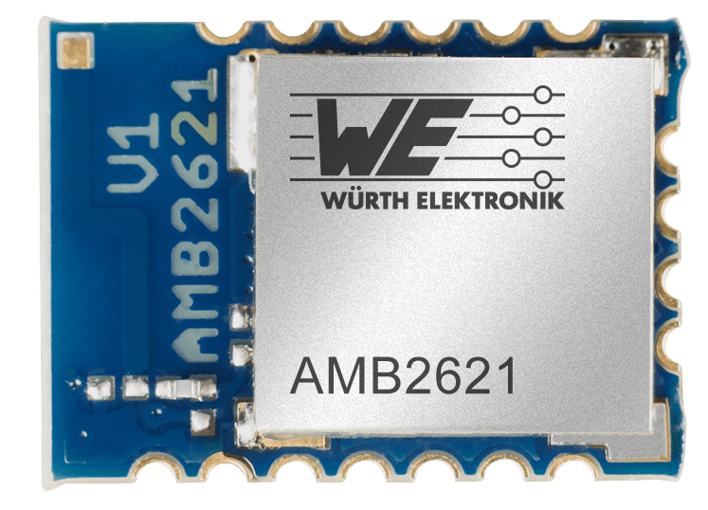
Image source: Würth Elektronik eiSos
Bluetooth Low Energy Module AMB2621-TR – The most important new feature is the increase in the UART (Universal Asynchronous Receiver Transmitter) baud rate.

About Würth Elektronik eiSos GmbH & Co. KG
Würth Elektronik eiSos GmbH & Co. KG is a manufacturer of electronic and electromechanical components for the electronics industry. Production sites in Europe, Asia and North America supply a growing number of customers worldwide. The product program encompasses EMC components, inductors, transformers, HF components, varistors, capacitors, power modules, LEDs, wireless technology, plug connectors, power supply elements, wireless power coils, switches, connection technology and fuse holders. Würth Elektronik eiSos GmbH & Co. KG together with its specialized affiliated companies form the Würth Elektronik eiSos Group.

About the Würth Elektronik eiSos Group
Würth Elektronik eiSos GmbH & Co. KG (Focus: standard components), Würth Elektronik iBE GmbH (Focus: customized passive components for the automotive industry), Wurth Electronics Midcom Inc. (Focus: transformers and custom magnetics), Würth Elektronik Stelvio Kontek S.p.A. (Focus: customized plug connectors) and IQD Frequency Products Ltd (Focus: frequency-producing devices) form the Würth Elektronik eiSos Group. The former subsidiary AMBER wireless GmbH with a focus on solutions for wireless data transmission became the Wireless Connectivity and Sensors division of Würth Elektronik eiSos GmbH & Co. KG in 2018. The group of companies with 6,700 employees generated sales of approx. € 653 million in 2017. The Würth Elektronik eiSos Group is one of the biggest European manufacturers of passive components and operates in 50 countries.
Through its technology partnership with the Audi Sport ABT Schaeffler Formula E Team and its support for the Formula E racing series, the Group demonstrates its innovative strength in eMobility
(www.we-speed-up-the-future.com). Other global growth markets, such as Energy Harvesting, Internet of Things and Wireless Communication, are addressed with innovative products.
The Würth Elektronik eiSos Group is part of the Würth Group, the world market leader for assembly and fastening technology.
Würth Elektronik: more than you expect!
Further info at www.we-online.com

More information:  Würth Elektronik eiSos GmbH & Co. KG  Regina Fingerhut  Max-Eyth-Strasse 1  74638 Waldenburg  Germany  Phone: +49 89 242936-101  E-Mail: regina.fingerhut@we-online.de  www.we-online.com | Press contact:  HighTech communications GmbH  Brigitte Basilio  Brunhamstrasse 21  81249 Munich  Germany  Phone: +49 89 500778-20  Telefax: +49 89 500778-77  E-Mail: b.basilio@htcm.de  www.htcm.de

