PRESS RELEASE
Würth Elektronik eiSos expands its pin and socket strip series WR-PHD
Board-to-board butt joints
Waldenburg (Germany), 25 July 2018 – Two-row pin and socket strips in the 90-degree SMT design in a space-saving 2.0 mm grid: These are the most recent members of the WR-PHD of Würth Elektronik eiSos product family. Positioning pegs on the pin strip permit precise placement on the PCB and prevent "floating" while soldering. The plug connectors optimized for SMT can be used in order to connect two PCBs horizontally with a butt joint.
The WR PHD plugs and sockets are each available in the standard pin numbers
4, 6, 8, 10, 12, 14, 16 and 20 ex stock in roll packaging. The current carrying capacity is 2 A per pin, the operating voltage goes to 200 V alternating current. Free samples can be requested.

Available images
The following images can be downloaded from the Internet in printable quality: http://www.htcm.de/kk/wuerth
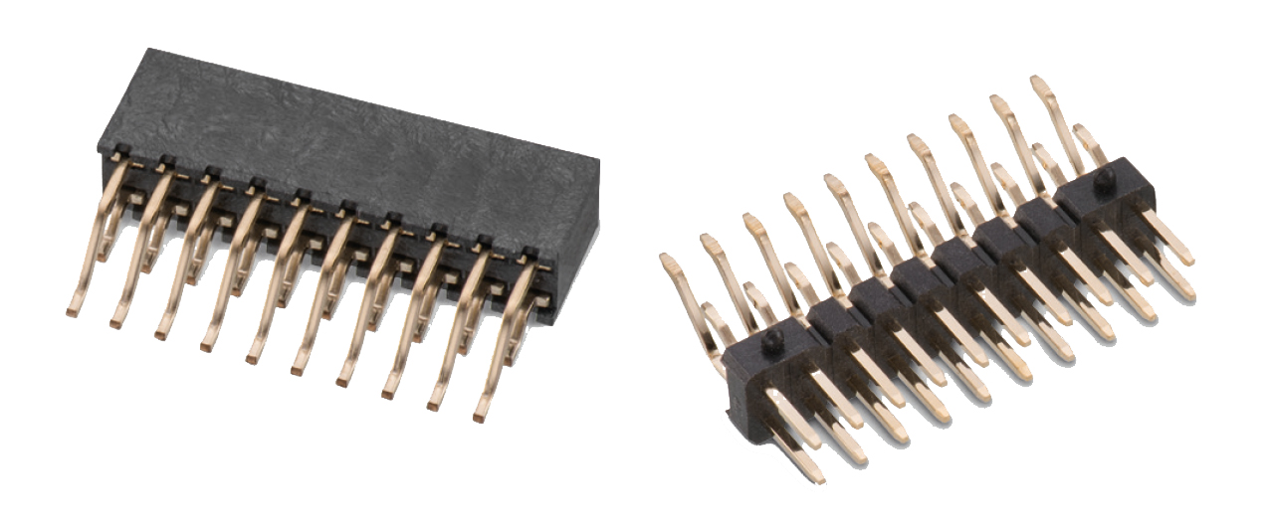Image source: Würth Elektronik eiSos
WR-PHD plugs for horizontal connection of two PCBs with a butt joint

About Würth Elektronik eiSos GmbH & Co. KG
Würth Elektronik eiSos GmbH & Co. KG is a manufacturer of electronic and electromechanical components for the electronics industry. Production sites in Europe, Asia and North America supply a growing number of customers worldwide. The product program encompasses EMC components, inductors, transformers, HF components, varistors, capacitors, power modules, LEDs, wireless technology, plug connectors, power supply elements, wireless power coils, switches, connection technology and fuse holders. Würth Elektronik eiSos GmbH & Co. KG together with its specialized affiliated companies form the Würth Elektronik eiSos Group.

About the Würth Elektronik eiSos Group
Würth Elektronik eiSos GmbH & Co. KG (Focus: standard components), Würth Elektronik iBE GmbH (Focus: customized passive components for the automotive industry), Wurth Electronics Midcom Inc. (Focus: transformers and custom magnetics), Würth Elektronik Stelvio Kontek S.p.A. (Focus: customized plug connectors) and IQD Frequency Products Ltd (Focus: frequency-producing devices) form the Würth Elektronik eiSos Group. The former subsidiary AMBER wireless GmbH with a focus on solutions for wireless data transmission became the Wireless Connectivity and Sensors division of Würth Elektronik eiSos GmbH & Co. KG in 2018. The group of companies with 6,700 employees generated sales of approx. € 653 million in 2017. The Würth Elektronik eiSos Group is one of the biggest European manufacturers of passive components and operates in 50 countries.
Through its technology partnership with the Audi Sport ABT Schaeffler Formula E Team and its support for the Formula E racing series, the Group demonstrates its innovative strength in eMobility
(www.we-speed-up-the-future.com). Other global growth markets, such as Energy Harvesting, Internet of Things and Wireless Communication, are addressed with innovative products.
The Würth Elektronik eiSos Group is part of the Würth Group, the world market leader for assembly and fastening technology.
Würth Elektronik: more than you expect!
Further info at www.we-online.com

More information:  Würth Elektronik eiSos GmbH & Co. KG  Sarah Hurst  Max-Eyth-Strasse 1  74638 Waldenburg  Germany  Phone: +49 7942 945-5186  E-mail: sarah.hurst@we-online.de  www.we-online.de | Press contact:  HighTech communications GmbH  Brigitte Basilio  Brunhamstrasse 21  81249 Munich  Germany  Phone: +49 89 500778-20  Telefax: +49 89 500778-77  E-mail: b.basilio@htcm.de  www.htcm.de

