PRESS RELEASE
Ultra Miniature High Frequency Fundamental Quartz Crystals
Waldenburg (Germany), 31 July 2018 – IQD has launched a range of quartz crystals which can operate in the fundamental mode up to 200 MHz. The quartz crystals are housed in an hermetically sealed 2.5 x 2.0 x 0.6mm (IQXC-152) and 2.0 x 1.6 x 0.5mm (IQXC-153) ceramic 4 pad package, 2 of the pads are grounded to the metal lid to improve the EMI. In the higher frequency range, 70MHz to 200MHz, the frequency tolerance can be as low as ±30ppm and the stability is also ±30ppm over the full industrial operating temperature range of -40 to +85 degrees C with the capacitance load ranging from 8 to 30pF.
The IQXC-152 and IQXC-153 enables design engineers to use higher frequencies in the fundamental mode which eliminates the need to use a PLL or a tank circuit picking up the 3rd, 5th or 7th harmonics. A higher starting frequency can also be used when looking to generate for example 2.4 GHz which cuts down on the jitter/phase noise in the circuit.
Packaging options are ‘Tape and Reel’ or ‘Cut Tape’ and detailed data sheets are available at www.iqdfrequencyproducts.com

Available images
The following images can be downloaded from the Internet in printable quality: http://www.htcm.de/kk/wuerth
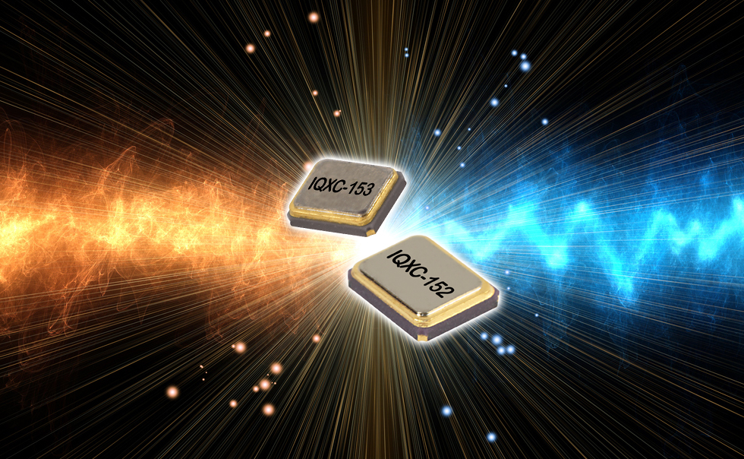
Image source: IQD
Quartz crystals IQXC-152 and IQXC-153

About IQD
Backed by over 40 years’ experience in the manufacture of frequency products, IQD is a recognised market leader in the frequency control market and part of the Würth Elektronik eiSos group, one of the leading European manufacturers of passive components. With active customers in over 80 countries, IQD offers one of the most comprehensive frequency product ranges available, from low cost commercial grade product to that used in high reliability industrial and automotive applications including: Quartz Crystals, Clock Oscillators, AEC-Q200/TS16949 Crystals & Oscillators, VCXOs, TCXOs, OCXOs, GPS Disciplined OCXOs, and Rubidium Oscillators.
Manufacturing capacity totals over 40 million units per month covering quantities from one off specials to multi-million unit orders. In addition, IQD offers customers a range of engineering support services including: application support, custom product design, sample development, electrical testing & screening, frequency/temperature testing, accelerated ageing, circuit characterisation and MTIE/TDEV testing. IQD’s products are specified by leading manufacturers in the aerospace, automotive, communications, computing, consumer and industrial industries throughout the world. The full range of products is available direct through sales offices or via an extensive worldwide distribution network.
Further info at www.iqdfrequencyproducts.com

About the Würth Elektronik eiSos Group
Würth Elektronik eiSos GmbH & Co. KG (Focus: standard components), Würth Elektronik iBE GmbH (Focus: customized passive components for the automotive industry), Wurth Electronics Midcom Inc. (Focus: transformers and custom magnetics), Würth Elektronik Stelvio Kontek S.p.A. (Focus: customized plug connectors) and IQD Frequency Products Ltd (Focus: frequency-producing devices) form the Würth Elektronik eiSos Group. The former subsidiary AMBER wireless GmbH with a focus on solutions for wireless data transmission became the Wireless Connectivity and Sensors division of Würth Elektronik eiSos GmbH & Co. KG in 2018. The group of companies with 6,700 employees generated sales of approx. € 653 million in 2017. The Würth Elektronik eiSos Group is one of the biggest European manufacturers of passive components and operates in 50 countries.
Through its technology partnership with the Audi Sport ABT Schaeffler Formula E Team and its support for the Formula E racing series, the Group demonstrates its innovative strength in eMobility
(www.we-speed-up-the-future.com). Other global growth markets, such as Energy Harvesting, Internet of Things and Wireless Communication, are addressed with innovative products.
The Würth Elektronik eiSos Group is part of the Würth Group, the world market leader for assembly and fastening technology.
Würth Elektronik: more than you expect!
Further info at www.we-online.com

More information:  IQD Frequency Products Ltd  Rebecca Long  Station Road  Crewkerne  Somerset  TA18 8AR  United Kingdom  Phone: +44 1460 270270  E-mail: rebecca.long@iqdfrequencyproducts.com  www.we-online.com  www.iqdfrequencyproducts.com | Press contact:  HighTech communications GmbH  Brigitte Basilio  Brunhamstrasse 21  81249 Munich  Germany  Phone: +49 89 500778-20  Telefax: +49 89 500778-77  E-mail:  b.basilio@htcm.de  www.htcm.de

