PRESS RELEASE
Würth Elektronik offers PLCC-RGB-LEDs
For Sophisticated Lighting Solutions
Waldenburg (Germany), 22 May 2019 - Würth Elektronik presents the WL-SFTW and WL-SFTD series of new RGB LEDs that are ideal for accent and decorative lighting, optical displays as well as industrial applications. Thanks to their PLCC contacting design, the two series of individually controllable LEDs are ideally suited for SMT assembly and reflow soldering. The WL-SFTW series offers three different standard packaging designs: 3528 with four pins as well as 3528 and 5050 with six pins. The WL-SFTD series in 3535 package can be of particular interest to lighting designers as it is characterized by its IPX6 protection class.
RGB LEDs can be used to create any color by additive color mixing. This makes these compact components interesting for a variety of decorative applications. With the WL-SFTW series LEDs, Würth Elektronik offers compact components with high light intensity. The 5050 package in particular is ideal for applications in areas with bright ambient light.
The IPX6 protection class of the WL-SFTD series stands for outdoor applications and insensitivity to water. The encapsulation resin of the RGB LED with diffuse lens also contains UV inhibitors to minimize the effects of long-term exposure to direct sunlight. This supports stable light yield throughout the service life of the LED. A wide beam angle and high intensities make these LEDs ideal for outdoor and indoor full color displays.
All the LEDs described are available from stock. You can request free samples.

Available images
The following images can be downloaded from the Internet in printable quality: http://www.htcm.de/kk/wuerth

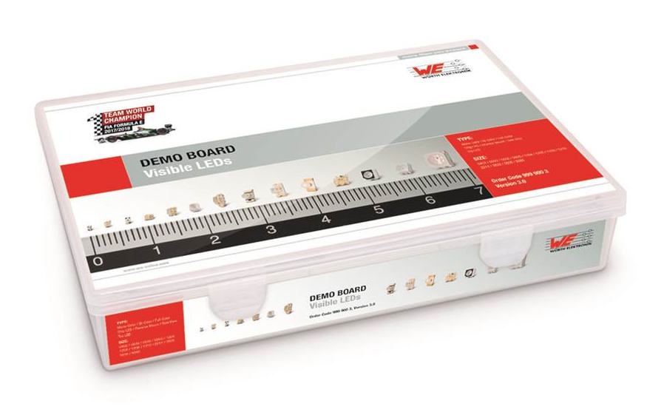  Image source: Würth Elektronik  With the Demo Board Visible LEDs, Würth Elektronik offers customers the possibility of seeing their LEDs in action even before they have been integrated into an application. | 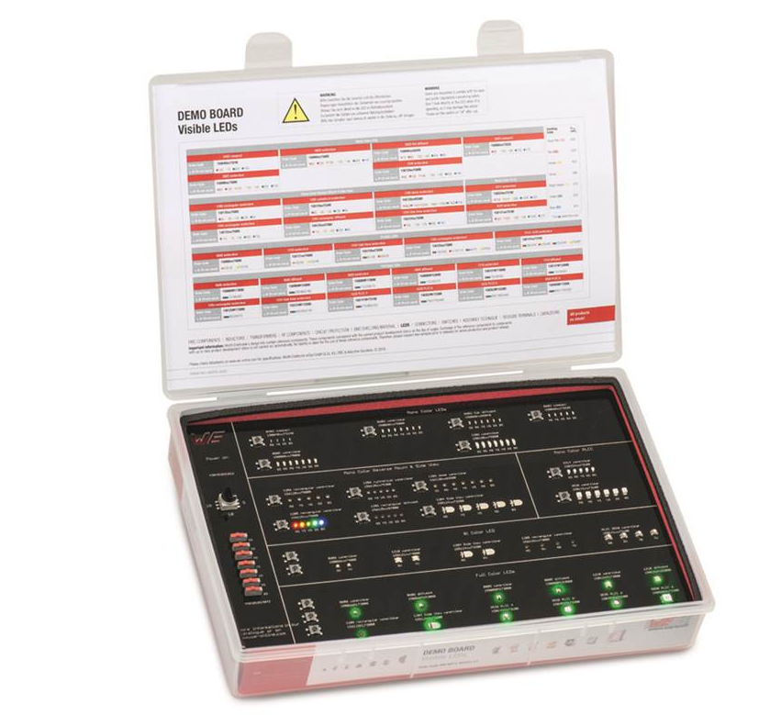  Image source: Würth Elektronik  Würth Elektronik offers two product series of high-quality PLCC RGB LEDs–WL-SFTW and WL-SFTD.

About Würth Elektronik eiSos Group
Würth Elektronik eiSos Group is a manufacturer of electronic and electromechanical components for the electronics industry and a technology company that spearheads pioneering electronic solutions. The company currently employs 8,300 staff and generated sales of 848 million euros in 2018. Würth Elektronik eiSos is one of the largest European manufacturers of passive components and is active in 50 countries. Production sites in Europe, Asia and North America supply a growing number of customers worldwide.
The product range includes EMC components, inductors, transformers, RF components, varistors, capacitors, resistors, quartz crystals, oscillators, power modules, Wireless Power Transfer, LEDs, sensors, connectors, power supply elements, switches, push-buttons, connection technology, fuse holders and solutions for wireless data transmission.
The unrivaled service orientation of the company is characterized by the availability of all catalog components from stock without minimum order quantity, free samples and extensive support through technical sales staff and selection tools.
Through its technology partnership with the Audi Sport ABT Schaeffler Formula E Team and its support for the Formula Student racing series, the company demonstrates its innovative strength in eMobility
(www.we-speed-up-the-future.com).
Würth Elektronik eiSos is part of the Würth Group, the world market leader for assembly and fastening technology.
Würth Elektronik: more than you expect!
Further information at www.we-online.com

Further information:  Würth Elektronik eiSos GmbH & Co. KG  Sarah Hurst  Max-Eyth-Strasse 1  74638 Waldenburg  Germany  Phone: +49 7942 945-5186  E-mail: sarah.hurst@we-online.de  www.we-online.de | Press contact:  HighTech communications GmbH  Brigitte Basilio  Brunhamstrasse 21  81249 Munich  Germany  Phone: +49 89 500778-20  Telefax: +49 89 500778-77  E-mail: b.basilio@htcm.de  www.htcm.de

