PRESS RELEASE
Würth Elektronik eiSos: WR-COM series with USB 3.1 type C
High Performance USB Connectors for Industry
Waldenburg (Germany), 28 November 2018 – Würth Elektronik eiSos continues to expand its high-grade USB connector program. The WR-COM series encompasses the new USB 3.1 standard, as well as 3.0 and 2.0. The data rate of 10 Gbps (USB 3.1 Gen 2) and 100 W power supply output make USB 3.1 interesting for use in demanding industrial applications. Würth Elektronik eiSos presents its type C connectors and jacks with exceptionally long service life.
In its USB connector program, Würth Elektronik eiSos offers an extraordinary range of dependable and space-saving solutions for fast and flexible installation.
Thanks to their high-quality workmanship, the user-friendly USB 3.1 standard type C bi-directional connectors and jacks are set to also become increasingly prevalent in industry, as well as in the consumer sector. The material quality goes hand-in-hand with superior shielding and greater coating of the contact surfaces.
The horizontal type-C connector complies with the high-quality class of 10,000 mating cycles. It can be contacted into the ports in either mating direction and boasts dielectric strength up to 100 V and maximum contact resistance of 30 mΩ.
With its WR-COM series, Würth Elektronik eiSos is equipped for the anticipated broader use of USB in industrial applications. The USB 3.1 Alternate Mode allows USB 3.1 hardware to be used to transmit data from other interface standards, such as HDMI, Ethernet, Thunderbolt or DisplayPort with audio and video signals.
You can request free samples at any time. The connectors are available from stock.

Available images
The following images can be downloaded from the Internet in printable quality: http://www.htcm.de/kk/wuerth
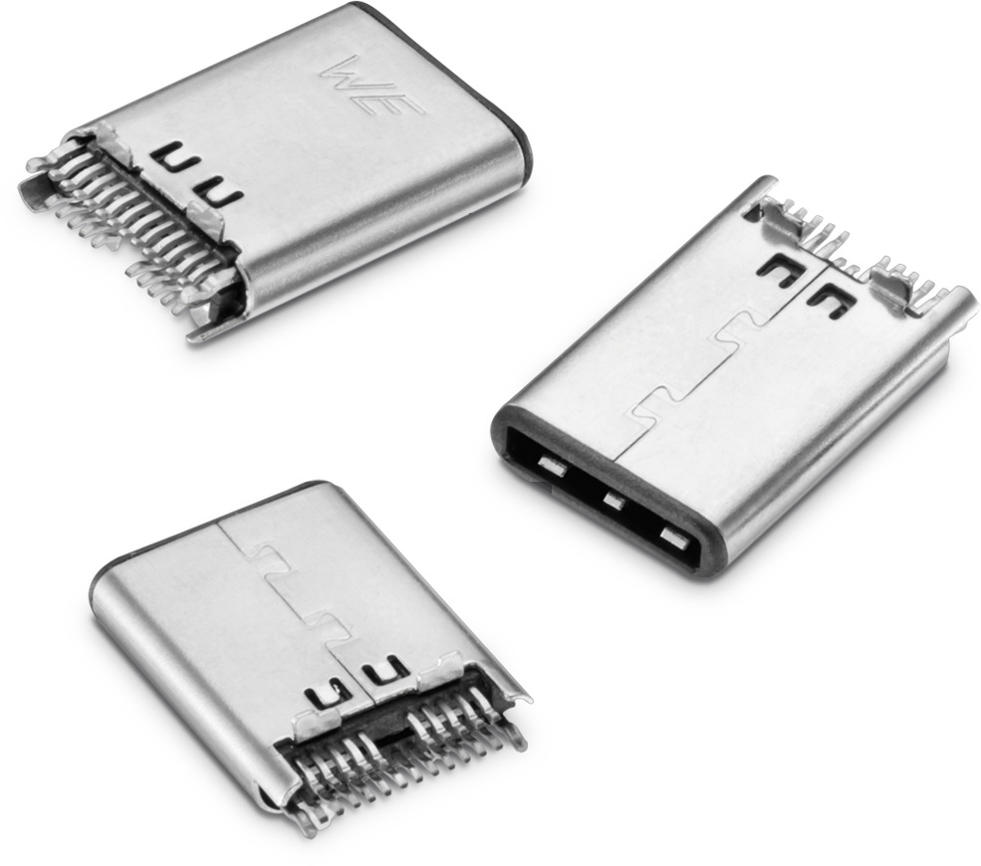
Image source: Würth Elektronik eiSos
WR-COM USB 3.1 type C is also suitable for industrial applications.

About Würth Elektronik eiSos
Würth Elektronik eiSos GmbH & Co. KG is a manufacturer of electronic and electromechanical components for the electronics industry. In 2017, the company employed 6 700 people and generated sales of approximately 653 million Euro. Würth Elektronik eiSos is one of the largest European manufacturers of passive components and is active in 50 countries. Production sites in Europe, Asia and North America supply a growing number of customers worldwide.
The product range includes EMC components, inductors, transformers, RF components, varistors, capacitors, resistors, quartz crystals, oscillators, power modules, Wireless Power Transfer, LEDs, sensors, connectors, power supply elements, switches, push-buttons, connection technology, fuse holders and solutions for wireless data transmission.
Through its technology partnership with the Audi Sport ABT Schaeffler Formula E Team and its support for the Formula E racing series, the company demonstrates its innovative strength in eMobility
(www.we-speed-up-the-future.com).
Würth Elektronik eiSos is part of the Würth Group, the world market leader for assembly and fastening technology.
Würth Elektronik: more than you expect!
Further information at www.we-online.com

More information:  Würth Elektronik eiSos GmbH & Co. KG  Sarah Hurst  Max-Eyth-Strasse 1  74638 Waldenburg  Germany  Phone: +49 7942 945-5186  E-mail: sarah.hurst@we-online.de  www.we-online.de | Press contact:  HighTech communications GmbH  Brigitte Basilio  Brunhamstrasse 21  81249 Munich  Germany  Phone: +49 89 500778-20  Telefax: +49 89 500778-77  E-mail: b.basilio@htcm.de  www.htcm.de

