PRESS RELEASE
Würth Elektronik eiSos launches a new DIP switch onto the market
Robust switch with gold contacts
Waldenburg (Germany), 30 August 2018 – With its new WS-DITU item, Würth Elektronik eiSos now has an improved DIP switch in its product range: the gold-plated contacts make sure that the WS-DITU switch has a stable contact resistance. This robust switch is durable and its pins are securely protected against deformation. The product’s unique design ensures the exact compliance to the grid dimension of 2.54 mm.
DIP switches are used everywhere that specific, basic settings need to be made swiftly and directly on board the PCB. The WS-DITU DIP switch can be easily mounted manually and is available with 2 to 10 switch units (evenpoles). The insulation material has a UL94 V-0 flammability rating and is capable of operating at temperatures between -40 and +85 °C. The rated current is 25 mA, the dielectric strength 500 V, and the contact resistance a mere 50 mΩ.
The design of the WS-DITU switch is patent-protected in many countries.
Free-of-charge samples can be provided on request. The switch is available from stock.

Available images
The following images can be downloaded from the Internet in printable quality: http://www.htcm.de/kk/wuerth
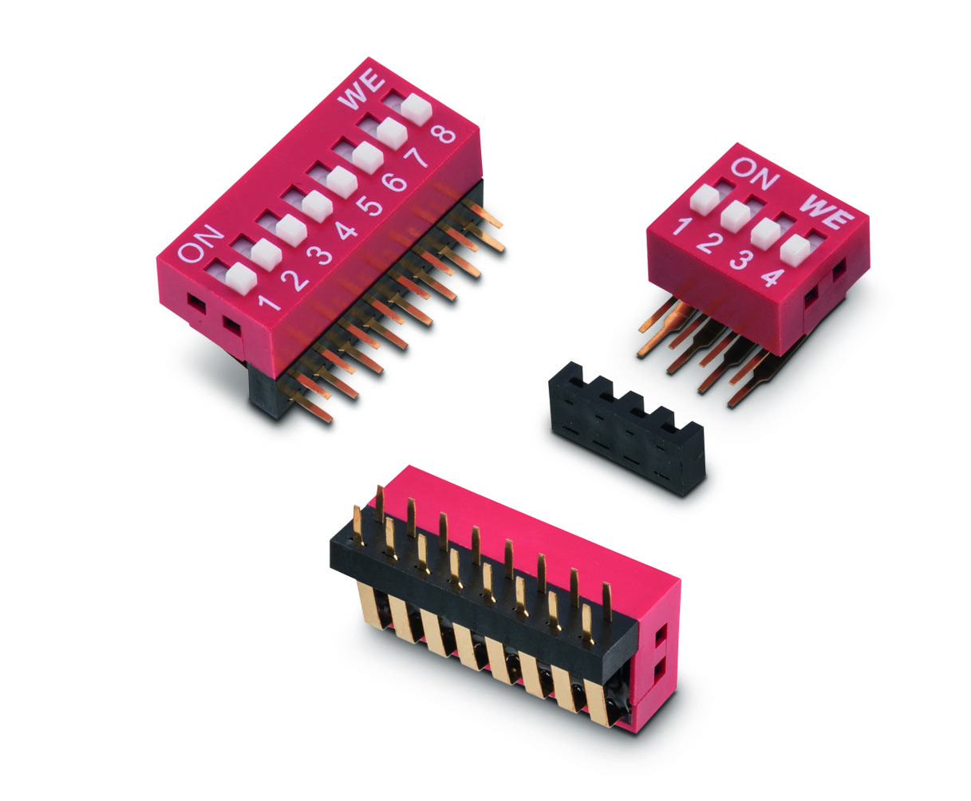
Image source: Würth Elektronik eiSos
The new WS-DITU DIP switch is available in an angular design with a raised actuator.

About Würth Elektronik eiSos GmbH & Co. KG
Würth Elektronik eiSos GmbH & Co. KG is a manufacturer of electronic and electromechanical components for the electronics industry. Production sites in Europe, Asia and North America supply a growing number of customers worldwide. The product program encompasses EMC components, inductors, transformers, HF components, varistors, capacitors, power modules, LEDs, wireless technology, plug connectors, power supply elements, wireless power coils, switches, connection technology and fuse holders. Würth Elektronik eiSos GmbH & Co. KG together with its specialized affiliated companies form the Würth Elektronik eiSos Group.

About the Würth Elektronik eiSos Group
Würth Elektronik eiSos GmbH & Co. KG (Focus: standard components), Würth Elektronik iBE GmbH (Focus: customized passive components for the automotive industry), Wurth Electronics Midcom Inc. (Focus: transformers and custom magnetics), Würth Elektronik Stelvio Kontek S.p.A. (Focus: customized plug connectors) and IQD Frequency Products Ltd (Focus: frequency-producing devices) form the Würth Elektronik eiSos Group. The former subsidiary AMBER wireless GmbH with a focus on solutions for wireless data transmission became the Wireless Connectivity and Sensors division of Würth Elektronik eiSos GmbH & Co. KG in 2018. The group of companies with 6,700 employees generated sales of approx. € 653 million in 2017. The Würth Elektronik eiSos Group is one of the biggest European manufacturers of passive components and operates in 50 countries.
Through its technology partnership with the Audi Sport ABT Schaeffler Formula E Team and its support for the Formula E racing series, the Group demonstrates its innovative strength in eMobility
(www.we-speed-up-the-future.com). Other global growth markets, such as Energy Harvesting, Internet of Things and Wireless Communication, are addressed with innovative products.
The Würth Elektronik eiSos Group is part of the Würth Group, the world market leader for assembly and fastening technology.
Würth Elektronik: more than you expect!
Further info at www.we-online.com

More information:  Würth Elektronik eiSos GmbH & Co. KG  Sarah Hurst  Max-Eyth-Strasse 1  74638 Waldenburg  Germany  Phone: +49 7942 945-5186  E-mail: sarah.hurst@we-online.de  www.we-online.de | Press contact:  HighTech communications GmbH  Brigitte Basilio  Brunhamstrasse 21  81249 Munich  Germany  Phone: +49 89 500778-20  Telefax: +49 89 500778-77  E-mail: b.basilio@htcm.de  www.htcm.de

