PRESS RELEASE
TVS diodes with low terminal voltage from Würth Elektronik eiSos
Three product series for safe protection against ESD
Waldenburg (Germany), 19 October 2018 – Würth Elektronik eiSos has expanded its portfolio of TVS diodes. The diodes are characterized by their short response time and an extremely low terminal voltage, and feature a high ESD dielectric strength with a contact discharge of up to ±30 kV. WE-TVS diodes in the three series “Standard”, “High Speed”, and “Super Speed” offer effective protection against electrostatic discharges at all protection levels. The new TVS diodes meet the industrial standards IEC 61000-4-2 (ESD), IEC 61000-4-4 (EFT), and IEC 61000-4-5 (surge) and are flame-resistant (UL 94 V-0).
The three WE-TVS series comprise sophisticated TVS diodes for the effective protection of sensitive data lines – for example in the consumer electronics field, such as headsets and accessories, digital cameras, laptops, or USB power-delivery applications (PD). In these areas, the semiconductor components such as ICs and LEDs are often in immediate contact with external interfaces that may be exposed to electrostatic discharges. The Würth Elektronik TVS diodes block the electrostatic discharges and reliably protect these components against direct or delayed interferences or even the complete failure of the end devices.
The diodes are available in three separate series: first, there’s the Standard series for slow interfaces such as RS232, RS485, or power-supply systems. In addition, there are the High Speed and the Super Speed series that have been developed for very fast interfaces such as USB 3.1, HDMI, Thunderbolt, or GBit Ethernet, a further characteristic feature of these two series being a small capacitance of as low as 0.12 pF. The “WE-TVS TVS Diode – Standard Series” is available in both the uni- and the bidirectional technologies. The “WE-TVS TVS Diode – High Speed Series” and “WE-TVS TVS Diode – Super Speed Series” can be supplied in a rail-to-rail protective circuit design, which offers the additional benefit of protecting the supply voltage using one and the same component.
Free-of-charge samples can be provided on request. The TVS diodes are available from stock.

Available images
The following images can be downloaded from the Internet in printable quality: http://www.htcm.de/kk/wuerth

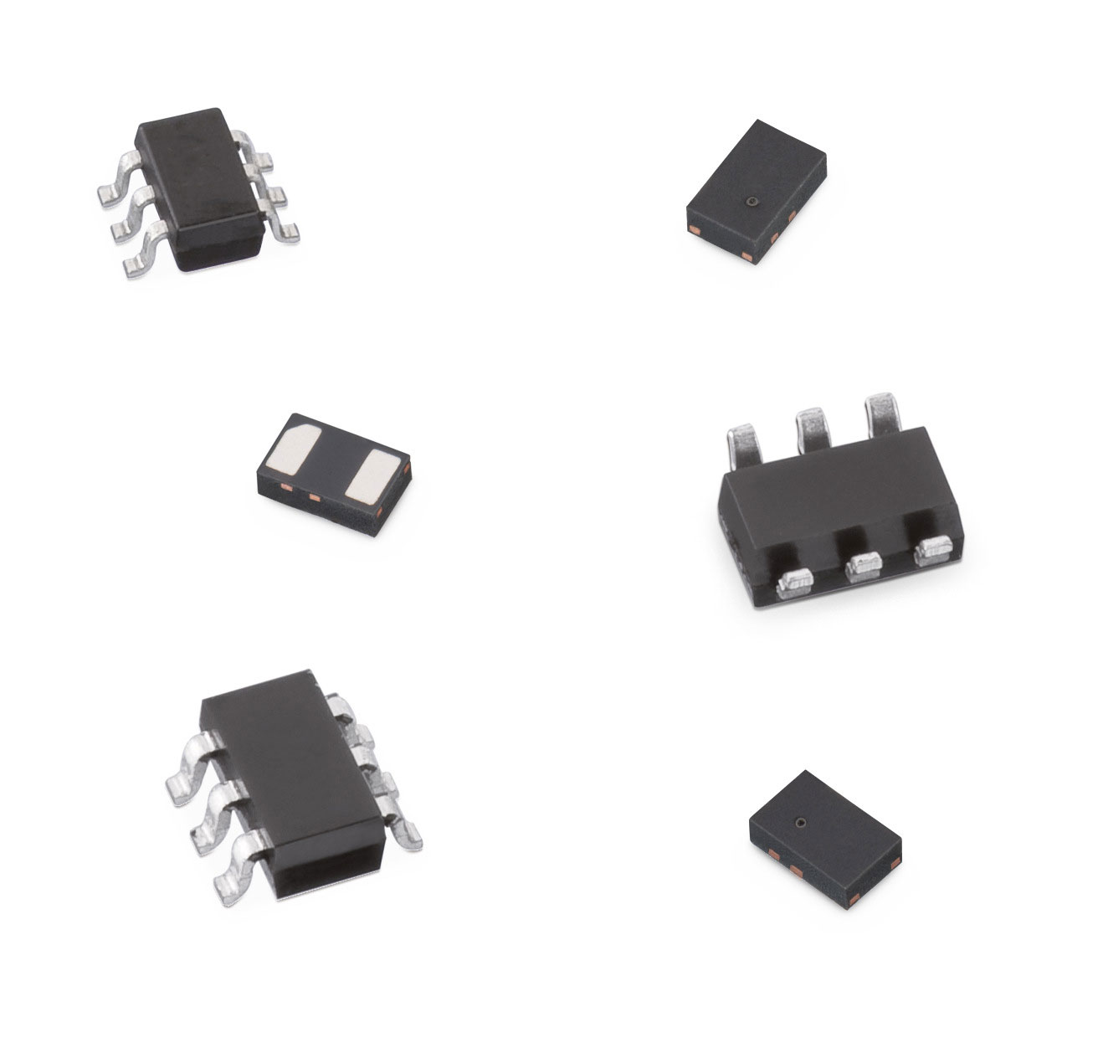
Image source: Würth Elektronik eiSos
The new WE-TVS series with extremely low terminal voltage

About Würth Elektronik eiSos GmbH & Co. KG
Würth Elektronik eiSos GmbH & Co. KG is a manufacturer of electronic and electromechanical components for the electronics industry. Production sites in Europe, Asia and North America supply a growing number of customers worldwide. The product program encompasses EMC components, inductors, transformers, HF components, varistors, capacitors, power modules, LEDs, wireless technology, plug connectors, power supply elements, wireless power coils, switches, connection technology and fuse holders. Würth Elektronik eiSos GmbH & Co. KG together with its specialized affiliated companies form the Würth Elektronik eiSos Group.

About the Würth Elektronik eiSos Group
Würth Elektronik eiSos GmbH & Co. KG (Focus: standard components), Würth Elektronik iBE GmbH (Focus: customized passive components for the automotive industry), Wurth Electronics Midcom Inc. (Focus: transformers and custom magnetics), Würth Elektronik Stelvio Kontek S.p.A. (Focus: customized plug connectors) and IQD Frequency Products Ltd (Focus: frequency-producing devices) form the Würth Elektronik eiSos Group. The former subsidiary AMBER wireless GmbH with a focus on solutions for wireless data transmission became the Wireless Connectivity and Sensors division of Würth Elektronik eiSos GmbH & Co. KG in 2018. The group of companies with 6,700 employees generated sales of approx. € 653 million in 2017. The Würth Elektronik eiSos Group is one of the biggest European manufacturers of passive components and operates in 50 countries.
Through its technology partnership with the Audi Sport ABT Schaeffler Formula E Team and its support for the Formula E racing series, the Group demonstrates its innovative strength in eMobility
(www.we-speed-up-the-future.com). Other global growth markets, such as Energy Harvesting, Internet of Things and Wireless Communication, are addressed with innovative products.
The Würth Elektronik eiSos Group is part of the Würth Group, the world market leader for assembly and fastening technology.
Würth Elektronik: more than you expect!
Further info at www.we-online.com

More information:  Würth Elektronik eiSos GmbH & Co. KG  Sarah Hurst  Max-Eyth-Strasse 1  74638 Waldenburg  Germany  Phone: +49 7942 945-5186  E-mail: sarah.hurst@we-online.de  www.we-online.de | Press contact:  HighTech communications GmbH  Brigitte Basilio  Brunhamstrasse 21  81249 Munich  Germany  Phone: +49 89 500778-20  Telefax: +49 89 500778-77  E-mail: b.basilio@htcm.de  www.htcm.de

