PRESS RELEASE
Würth Elektronik eiSos presents WE-MTCI - the smallest 1:N transformer
Small, Shielded, Robust and Versatile in Use
Waldenburg (Germany), 6 December 2018 – The coupled power chokes product category from Würth Elektronik eiSos has a new entrant: “WE-MTCI SMT Multi-Turn Ratio Double Choke”. With WE-MTCI, the manufacturer of electronic and electromechanical components presents its smallest double choke yet (5030 package) with different winding ratios from 1:1.5 to 1:3. The magnetically shielded double choke with 0.8 kV isolation is specified for an operating temperature of -40 to +125°C.
WE-MTCI is available in versions for rated currents from 0.45 to 0.95 A. The double choke is the ideal solution for buck/boost converters with regulated or unregulated output voltage. Isolated converter applications – such as flyback converters – with high packaging density are also areas of use, as well as step-up or step-down converters with auxiliary windings, as are auto-transformer applications. The WE-MTCI double choke is now available from stock in any quantities. You can request free samples.

Available images
The following images can be downloaded from the Internet in printable quality: http://www.htcm.de/kk/wuerth

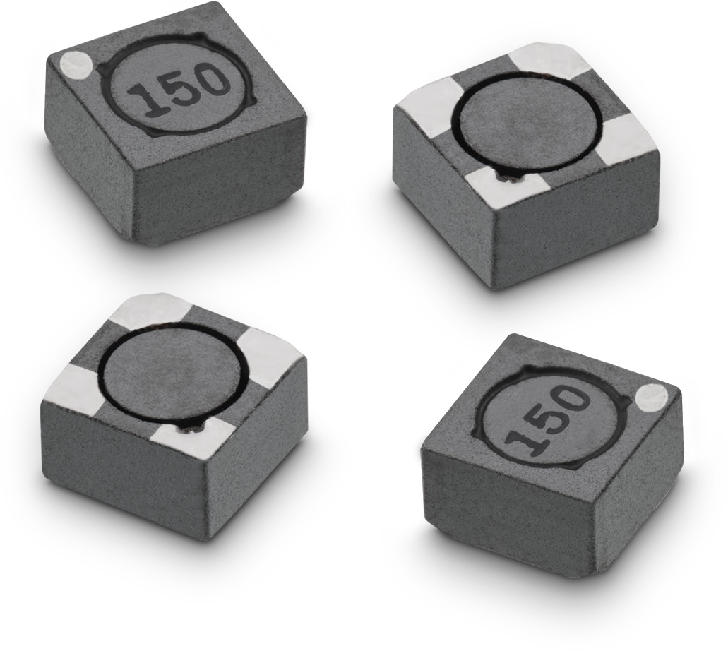
Image source: Würth Elektronik eiSos
New and smallest ever double power choke from Würth Elektronik eiSos: WE-MTCI SMT Multi-Turn Ratio

About Würth Elektronik eiSos
Würth Elektronik eiSos GmbH & Co. KG is a manufacturer of electronic and electromechanical components for the electronics industry. In 2017, the company employed 6 700 people. Würth Elektronik eiSos is one of the largest European manufacturers of passive components and is active in 50 countries. Production sites in Europe, Asia and North America supply a growing number of customers worldwide.
The product range includes EMC components, inductors, transformers, RF components, varistors, capacitors, resistors, quartz crystals, oscillators, power modules, Wireless Power Transfer, LEDs, sensors, connectors, power supply elements, switches, push-buttons, connection technology, fuse holders and solutions for wireless data transmission.
Through its technology partnership with the Audi Sport ABT Schaeffler Formula E Team and its support for the Formula E racing series, the company demonstrates its innovative strength in eMobility
(www.we-speed-up-the-future.com).
Würth Elektronik eiSos is part of the Würth Group, the world market leader for assembly and fastening technology.
Würth Elektronik: more than you expect!
Further information at www.we-online.com

Further information:  Würth Elektronik eiSos GmbH & Co. KG  Sarah Hurst  Max-Eyth-Strasse 1  74638 Waldenburg  Germany  Phone: +49 7942 945-5186  E-mail: sarah.hurst@we-online.de  www.we-online.de | Press contact:  HighTech communications GmbH  Brigitte Basilio  Brunhamstrasse 21  81249 Munich  Germany  Phone: +49 89 500778-20  Telefax: +49 89 500778-77  E-mail: b.basilio@htcm.de  www.htcm.de

