PRESS RELEASE
Würth Elektronik eiSos presents WE-CPIB HV
Smallest High Voltage Double Chokes
Waldenburg (Germany), 15 January 2019 – 2 kV isolation voltage distinguishes the WE-CPIB HV double chokes. With its 4828 package it is the smallest of its type in the Würth Elektronik eiSos portfolio. The 1:1 transformer is magnetically shielded and offers functional isolation for a working voltage of 250 V_{RMS}. The double choke offers better leakage inductance (L_{S}) and resistance (R_{DC}) values than comparable components on the market. The component optimised for SMT manufacture is specified for the temperature range from 40 to +125°C.
Typical applications for the WE-CPIB HV high voltage double choke include isolated converter applications (such as flyback converters) with high packaging density buck, boost, Sepic, Zeta, and CUK converters, as well as switching controllers with a second, unregulated output voltage. WE-CPIB HV can be used as an individual inductor with series and parallel connection.
WE-CPIB is now available from stock in any quantities in versions with inductance values between 4.7 and 47 µH. You can request free samples.

Available images
The following images can be downloaded from the Internet in printable quality: http://www.htcm.de/kk/wuerth
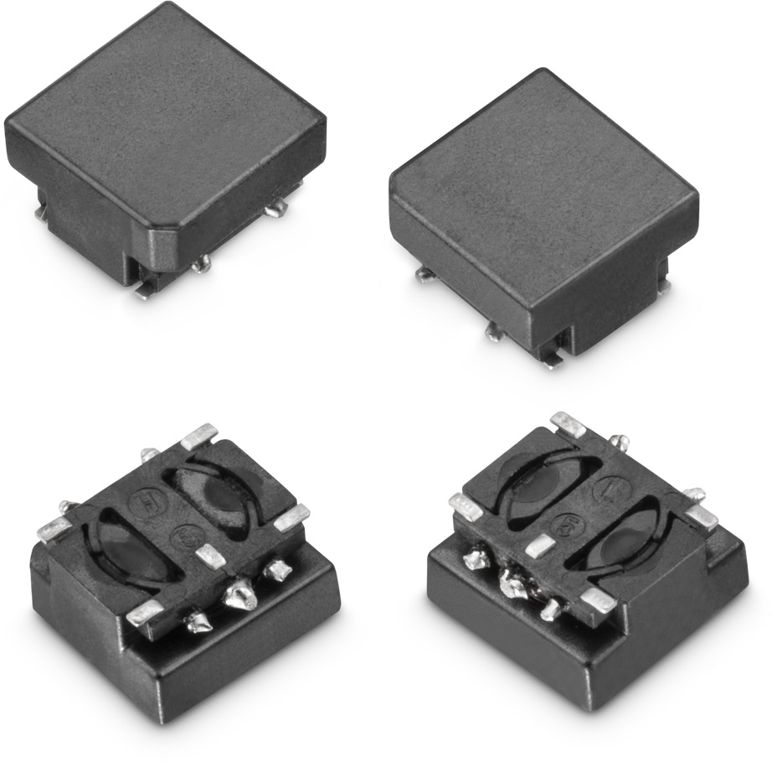
Image source: Würth Elektronik eiSos
WE-CPIB HV double chokes with 2 kV isolation voltage

About Würth Elektronik eiSos
Würth Elektronik eiSos GmbH & Co. KG is a manufacturer of electronic and electromechanical components for the electronics industry. In 2017, the company employed 6 700 people. Würth Elektronik eiSos is one of the largest European manufacturers of passive components and is active in 50 countries. Production sites in Europe, Asia and North America supply a growing number of customers worldwide.
The product range includes EMC components, inductors, transformers, RF components, varistors, capacitors, resistors, quartz crystals, oscillators, power modules, Wireless Power Transfer, LEDs, sensors, connectors, power supply elements, switches, push-buttons, connection technology, fuse holders and solutions for wireless data transmission.
Through its technology partnership with the Audi Sport ABT Schaeffler Formula E Team and its support for the Formula E racing series, the company demonstrates its innovative strength in eMobility
(www.we-speed-up-the-future.com).
Würth Elektronik eiSos is part of the Würth Group, the world market leader for assembly and fastening technology.
Würth Elektronik: more than you expect!
Further information at www.we-online.com

Further information:  Würth Elektronik eiSos GmbH & Co. KG  Sarah Hurst  Max-Eyth-Strasse 1  74638 Waldenburg  Germany  Phone: +49 7942 945-5186  E-mail: sarah.hurst@we-online.de  www.we-online.de | Press contact:  HighTech communications GmbH  Brigitte Basilio  Brunhamstrasse 21  81249 Munich  Germany  Phone: +49 89 500778-20  Telefax: +49 89 500778-77  E-mail: b.basilio@htcm.de  www.htcm.de

