PRESS RELEASE
Würth Elektronik eiSos presents its WE-TDC HV high voltage double chokes
Perfectly Shielded and Isolated
Waldenburg (Germany), 14 February 2019 – With its WE-TDC HV, Würth Elektronik eiSos presents a further double choke optimised for SMT assembly. The magnetically shielded 1:1 transformers with an isolation voltage of 2,000 V stands out from similar components through lower losses and a low level of stray inductance. The WE-TDC HV product family encompasses nine different models – five in a 8038 package and four in 8018. The height of just 1.8 mm makes these chokes unique in their class.
WE-TDC HV chokes are specified for the extended operating temperature from -40 to +125°C and have a functional isolation for a working voltage of 250 V_{RMS}. They are suitable for use in switching controllers with a second, unregulated output voltage, in buck, boost, Sepic, Zeta, and CUK converters, as well as in isolated converter applications with high packaging density (e.g. flyback converters).
The components packaged in 16-mm tapes are available from stock. You can request samples at any time.

Available images
The following images can be downloaded from the Internet in printable quality: http://www.htcm.de/kk/wuerth
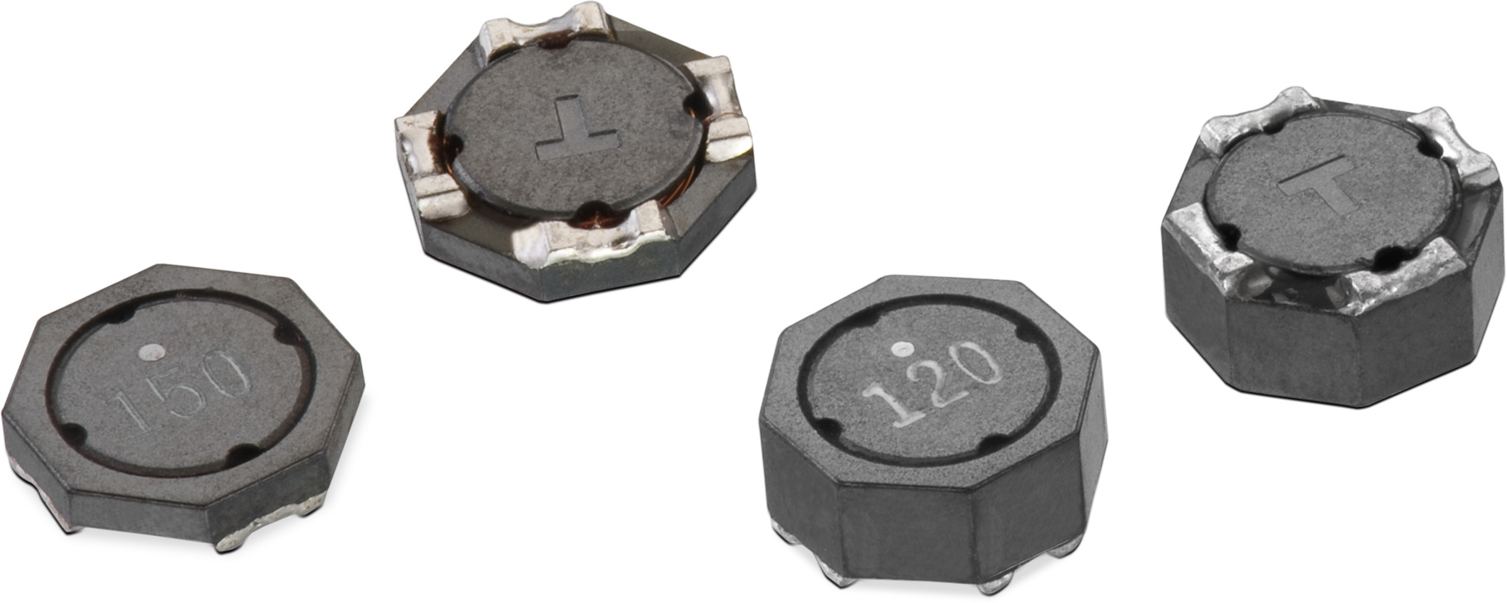
Image source: Würth Elektronik eiSos
The WE-TDC HV double choke product family - magnetically shielded 1:1 transformers with an isolation voltage of 2,000 V

About Würth Elektronik eiSos
Würth Elektronik eiSos GmbH & Co. KG is a manufacturer of electronic and electromechanical components for the electronics industry. In 2017, the company employed 6 700 people. Würth Elektronik eiSos is one of the largest European manufacturers of passive components and is active in 50 countries. Production sites in Europe, Asia and North America supply a growing number of customers worldwide.
The product range includes EMC components, inductors, transformers, RF components, varistors, capacitors, resistors, quartz crystals, oscillators, power modules, Wireless Power Transfer, LEDs, sensors, connectors, power supply elements, switches, push-buttons, connection technology, fuse holders and solutions for wireless data transmission.
Through its technology partnership with the Audi Sport ABT Schaeffler Formula E Team and its support for the Formula E racing series, the company demonstrates its innovative strength in eMobility
(www.we-speed-up-the-future.com).
Würth Elektronik eiSos is part of the Würth Group, the world market leader for assembly and fastening technology.
Würth Elektronik: more than you expect!
Further information at www.we-online.com

Further information:  Würth Elektronik eiSos GmbH & Co. KG  Sarah Hurst  Max-Eyth-Strasse 1  74638 Waldenburg  Germany  Phone: +49 7942 945-5186  E-mail: sarah.hurst@we-online.de  www.we-online.de | Press contact:  HighTech communications GmbH  Brigitte Basilio  Brunhamstrasse 21  81249 Munich  Germany  Phone: +49 89 500778-20  Telefax: +49 89 500778-77  E-mail: b.basilio@htcm.de  www.htcm.de

