PRESS RELEASE

Würth Elektronik presents WL-SMCC LED series
Super Compact, Super Intensive
Waldenburg (Germany), 10 July 2019 – Würth Elektronik has expanded its LED portfolio with a particularly compact model series. The WL-SMCC series of SMT chip LEDs, available in 0402 and 0603 packages, is characterized by a full-surface lens design and a significantly higher light intensity than competitor products. Both WL-SMCC package types are available in five colors: red, yellow, light green, green and blue.
The very small size and the full-surface lens make the LEDs ideal for miniaturized layouts of mobile devices. The ultra-thin 0603 version – just 0.2 mm high – is also perfect for space-saving backlighting, such as in dashboards, entertainment consoles and industrial switches. The WL-SMCC series LEDs are optimized for good solderability, high performance and durability. The contacts are 2.5 µm gold-plated.
The compact LEDs are available from stock. Samples can be requested.

Available images
The following images can be downloaded from the Internet in printable quality: http://www.htcm.de/kk/wuerth

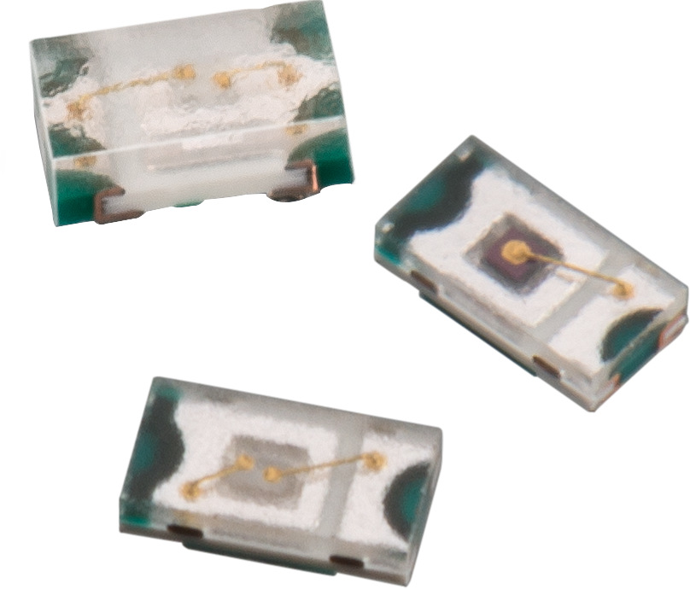
Image source: Würth Elektronik
WL-SMCC LED series in small packages and with high light intensity

About Würth Elektronik eiSos Group
Würth Elektronik eiSos Group is a manufacturer of electronic and electromechanical components for the electronics industry and a technology company that spearheads pioneering electronic solutions. The company currently employs 8,300 staff and generated sales of 848 million euros in 2018. Würth Elektronik eiSos is one of the largest European manufacturers of passive components and is active in 50 countries. Production sites in Europe, Asia and North America supply a growing number of customers worldwide.
The product range includes EMC components, inductors, transformers, RF components, varistors, capacitors, resistors, quartz crystals, oscillators, power modules, Wireless Power Transfer, LEDs, sensors, connectors, power supply elements, switches, push-buttons, connection technology, fuse holders and solutions for wireless data transmission.
The unrivaled service orientation of the company is characterized by the availability of all catalog components from stock without minimum order quantity, free samples and extensive support through technical sales staff and selection tools.
Through its technology partnership with the Audi Sport ABT Schaeffler Formula E Team and its support for the Formula Student racing series, the company demonstrates its innovative strength in eMobility
(www.we-speed-up-the-future.com).
Würth Elektronik eiSos is part of the Würth Group, the world market leader for assembly and fastening technology.
Würth Elektronik: more than you expect!
Further information at www.we-online.com

Further information:  Würth Elektronik eiSos GmbH & Co. KG  Sarah Hurst  Max-Eyth-Strasse 1  74638 Waldenburg  Germany  Phone: +49 7942 945-5186  E-mail: sarah.hurst@we-online.de  www.we-online.de | Press contact:  HighTech communications GmbH  Brigitte Basilio  Brunhamstrasse 21  81249 Munich  Germany  Phone: +49 89 500778-20  Telefax: +49 89 500778-77  E-mail: b.basilio@htcm.de  www.htcm.de

