PRESS RELEASE
Simulation models for LAN transformers from Würth Elektronik eiSos
As Informative as Measurement Results
Waldenburg (Germany), 22 November 2018 – As the first manufacturer worldwide, Würth Elektronik eiSos offers high precision simulation data for all catalogue articles from its LAN transformer series - WE-LAN, WE-LAN 10G and WE-LAN AQ. The LTSpice and PSpice models, as well as S parameters, are extremely accurate all the way through high frequencies. By offering simulation models, Würth Elektronik eiSos makes Ethernet design easier for developers and contributes to shorter project times. The component manufacturer is now making the simulation models available for free download from its website.

Available images
The following images can be downloaded from the Internet in printable quality: http://www.htcm.de/kk/wuerth
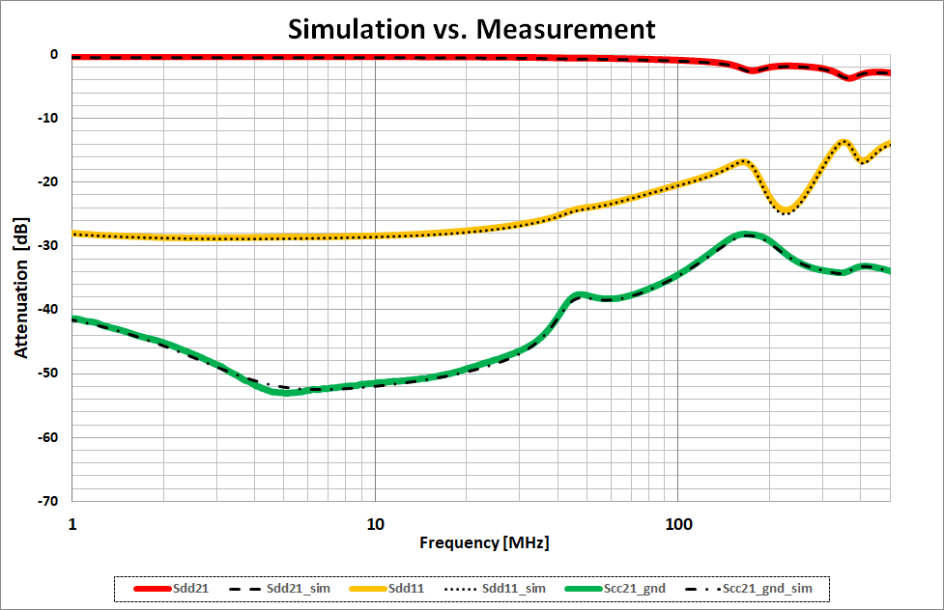  Image source: Würth Elektronik eiSos  Comparison of measurement and simulation within the frequency range | 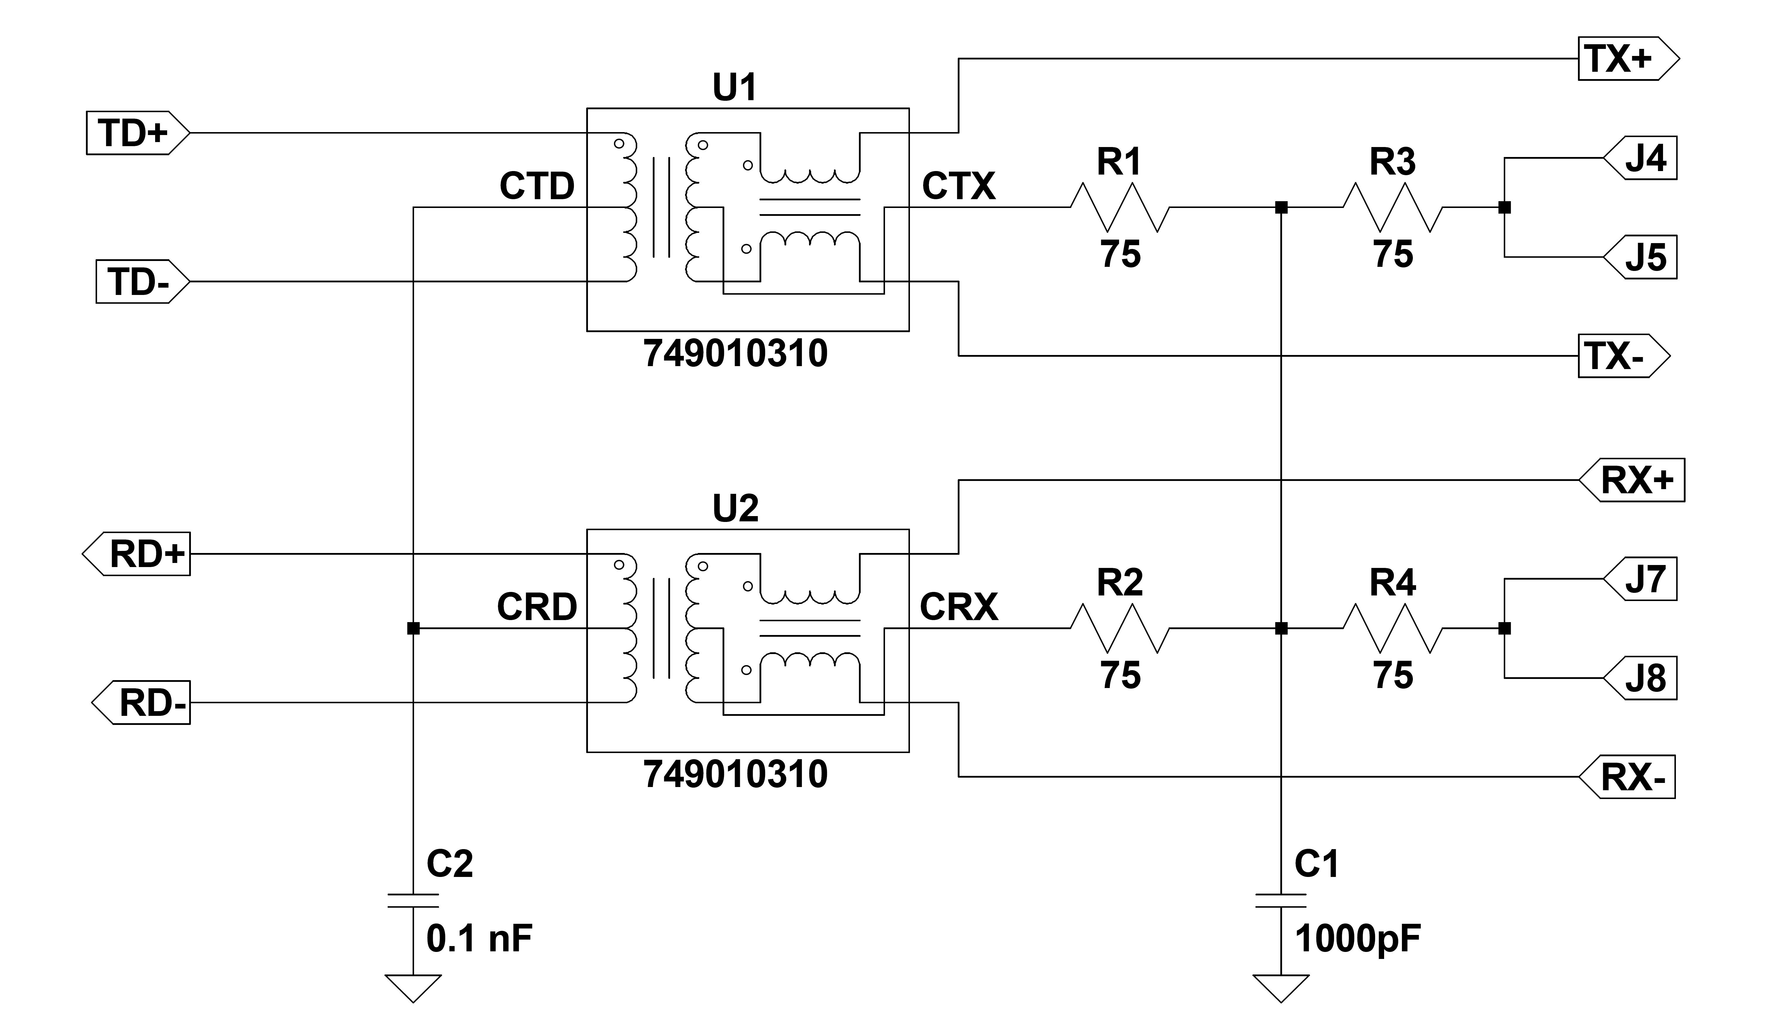 Image source: Würth Elektronik eiSos  Schematic of a 100 Base-TX LAN transformer in LTSpice with the Würth Elektronik models

About Würth Elektronik eiSos
Würth Elektronik eiSos GmbH & Co. KG is a manufacturer of electronic and electromechanical components for the electronics industry. In 2017, the company employed 6 700 people and generated sales of approximately 653 million Euro. Würth Elektronik eiSos is one of the largest European manufacturers of passive components and is active in 50 countries. Production sites in Europe, Asia and North America supply a growing number of customers worldwide.
The product range includes EMC components, inductors, transformers, RF components, varistors, capacitors, resistors, quartz crystals, oscillators, power modules, Wireless Power Transfer, LEDs, sensors, connectors, power supply elements, switches, push-buttons, connection technology, fuse holders and solutions for wireless data transmission.
Through its technology partnership with the Audi Sport ABT Schaeffler Formula E Team and its support for the Formula E racing series, the company demonstrates its innovative strength in eMobility
(www.we-speed-up-the-future.com).
Würth Elektronik eiSos is part of the Würth Group, the world market leader for assembly and fastening technology.
Würth Elektronik: more than you expect!
Further information at www.we-online.com

More information:  Würth Elektronik eiSos GmbH & Co. KG  Sarah Hurst  Max-Eyth-Strasse 1  74638 Waldenburg  Germany  Phone: +49 7942 945-5186  E-mail: sarah.hurst@we-online.de  www.we-online.de | Press contact:  HighTech communications GmbH  Brigitte Basilio  Brunhamstrasse 21  81249 Munich  Germany  Phone: +49 89 500778-20  Telefax: +49 89 500778-77  E-mail: b.basilio@htcm.de  www.htcm.de

