PRESS RELEASE

IQD introduces IQXO-597-Series
Ultra-High Frequency Clock Oscillator
Waldenburg (Germany), 1 October 2018 – The new IQXO-597 range of clock oscillators recently launched by IQD has an ultra-high frequency range of between 1GHz and 2.2GHz. Housed in a 14.0 x 9.0 x 3.3mm, 6 pad, this surface mount package has an FR4 base with a non-hermetically sealed metal lid. The IQXO-597 is available in three different outputs; Sine, Differential Sine and LVPECL.
With a tight frequency stability of ±20ppm over the operating temperature range of -40 to 85 degree C, this gives a maximum frequency deviation from nominal of just ±70ppm (including Frequency Tolerance @ 25°C, operating temperature range, supply voltage variation, load variation and 10yrs ageing @ 25°C). This new clock oscillator is ideal for applications such as 100G/400G data communications, high speed ADC, DAC & SerDes as well as coherent optical modules.
The new oscillator is available in 3.3V with a maximum current draw of 70mA (Sine) or 120mA (LVPECL) and a ultra-low RMS phase jitter of 15fs over 12kHz to 20MHz (Sine @2.1930GHz) or 46fs over 10kHz to 20MHz (LVPECL @ 1.0960GHz).
Packaging options are ‘Bulk’ or ‘Tape and Reel’ and detailed data sheets are available at www.iqdfrequencyproducts.com

Available images
The following images can be downloaded from the Internet in printable quality: http://www.htcm.de/kk/wuerth
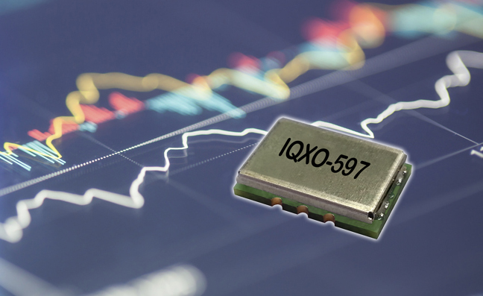
The new IQXO-597 range of clock oscillators recently launched by IQD
Image source: IQD

About IQD
Backed by over 40 years’ experience in the manufacture of frequency products, IQD is a recognised market leader in the frequency control market and part of the Würth Elektronik eiSos group, one of the leading European manufacturers of passive components. With active customers in over 80 countries, IQD offers one of the most comprehensive frequency product ranges available, from low cost commercial grade product to that used in high reliability industrial and automotive applications including: Quartz Crystals, Clock Oscillators, AEC-Q200/TS16949 Crystals & Oscillators, VCXOs, TCXOs, OCXOs, GPS Disciplined OCXOs, and Rubidium Oscillators.
Manufacturing capacity totals over 40 million units per month covering quantities from one off specials to multi-million unit orders. In addition, IQD offers customers a range of engineering support services including: application support, custom product design, sample development, electrical testing & screening, frequency/temperature testing, accelerated ageing, circuit characterisation and MTIE/TDEV testing. IQD’s products are specified by leading manufacturers in the aerospace, automotive, communications, computing, consumer and industrial industries throughout the world. The full range of products is available direct through sales offices or via an extensive worldwide distribution network.
Further info at www.iqdfrequencyproducts.com

About the Würth Elektronik eiSos Group
Würth Elektronik eiSos GmbH & Co. KG (Focus: standard components), Würth Elektronik iBE GmbH (Focus: customized passive components for the automotive industry), Wurth Electronics Midcom Inc. (Focus: transformers and custom magnetics), Würth Elektronik Stelvio Kontek S.p.A. (Focus: customized plug connectors) and IQD Frequency Products Ltd (Focus: frequency-producing devices) form the Würth Elektronik eiSos Group. The former subsidiary AMBER wireless GmbH with a focus on solutions for wireless data transmission became the Wireless Connectivity and Sensors division of Würth Elektronik eiSos GmbH & Co. KG in 2018. The group of companies with 6,700 employees generated sales of approx. € 653 million in 2017. The Würth Elektronik eiSos Group is one of the biggest European manufacturers of passive components and operates in 50 countries.
Through its technology partnership with the Audi Sport ABT Schaeffler Formula E Team and its support for the Formula E racing series, the Group demonstrates its innovative strength in eMobility
(www.we-speed-up-the-future.com). Other global growth markets, such as Energy Harvesting, Internet of Things and Wireless Communication, are addressed with innovative products.
The Würth Elektronik eiSos Group is part of the Würth Group, the world market leader for assembly and fastening technology.
Würth Elektronik: more than you expect!
Further info at www.we-online.com

More information:  IQD Frequency Products Ltd  Rebecca Long  Station Road  Crewkerne  Somerset  TA18 8AR  United Kingdom  Phone: +44 1460 270270  E-mail: rebecca.long@iqdfrequencyproducts.com  www.we-online.com  www.iqdfrequencyproducts.com | Press contact:  HighTech communications GmbH  Brigitte Basilio  Brunhamstrasse 21  81249 Munich  Germany  Phone: +49 89 500778-20  Telefax: +49 89 500778-77  E-mail:  b.basilio@htcm.de  www.htcm.de

