PRESS RELEASE
Optimum coil combination with the Mix-and-Match Disk
Würth Elektronik eiSos Does a Good Turn for Wireless Power Transfer
Waldenburg (Germany), 27 March 2019 – Würth Elektronik eiSos GmbH & Co. KG expands its range of services: With the new Mix-and-Match Disk, you can quickly and easily select suitable transmitter and receiver coils for wireless power transfer applications. It complements the corresponding online tool at www.we-online.com, which was distinguished as ‘Innovator of the Year’ by the Design & Elektronik trade journal in 2017.
The Mix-and-Match Disk has two sides: On the front is an overview of the transmitter coils for wireless power transfer applications. If the customer turns the disk to the desired article number of the transmitter coil, the matching receiver coils are displayed in a cutout. Coils highlighted in green match perfectly, orange highlighted pairs can only be used to a limited extent.
On the reverse of the disk, the suitable wireless power transfer transmitter coils for preselected receiver coils can be found in the same way.
With the 20 cm diameter disk, Würth Elektronik eiSos supports its customers in always selecting the optimum coil combination. Even without Internet access, anybody who wants to get a quick and easy overview of the wireless power transfer coils now has an analog alternative at hand. If required, the QR code takes you directly to the Würth Elektronik eiSos website, where the coil data sheets and detailed information can be found.
The first 1,000 units were snapped up within a short time. The Mix-and-Match Disk is now available again free of charge.

Available images
The following images can be downloaded from the Internet in printable quality: http://www.htcm.de/kk/wuerth

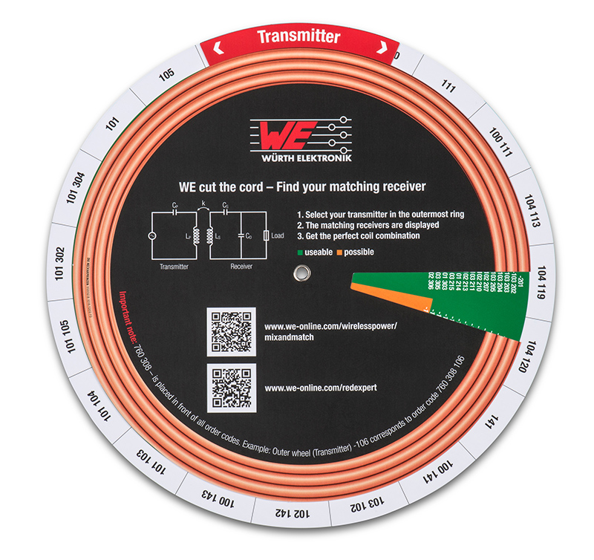
Image source: Würth Elektronik eiSos
Mix-and-Match Disk – take a turn for the better in wireless power transfer with the optimal coil combination

About Würth Elektronik eiSos
Würth Elektronik eiSos GmbH & Co. KG is a manufacturer of electronic and electromechanical components for the electronics industry. The company currently employs 8,300 staff and generated sales of 848 million euros in 2018. Würth Elektronik eiSos is one of the largest European manufacturers of passive components and is active in 50 countries. Production sites in Europe, Asia and North America supply a growing number of customers worldwide.
The product range includes EMC components, inductors, transformers, RF components, varistors, capacitors, resistors, quartz crystals, oscillators, power modules, Wireless Power Transfer, LEDs, sensors, connectors, power supply elements, switches, push-buttons, connection technology, fuse holders and solutions for wireless data transmission.
Through its technology partnership with the Audi Sport ABT Schaeffler Formula E Team and its support for the Formula E racing series, the company demonstrates its innovative strength in eMobility
(www.we-speed-up-the-future.com).
Würth Elektronik eiSos is part of the Würth Group, the world market leader for assembly and fastening technology.
Würth Elektronik: more than you expect!
Further information at www.we-online.com

Further information:  Würth Elektronik eiSos GmbH & Co. KG  Sarah Hurst  Max-Eyth-Strasse 1  74638 Waldenburg  Germany  Phone: +49 7942 945-5186  E-mail: sarah.hurst@we-online.de  www.we-online.de | Press contact:  HighTech communications GmbH  Brigitte Basilio  Brunhamstrasse 21  81249 Munich  Germany  Phone: +49 89 500778-20  Telefax: +49 89 500778-77  E-mail: b.basilio@htcm.de  www.htcm.de

